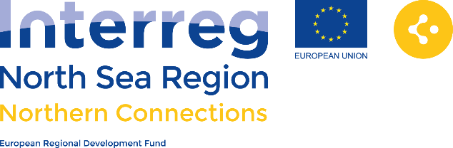

We believe

* that if we improve conditions for transnational cooperation between cluster networks, SMEs and cities/regions, and become better at expressing our innovation challenges we can stimulate growth and innovation in our SMEs in the North Sea Region.

We wish

* to start the dialogue between policy makers and our clusters on how we in practice can overcome existing barriers and push towards more transnational cooperation between clusters and SME.

POLICY

* Rough long-list of tools and recommendations.
* Conceptualizing national workshops and local decision-makers meeting.

STATUS

WHY?

HOW?

**Dialogue 1:1 with policy- and decision-makers**

* Ex: We meet up with local/regional policy and decision-makers for dialogue and lobbying.

**Regional and national workshops – opening the dialogue on transnational innovation cooperation**

* Ex: In each country we arrange coordinated workshops and meetings. Two-way awareness dialogue with regional and national organizations.

**Policy recommendations – calls to action to easier innovation cooperation across borders for SMEs and clusters**

* Ex: Growing the cluster intelligence to transnational innovation collaboration.

**Toolbox with concrete measures for cities and regions to choose from**

* Ex: Workshop concept where cities and regions learn how to identify and express challenges as business opportunities for pushing innovation.
* Ex. Fact sheet on where to go and who to talk to on innovation procurement – the legal overview.
* Ex. Debate-kit with “10 questions” on pros and cons on opening our cities to innovation partnerships across national borders.