‘SCORE Guideline for Smart City Challenge detection and Solution selection’ (or guidelines T3.1).
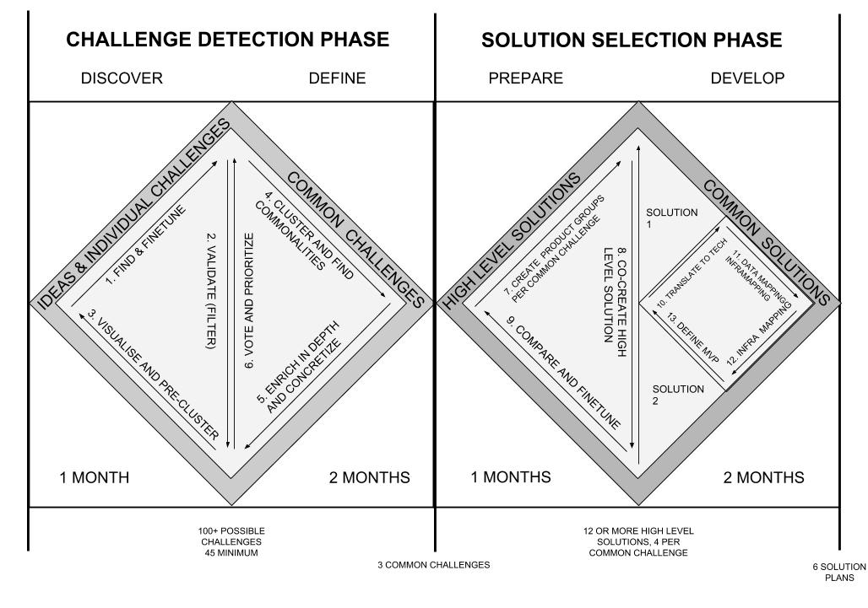
The whole process is based upon a Design Thinking double diamond design process and should enable partners to go from a more linear approach in defining challenges and selecting solutions to an iterative process in small loops to finetune towards well defined technical solutions. Each step is estimated to take 1 to 2 months, divided in 4 phases .

CHALLENGE DETECTION PHASE

Challenge phase | Seed 🥜 | Seedling 🌱 | Plant 🌿 | Harvest 🚜
Focus | What? What is it about? | Why / How? Why is this challenge important? What are the partial aspects of this challenge?  How do you see this challenge emerging?  How do you see this challenge solved (regardless of tech) | Who?  Who experiences the problem (end-user)? Who owns the problem (city service)? Who endorses the problem from other cities? | Harvesting is based on the former forms to pick the most interesting emerging challenges based on both depth (how much of the info is there) and endorsement (who showed interest)
Maturity | One sentence idea of what you want to solve for your particular city | Expansion on the first iteration based on a number of more in depth questions in order to really understand the roots of the problem or challenge. | Shows endorsement and internal players, this exercise is more a stepping stone in order to create product groups. | Ready to move to solutions.
Target | 100+ submits total | 45 submits | Min 3, maximum 6 | We should end with 3 common challenges
Transition to next phase | Validate and cluster based on thematics and preferences | Validate and invite consortium members to show (no) interest. | Have a discussion via confcall to ensure 3 common challenges are selected, live is better

DISCOVER (DIVERGENCE)

Timing: 1 month
Online tools:
- Google Forms - simple question form where the input is editable by the respondents.
- What is your city challenge, explain in one sentence
- Give us some challenge related keywords (minimum 3)
- Own tool to provide connections through a network graph visualisation like http://discograph.mbrsi.org/
Offline tools:
A brainstorm kit and short guide on how to come up with the right challenges.
I/O:
- Input: Vague ideas of potential challenges for SCORE
- Output: +100 oneline ideas for potential challenges by the partners

Steps:

1. FIND AND FINETUNE
Looking for: specific challenges, broadly described
Focus: quantitative - more is more, moonshot ideas are ok for now.

Brief: Talk with city operators and civil servants on issues they have regarding the three topics (Mobility, Environment, water & waste management) and send us as many ideas as possible, with a minimum of 5 per partner per waterfall. The questionnaire used should be really lightweight enabling anyone to propose ideas fast. More challenges are welcome and will enable us reiterate when needed. We will provide a brainstorm kit to help consortium members to think about these challenges.

The questions are:
  - What is the challenge about? Can you explain in one sentence what the challenge or problem is about?
  - Give us a few related keywords about this challenge
  - Which city is having issues with this challenge (for contact purposes)?

Proces: Organise a workshop around each topic (Mobility, Environment, water & waste management)

Brainstorm kit:
The brainstorm kit should also include guidelines about the challenge scope we are looking for.

2. VALIDATE (FILTER)
WP3 leads checks whether
- The challenge is indeed a challenge, not a solution
- The challenge fits within the three topics as defined in the Interreg proposal
- The challenge is concrete and specific enough and not too broad
WHEN APPROVED a challenge is only then asked to provide more info.
WHEN DENIED a partner goes back to the drawing board
- to create new challenges
- or in case it was a solution or technology component that was suggested re-explore the solution to bring it to the underlying / overarching / partial overlapping challenge, should not contain technical keywords.
(the list should also be open to all partners, having insights in what challenges are being suggested, and it would be good to approve all challenges by the consortium before moving on to the next step)

3. VISUALISE & PRE-CLUSTER
Validated challenges will be inputted into a seperate database. This database is connected to a social network graph that visualises connections between challenges, keywords and cities. This visualisation with our own built tool can be the inspiration for others to come up with new challenges in their respective fields.

DEFINE (CONVERGENCE)

Timing: 2 months
Online tools:
- Loomio.org or for the prioritizing and voting (yes, no, abstinent)
- Challenge template for the specific challenges (Google Docs)
Offline tools: /
I/O:
- Input: +100 one-liner ideas for potential challenges by the partners
- Output: 3 well defined common challenge (water / environment / mobility)

4. CLUSTER AND FIND COMMONALITIES
After the convergence level we give WP3 leads the chance to find commonalities within the suggested challenges, group topics together in order for the voting period to be more structured. We should go through at least two iterations. One from 100+ ideas to 45 challenges and from 45 individual challenges to 3 common challenges.

5. VOTE AND PRIORITIZE
Based on all validated challenges, partners will prioritize the challenge/s through a voting process. Partners can upvote or downvote every suggested challenge. Upvoting meaning that they have a need for this challenge, downvoting the challenge they do not face.
The move from 45 challenges to 3 common challenges could be beneficial when done in a live meeting.

6. ENRICH IN DEPTH AND CONCRETIZE
A challenge is researched further on needs and impacts to finetune and complete the challenge, this is based on a more detailed questionnaire based on former submissions. We can research the following aspects:
  - Target groups of challenge (who)
  - Contextualisation (where)
  - Points of pain (what)

SOLUTION SELECTION PHASE

Solutions phase | Seed 🥜 | Seedling 🌱 | Plant 🌿 | Harvest 🚜
Focus | What are we going to do to fix this challenge | What is needed to translate the high level solution to a technical one. | Can we break it down to technical components? And who will be developing the missing components? | Harvesting is handing over the solution over to WP4 team.
Maturity | High level solution, without technical substantiation | More concrete solution analysis of the available datastreams and needed components | Full breakdown of components, with a clear view on the MVP up to the final Open Source product | Starting to develop the solution
Target | 10 per common challenge | 2 solutions per challenge | 6 solution plans
Transition | Validate these solutions are indeed fit to solve the underlying challenges and identify technical owners | Validate that these are the main challenges and that at least half of the cities want to work or implement this challenge. | Sign off the development plan by WP4 leads

PREPARE (DIVERGENCE)
Timing: 1 months
Online tools:
- Some sort of Wiki to map the iterative process and requirements, but can also be done with Google Docs.
Offline tools: High level solutions templates can help the #8 process
I/O:
Input: 3 well defined challenges
Output: 30 High level solutions

7. CREATE PRODUCT GROUPS PER COMMON CHALLENGE

Before defining solutions we need to create product groups consisting of one problem owner, one co-owner and one technical person. Together they create 10 high level solutions to their problem or challenge, based on the solutions template.

Product groups should contain at least 2 of the 9 cities. We should have at least one product group per common challenge.

8. CO-CREATE A HIGH LEVEL SOLUTION & BUSINESS CASE
The task of these product groups is to think about solutions for one of the common challenges. This is still high level, meaning they should not think about feasibility, data-presence and total cost of ownership.

Stuff to take into account:
  - Solutions can be symbiotic, with one feeding data or insights to another.
  - Both can be similar solutions that are not symbiotic, but a great way to AB-test which one solves the challenge better.
  - Or solutions can be relevant for the challenge, but unrelated otherwise
  - Solutions will be presented to end-users (citizens or city operators) through a short paper prototyping workshop validating 2 things.
  - Does this (partly) solve the challenge?
  - Is this the right interface for the otherwise technical solution?
  - Solutions can also turn out to be components, so with no interface.
  - This will enable the product group to either finetune their solutions or bump into a new solution idea to develop into a high level solution.

- Translate the high level solution to a tech solution? Guiding questionnaire and parameters can help setup things.

- What is the solution type? One or more can apply
  - On data collection
  - On coordination
  - On decision making
  - Decision making support
  - Communication (informing)
  - Coordination (collaborating)
  - Providing / opening up data
  - Physical resources
  - Logistics
  - Visualising data
  - Influencing / creating awareness
  - Idea generation
- Who are the problem owners or supporters? Can be high level, like citizens, tourists, civil servants, mayors,...
- In what way is it open data related? Brief reflection on needed data sources or what they’re trying to gather.
- (Is this something you have solved, solved partially, or have no solution for yet?)

9. COMPARE AND FINETUNE

This step is all about showing your high level solution to the SCORE partners that were no part of the product group and see whether they have any interests in co-producing or even replicating the solution. They can also provide extra questions and remarks about the high level solution that might provide new insights to finetune your solution. It might even arise a new development group that works around another (similar) solution.

DEVELOP (CONVERGENCE)
Timing: 2 months
Online tools:
Offline tools: Template for a technical solution description
I/O:
Input: 10 high level solutions per common challenge
Output: 2 well-defined solutions (+ components) per common challenge

10. TRANSLATE TO TECH
From this point on the tech leads take over and start translating the solution to a more technical level. One of the first to do’s in that in looking for existing project that solve similar challenges and see how they approached development.
Also translating the high level solution into technical components makes it easier to detect what exists and what doesn’t.

11. DATA MAPPING
Next to components breakdowns we need to do some data mapping.
If the solution ingests data, more information is needed about which datastreams are needed, are they about real time data or static data?
Are these datastreams available with all partners? If not can they attempt to open them and make them available?

If the solution generates data, can we find taxonomies and common data models to structure this data? Can we use that data in other solutions?

12. INFRA MAPPING
Next to data, what is needed on an infrastructure level?

13. DEFINE MVP & FINAL BUSINESS CASE
Combine breakdown, data and infrastructure into one comprehensive document to hand over to the WP4 people.

Solutions can drop out in this 10 to 13 circular process due to a number of reasons.
- There are components missing that are beyond the SCORE scope
- There are datastreams not available with the partners to be used by the solution
- The infrastructure or software architecture is lacking to execute and integrate
- The MVP is not feasible with the current resources

