PHOTOS OF PROJECT MEETING G-PATRA IN GRONINGEN, NETHERLANDS

7th en 8th November 2018

At Province of Groningen, 7th November 2018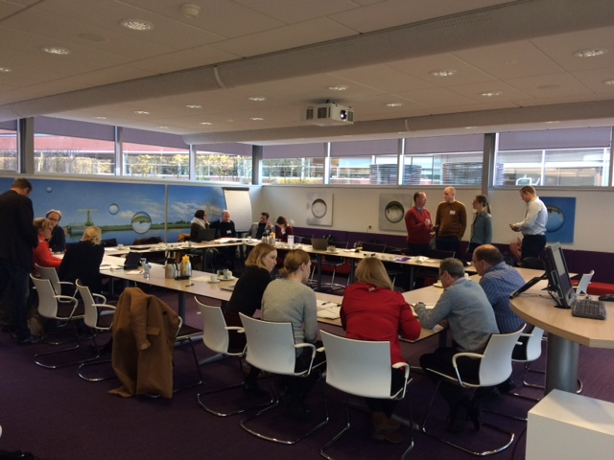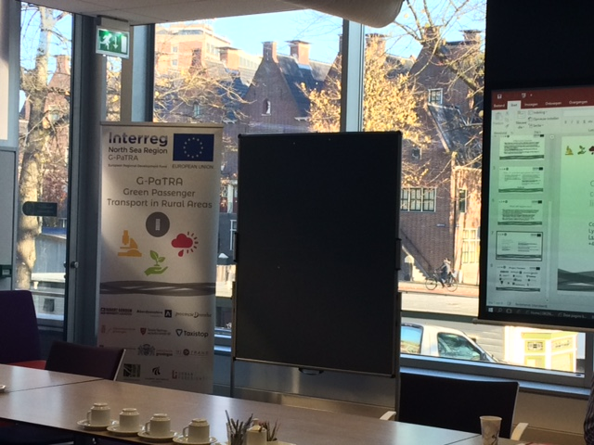

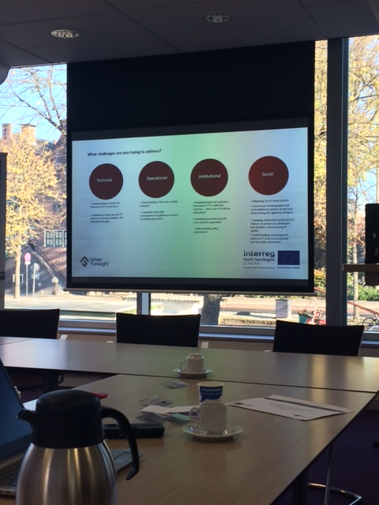

At Province of Groningen, 8th November 2018 