Calculating the value of the redesign of the Dordwijkzone using the TEEB-tool

The municipality of Dordrecht

Sanne Schalekamp (2588152)
Research assignment GI-minor
Vrije Universiteit Amsterdam
Supervisor VU: Maurice de Kleijn
Supervisors municipality of Dordrecht: Rik Heinen and Berry Gersonius
Amstelveen, 23-12-2018

Table of contents

Table of contents 2
Introduction and problem 4
Plan 5
Literature review 5
Methods 5
Evaluation of the tool 5
Health 6
Power consumption 6
House value 6
Recreation and spare time 7
Social cohesion 7
Adjustments to the model 8
Power consumption 8
House value 8
Data 9
Analysis and results 10
Current model processes 10
Health 10
Power consumption 10
House value 10
Recreation and spare time 11
Social cohesion 11
Model adjustment processes 11
Power consumption 11
House value 11
Results current model 12
Scenario 1: now 12
Scenario 2: after parks 13
Scenario 3: after houses 14
Results after adjustments of the model 15
Power consumption 15
House value 15
Discussion and conclusion 16
Discussion 16
Conclusion 16
Sources 18
Appendix 19

Introduction and problem

The Dordwijkzone in the municipality of Dordrecht is a connected green and blue area, which lies inside the city. In a green and blue area, there is a lot of nature: vegetation (green) and water (blue). The Dordwijkzone holds ecological, recreational and societal value, by providing biodiversity, water quality, and recreation and sporting areas. The municipality of Dordrecht has planned the construction of 10.000 new houses for 2030, surrounding the Dordtwijk zone. As a result, the pressure on the Dordwijkzone will increase, since there will be more people making use of the benefits that it provides. This is why the municipality of Dordrecht has decided to redesign parts of the Dordwijkzone. They want it to become a large city park, being inspired by Central Park in New York.

Their idea is to make several sporting parks, which are now exclusively for members, open to the public. The accommodations in the sporting parks will be partly renewed. Additionally, they want a better walking and cycling connection throughout the whole Dordwijkzone. The ecological value also has to be increased, by improving the biodiversity and water quality.

Before the municipality can execute their plan, they need research that supports that the benefits provided by the Dordwijkzone will actually improve. They want to know what the value is now, what the value is immediately after the redesign, and what the value will be in the future, after the redesign and the new house construction. The municipality wants to make use of the TEEB-tool for this. TEEB stands for “The Economics of Ecosystems and Biodiversity”, created by P. Sukhdev, et al. (2010). which expresses the values of the benefits in money. This is not actual money that will be earned, but a kind of societal value, that describes how much the benefit is worth.

The main question is: “What are the expected societal benefits and values of the new design of the Dordtwijk zone, taking into account the construction plan of 10.000 new houses?”

The partial questions for this are:
- “What are the societal benefits and values of the Dordtwijk zone now?”
- “What are the expected societal benefits and values of the Dordtwijk zone after the redesign?”
- “What are the expected societal benefits and values of the Dordtwijk zone after the redesign and the house construction?”

Plan

Literature review
Similar researches using the TEEB-tool have already been done. For example: “Goed groen is goud waard” (De Urbanisten, 2016), which was done for the city of Zwolle. The value of several different possible redesigning scenarios was calculated and compared.
In “Spatial analysis of the multiple benefits of Urban Blue Green Infrastructures” (Damani Bruno, 2018), a very similar analysis was done for the municipality of Dordrecht, but this was for Dordrecht as a whole, not just the Dordwijkzone. This is because the plans for the new design of the Dordwijkzone did not exist yet at that time.

Methods
For calculating the values of the Dordwijkzone, the TEEB-tool will be used. The TEEB-tool is located on the website https://www.teebstad.nl/. This tool gives societal benefits like health, social cohesion and recreation a value in money. This money will not directly be earned by the municipality, it is just a value that expresses how much a benefit is worth.
First, the three scenarios will be calculated with the existing model, which is described in the evaluation of the tool. Then, some changes will be made to the model to add more spatial elements to the benefits. This will be explained in the part adjustments to the model.
The first scenario of the situation now will be calculated with the parks and houses how they are now. In the second scenario, several parks and 1 body of water are added in places where the municipality plans to build those. There are maps illustrating these scenarios in the appendix.
The municipality does not know yet where the new houses will be built, so this has to be done differently. 10.000 new houses have to be built, there are currently approximately 55.000. This is an increase of 18%, so the values of the second scenario will be multiplied by 1,18 to approximate the value added by the new houses.
The input values for the model will mostly be calculated using ArcGIS. Additionally, Excel will be used for some calculations.

Evaluation of the tool
The TEEB-tool consists of 6 benefit categories: health, power consumption, house value, recreation and spare time, social cohesion, and water management. These categories contain indicators for those benefits. For this research, not all of the categories and indicators will be used. The water management category will be left out because there is no information about water depth. Several indicators are left out because they overlap with others, and should only be used separately. Some indicators are also left out because they are not relevant for this research. Below is a list of the used categories and indicators. A short explanation and the formula of the benefit are given.
The output value of the formulas is the value that the benefit delivers in 30 years. To calculate this, a discontofactor is used, to take into account the change in the worth of money throughout the years. The discontofactor is 20,6. A detailed explanation of the discontofactor, along with the sources for all the constant values in the formulas, can be found in the Bronvermelding kengetallen TEEB-stad tool (TEEB, 2016).

Health

Less health costs
In surroundings with more green in the area, less people are registered at the doctor. When the amount of patients decreases, money is saved from health costs.
Formula: (# inhabitants in a 1000 meter radius from the green * 0,835 less patients per 1000 persons* 0,001) * €868,- average health costs per patient * 20,6

Less labor loss
In surroundings with more green in the area, less people are registered at the doctor. This leads to better labor performance, and saves money on labor loss.
Formula: (# inhabitants in a 1000 meter radius from the green * 0,835 less patients per 1000 persons * 0,67 participation level * 0,001) * €6341,- average labor loss costs per person * 20,6

Power consumption

Tree line within 50 meters from houses
A tree line shelters a house from the cold wind. Because of this, the power consumption becomes lower. In a zone from 0-50 meters from a tree line (assuming the standard height of 10 meters), the wind speed is reduced by 70%. This makes the energy consumption of each house decrease by 10%.
Formula: (# houses * 1600 m3 average gas use * 0,1 less energy usage * 0,3 standard correction wind direction) * €0,66,- average gas price * 20,6

Tree line with 50-100 meters from houses
A tree line shelters a house from the cold wind. Because of this, the power consumption becomes lower. In a zone from 50-100 meters from a tree line (assuming the standard height of 10 meters), the wind speed is reduced by 50%. This makes the energy consumption of each house decrease by 7,5%.
Formula: (# houses * 1600 m3 average gas use * 0,075 less energy usage * 0,3 standard correction wind direction) * €0,66,- average gas price * 20,6

House value

Proximity of water
Houses in the proximity of water increase in value. For proximity, a buffer of 400 meters is used.
Formula: # houses * average WOZ-waarde x 0,06 worth increase

Proximity of parks
Houses in the proximity of parks increase in value. For proximity, a buffer of 400 meters is used.
Formula: # houses * average WOZ-waarde x 0,06 worth increase

View on water
Houses with a view on water increase in value.
Formula: # houses * average WOZ-waarde x 0,08 worth increase

View on parks
Houses with a view on parks increase in value.
Formula: # houses * average WOZ-waarde x 0,08 worth increase

View on green line
Houses with a view on a green line, for example a tree line, increase in value.
Formula: # houses * average WOZ-waarde x 0,05 worth increase

Bordering water
Houses bordering water increase in value.
Formula: # houses * average WOZ-waarde x 0,12 worth increase

Recreation and spare time

New green
New green provides more space for extra recreation. To determine the value of this, a value that people are prepared to pay for recreation is used.
Formula: # expected new recreationists * €1,- preparedness to pay * 20,6

Social cohesion
Social cohesion in a neighborhood is measure on a scale from 1-5 points, where the average neighborhood has a social cohesion of 3.

Increase in plantation surface
Small-scaled green provides higher social cohesion in the neighborhood. For this research, the assumption is made that parks have the same effect as small-scaled green. An increase of 1% green in the neighborhood, makes the social cohesion increase with 0,55%. For the average neighborhood with a social cohesion of 3, this means a (0,01 * 0,55 * 3 =) 0,016 points. When the social cohesion rises, people are less likely to move. This saves on moving costs.
Formula: (#inhabitants in neighborhood * relative surface park-neighborhood * 0,55 social cohesion increase * 3 average social cohesion * 0,021 less people who move per point social cohesion) * €2945,- average moving costs * 20,6

Increase in water surface
More water surface causes increase of social cohesion in the neighborhood. An increase of 1% green in the neighborhood, makes the social cohesion increase with 0,37%. For the average neighborhood with a social cohesion of 3, this means a (0,01 * 0,37 * 3 =) 0,011 points. When the social cohesion rises, people are less likely to move. This saves on moving costs.
Formula: (#inhabitants in neighborhood * relative surface water-neighborhood * 0,37 social cohesion increase * 3 average social cohesion * 0,021 less people who move per point social cohesion) * €2945,- average moving costs * 20,6

Adjustments to the model
To add more of the spatial element, some adjustments will be made to the model. The values will be calculated for this model too, additionally to the current model.

Power consumption
In the current model, a standard tree height of 10 meters is assumed. This can be changed to take into account the actual heights of the trees.
Within a zone from 0-5 times the height of the tree, the wind speed is reduced by 70%. This causes 10% less power constumption.
Within a zone from 5-10 times the height of the tree, the wind speed is reduced by 50%. This causes 7,5% less power consumption
(Ministerie van LNV (2006): Kentallen Waardering Natuur, Water, Bodem en Landschap Hulpmiddel bij MKBA´s)

House value
For the proximity of parks and water, a buffer of 400 meter is used in the current model. To make the houses which are closer to the parks/water increase more in value, and the houses which are further from the parks/water increase less in value, this buffer will be divided into 4 rings with different weights. The rings will be 0-100 meter, 101-200 meter, 201-300 meter and 301-400 meter. The weights will be respectively 1,3, 1,1, 0,9 and 0,7. The average of the weights has to be 1, to compare it fairly to the current model.

Data

The collected data corresponds to the indicators in the TEEB-tool.
Title | Source | Year | Scale | Format | Fit for purpose
Population density | Municipality of Dordrecht | 2018 | Postal code area | Shapefile | The postal code areas are small enough to be representative for the population density within that area.
Houses | Municipality of Dordrecht | 2018 | House | Shapefile | Every house is a polygon, so this is very accurate to determine where houses are.
WOZ-waarde | Municipality of Dordrecht | 2018 | Postal code area | Shapefile | The postal code areas are small enough to be representative for the WOZ-waarde within that area.
Land use | PDOK | 2012 | 25x25 m | Shapefile | The raster is small enough to have an accurate representation of where the main features are located.
Tree map | Municipality of Dordrecht | 2018 | Tree | Shapefile | Every tree is a point, so the position of the trees is accurate.

Analysis and results

First, the processes of calculating the input values for the model are explained. For some indicators, flowcharts are shown to illustrate the calculation process. This will first be done for the current model, and then for the adjustments to the model. Then, the results for every scenario will be discussed for both the current model and the adjustments.

Current model processes

Health

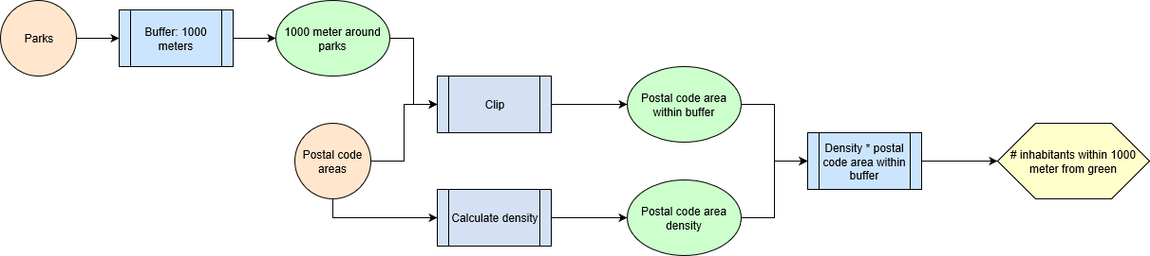
To calculate the number of inhabitants within 1000 meters from the green, a buffer around the parks is first created. The postal code areas are clipped to this buffer. Then, the area of the clipped postal code areas is multiplied with the density of the original postal code areas.

Power consumption

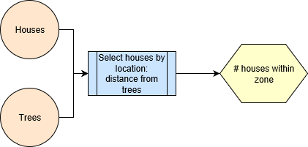
The houses are selected by location, first in a distance from 50 meters from the trees. The number of selected houses is noted. Then the houses are selected in 100 meters from the trees. Subtract the number of houses in a distance from 50 meters from the trees, and the result is the number of houses in the distance from 50-100 meters.

House value

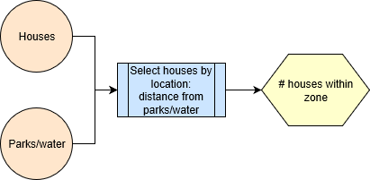
The houses are selected by location from distances from the parks and water. For the proximity indicator, a buffer of 400 meter is used (this has been used in earlier research). For the view indicator, a buffer of 35 meter is used. This buffer has been determined by trying out different buffers and seeing on the map which buffer best selected the only the first row of houses to look out on a park, water or treeline. For treeline, the same process as in the flowchart is used.
For the indicator bordering water, a small buffer (5 meter) is first used to select possible houses that border water. Then, visual analysis is done using satellite images from Google maps, to look if the houses actually border water.

Recreation and spare time
For this indicator, an estimation of the expected recreationists has been made by the municipality. These are the numbers:
Now: 10.000 recreationists
After parks: 15.000 recreationists (5.000 extra)
After houses: 17.700 recreationists (18% extra)

Social cohesion
For social cohesion, the parks and postal code areas are intersected. Then, the surface of the park within the postal code areas is calculated. After that, the attribute table is copied to Excel. This is because some postal code areas will be in the table multiple times, and need to be merged. For every same postal code area, add up the park area surfaces. Then, the relative area of park and postal code area can be calculated by dividing the total park surface by the postal code area surface. The same thing can be done for the water.

Model adjustment processes

Power consumption

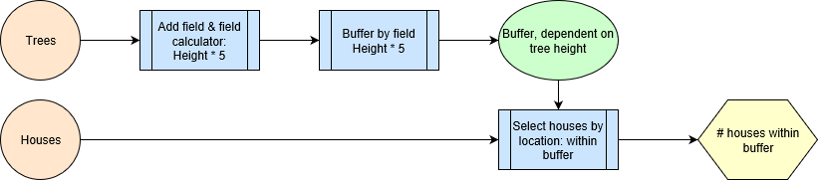
A field is added to the attribute table of the shapefile. Using field calculator, this field is given the value of height * 5. Then, a buffer is created using the new field of height * 5. Select the houses by location within the buffer. This results in the number of houses within the buffer. The same can be done for the 5-10 times the height buffer. The added field will have the value of height * 10. At the end, subtract the number of houses in the 0-5 times buffer from the 0-10 times buffer, to get the 5-10 times the height buffer.

House value
For the house value, adjustments are made to the proximity to park and proximity to water indicators. The amount of houses in the distances 0-100 meter, 101-200 meter, 201-300 meter and 301-400 meter are calculated. The outcomes are multiplied by the weights, respectively 1,3, 1,1, 0,9 and 0,7.

Results current model

Scenario 1: now

Health total: €4.539.473,30
Health costs: 43,069 less patients €770.113,54
Labor loss: 28,856 less labor loss €3.769.359,76

Power consumption total: €967.817,67
<50 meter: 36336 less m3 gas €494.024,26
50-100 meter: 34848 less m3 gas €473.793,41

House value total:€212.995.277,56
Proximity of water: €76.729.891,4
Proximity of parks: €120.428.838,-
View on water: €1.340.003,62
View on park: €8.849.545,84
View on greenline: €5.646.998,7
Bordering water: €0

Recreation and spare time total: €206.000,-
New green: €206.000,-

Social cohesion total: €3.309.352,71
Increase in plantation surface: 50,303 less movers €3.051.751,76
Increase in water surface: 4,246 less movers €257.600,95

total: €222.017.921,24

Scenario 2: after parks

Health total: €4.564.379,68

Difference with now: €24.906,38
Health costs: 43,306 less patients €774.338,86
difference with now: 0,237 less patients, €4.225,32
Labor loss: 29,015 less labor loss €3.790.040,82
verschil nu: 0,159 minder arbeidsverlies, €20.681,06

Power consumption total: €967.817,67

Difference with now: €0,-
<50 meter: 36336 less m3 gas €494.024,26
difference with now: €0,-
50-100 meter: 34848 less m3 gas €473.793,41
difference with now: €0,-

House value total:€228.178.364,38

Difference with now: €15.183.086,82
Proximity of water: €88.168.178,60
difference with now: €11.438.287,20
Proximity of parks: €122.764.336,-
difference with now: €2.335.498,-
View on water: €1.426.358,88
difference with now: €86.355,26
View on park: €10.172.492,20
difference with now: €1.322.946,36
View on greenline: €5.646.998,7
difference with now: €0
Bordering water: €0
difference with now: €0

Recreation and spare time total: €309.000,-

Difference with now: €103.000,-
New green: 309.000,-
difference with now: 103.000,-

Social cohesion total: €4.181.978,85

Difference with now: €872.626,14
Increase in plantation surface: 64,399 less movers €3.906.894,36
difference with now: 14,096 less movers, €855.142,60
Increase in water surface: 4,534 less movers €275.084,49
verschil nu: 0,288 less movers, €17.483,54

total: €238.201.540,58
difference with now: €16.183.619,34

Scenario 3: after houses

Health total: €5.383.938,09

Difference with now: €844.464,79

Difference with after parks: €819.558,41
Health costs: 51,100 less patients €913.714,78
Labor loss: 34,24 less labor loss €4.472.223,31

Power consumption total: €1.141.737,69

Difference with now: €173.920,02

Difference with after parks: €173.920,02
<50 meter: 42864 less m3 gas €582.778,94
50-100 meter: 41112 less m3 gas €558.958,75

House value total:€395.884.850,64

Difference with now: €182.889.573,08

Difference with after parks: €167.706.486,26
Proximity of water: €104.039.317,-
Proximity of parks: €144.857.340,-
View on water: €1.676.935,44
View on park: €11.997.798,20
View on greenline: €133.313.460,-
Bordering water: €0

Recreation and spare time total: €364.620,-

Difference with now: €158.620,-

Difference with after parks: €55620,-
New green: €364.620,-

Social cohesion total: €4.934.735,05

Difference with now: €1.625.382,34

Difference with after parks: €753.756,20
Increase in plantation surface: 75,991 less movers €4.610.135,35
Increase in water surface: 5,351 less movers €324.599,70

total: €407.551.261,47
Difference with now: €185.533.340,23
Difference with after parks: €169.349.720,89

Results after adjustments of the model

Power consumption

Now total: €2.571.112,36

Difference with current model: €1.603.294,69
0-5 times tree height: 75.744 m3 less gas €1.029.815,42
5-10 times tree height: 113.364 m3 less gas €1.541.296,94

After houses total: €3.033.974,6

Difference with current model: €1.892.236,91
0-5 times tree height: 89.376 m3 less gas €1.215.156,1
5-10 times tree height: 133.776 m3 less gas €1.818.818,5

House value

Now total:€180.118.957,61

Difference with current model: -€17.039.771,79
Proximity to water: €66.880.106,22
Proximity to parks: €113.238.851,39

After parks total:€194.548.046,56

Difference with current model: -€16.384.468,04
Proximity to water: €77.989.430,89
Proximity to parks: €116.558.615,67

After houses total: €229.961.895,-

Difference with current model: -€18.934.762,-
Proximity to water: €92.028.784,29
Proximity to parks: €137.933.110,71

Discussion and conclusion

Discussion

In the TEEB-tool, the study “Morbidity is related to a green living environment” (J. Maas, et al., 2009) is used as a source for the health category. The result of this study says: “The annual prevalence rate of 15 of the 24 disease clusters was lower in living environments with more green space in a 1 km radius. The relation was strongest in slightly urban areas and not apparent in very strongly urban areas.” A very strong urban area is by CBS definition an area with an average address density of 2500 or more addresses per km2. The address density around the Dordwijkzone exceeds this number in some places, and in some not. It depends on the locations of the square kilometers that are chosen. Because of this, it is not certain if the relation between health and green is present around in every place around the Dordwijkzone. For the purpose of this research, the average address density around the Dordwijk zone was used and this resulted in an address density of approximately 1900 adresses per km2. This is under 2500, so the health category has been used.

In the health category, the number of inhabitants within a 1000-meter radius must be calculated. This has been done using postal code area population density. This causes MAUP to be present. The assumption is made here that the population is distributed evenly throughout the postal code areas.

The social cohesion category has small scaled green and plantation as an indicator. However, the plan for the Dordwijkzone is not focused on making small green, but on making parks. For this research, it has been assumed in consultation with the municipality supervisors that the parks of the Dordwijkzone have the same impact on social cohesion as small green would have.

The TEEB-model could still be improved, for example with the adjustments that have been done in this research. Also, the wind direction could be taken into account for the category of energy consumption. If the municipality collects data on the depth of the bodies of water, they would also be able to use the TEEB-tool’s category of water management.

Conclusion

The societal benefit of the Dordwijkzone in the current situation is the positive influence it has on health, power consumption, house value, recreation and social cohesion. Per year, there are 43 less patients due to the Dordwijkzone and 29 less sick workers. In total, 71.184 m3 of gas is saved by the shelter that the trees give to the houses. An estimated 10.000 recreationists make use of the Dordwijkzone per year. The social cohesion is also higher because of the Dordwijkzone: there are 55 less people per year who move away. All these things together deliver a value of €222.017.921,24.

When new parks are built, the category of house value has the highest increase, namely an increase of €15.183.086,82. Social cohesion also increases, there will be 14 less people who move away per year compared to the current situation. The change in value for this is €872.626,14. It is estimated that there will be 5000 new recreationists when the parks have been made. This will increase the value of recreation by 103.000. Health and energy consumption do not undergo notable change. The total increase in value compared to the current situation is €16.193.619,34.

The construction of new houses has a lot of value. There will be 8 less patients per year compared to the current situation, and 5 less sick workers per year. This increases the value of health by €844.464,79 compared to now. 12.792 extra m3 of gas is saved, which produces €173.920,02. The house value is again the thing that has the largest increase. Compared to the current situation, this will deliver €182.889.573,08 more. With the construction of the new houses also come new inhabitants, it has been estimated that there will be 18% new recreationists. This results in an added value of €158.620 compared to the current situation. Lastly, the social cohesion increases. There will be 25 less people who move away every year compared to now. The value of this is €1.625.382,34 compared to the current situation.

The complete plan of the construction of parks and houses results in an added value of €185.533.340,23. The biggest part of this comes from the house construction, namely €169.349.720,89.

Sources

P. Sukhdev, et al. (2010): “The Economics of Ecosystems and Biodiversity”
De Urbanisten (2016): “Goed groen is goud waard”
Damani Bruno (2018): “Spatial analysis of the multiple benefits of Urban Blue Green Infrastructures”
TEEB (2016): Bronvermelding kengetallen TEEB-stad tool
J. Maas, et al. (2009): “Morbidity is related to a green living environment”

Appendix

Parks in scenario 1: now
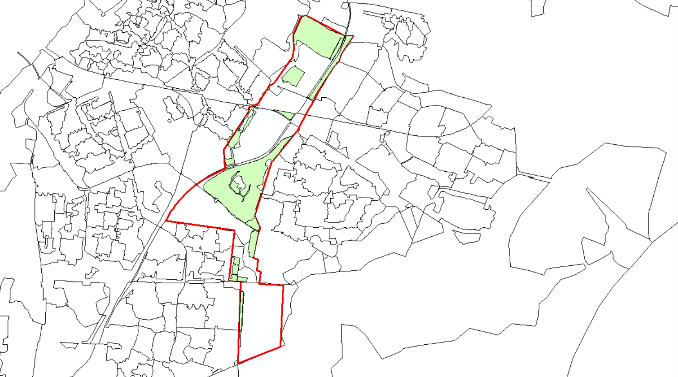
Water in scenario 1: now
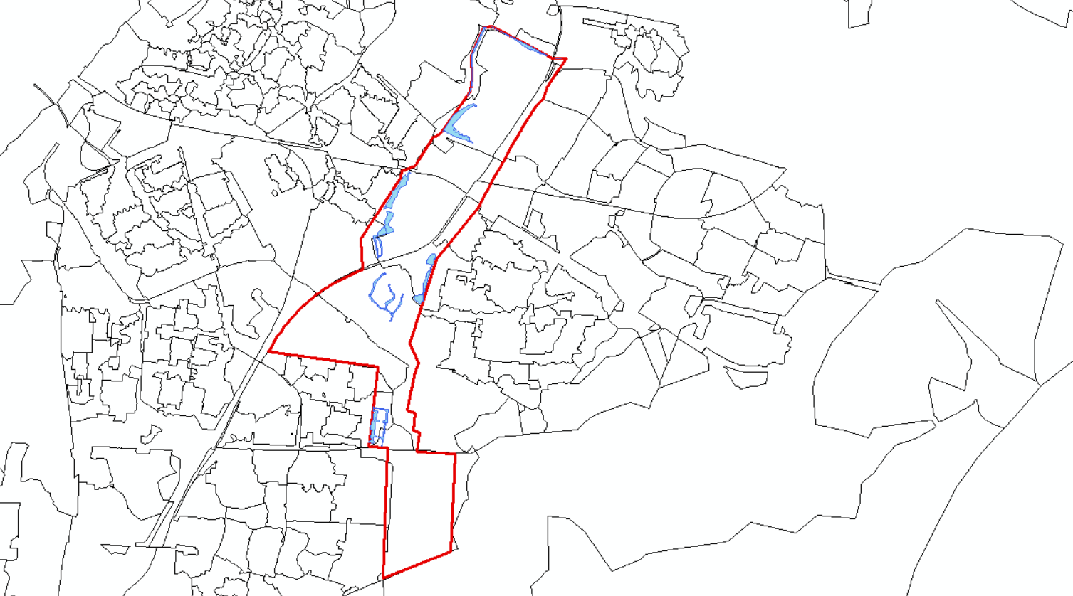

Parks in scenario 2/3: after redesign

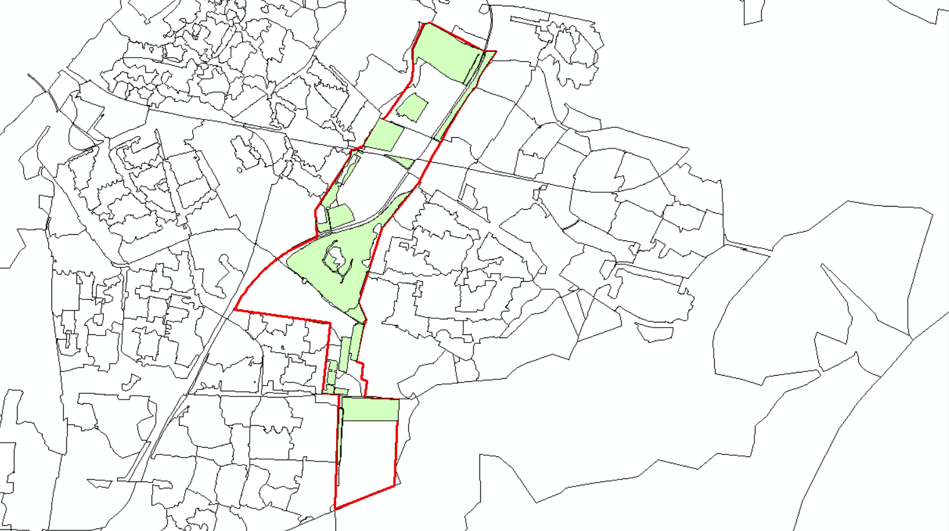
Water in scenario 2/3: after redesign
