Day 1: Workshop on policy brief
- Jannes Willems (EUR) and William Veerbeek (IHE-Delft) facilitated a workshop in which several BEGIN partners jointly worked on further developing the policy brief.
- The aim of the workshop was to identify the most important barriers to foster BGI through social innovation, corresponding solutions, evidence from various BEGIN partners and ongoing challenges.
- During the previous BEGIN partner meeting in Bergen in May 2019, several barriers were already identified. These formed the starting point from the discussion.
- BEGIN partners jointly identified 5 barriers: culture, closing the business case, community engagement, maintenance, and a lack of political awareness. BEGIN partners split up and identified potential solutions to these barriers, evidence from their cities and ongoing challenges for the first three barriers.
- In the upcoming period, EUR will further develop the policy brief. This will be done via working in writing teams and asking BEGIN partners for feedback. The first version will be presented around December 2019. The policy brief will be presented during the Blue Green Cities conference in Dordrecht in October 2020.
- After the workshop, BEGIN partners joined the lord mayor, several chief executives and other colleagues from Bradford for a reception at city hall. Afterwards, BEGIN partners had a lovely meal at an Indian restaurant.

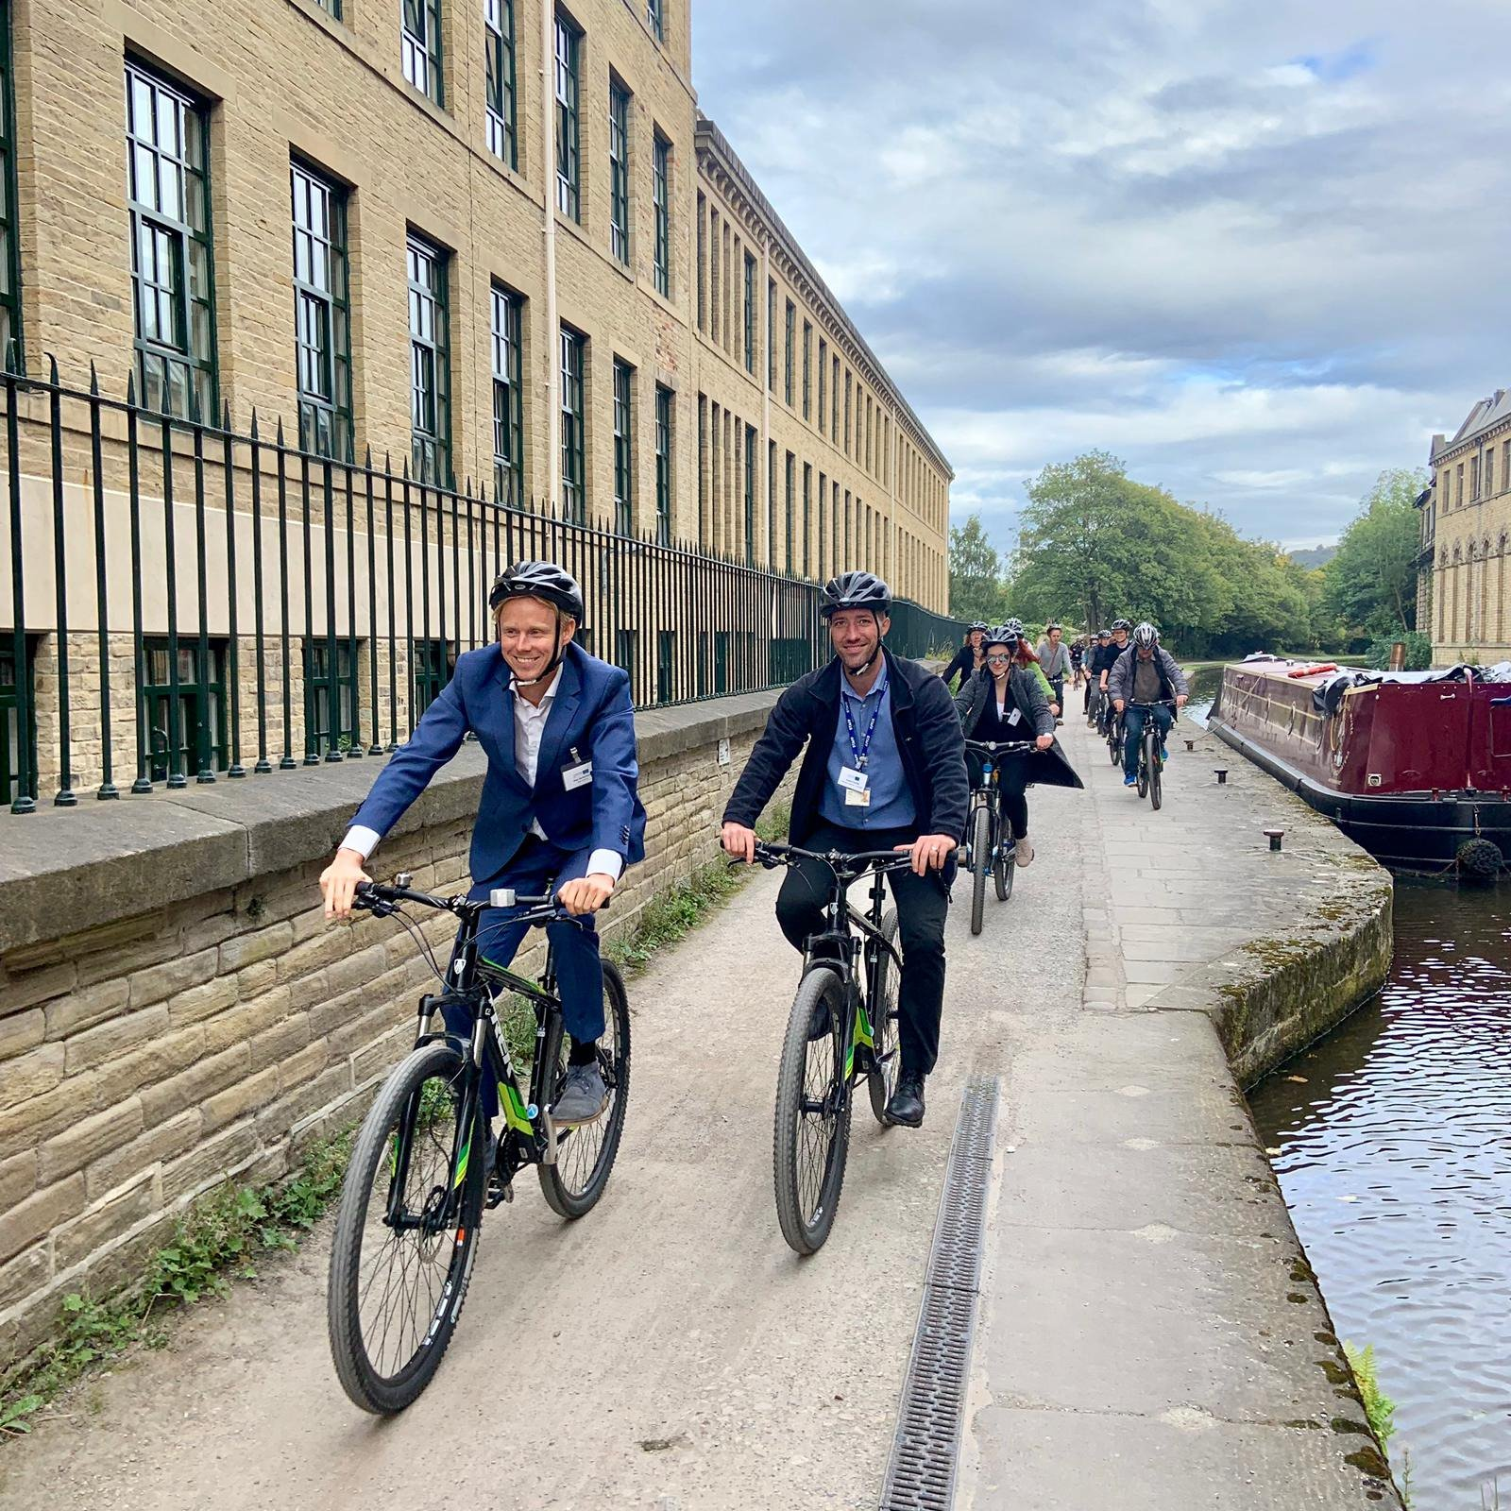
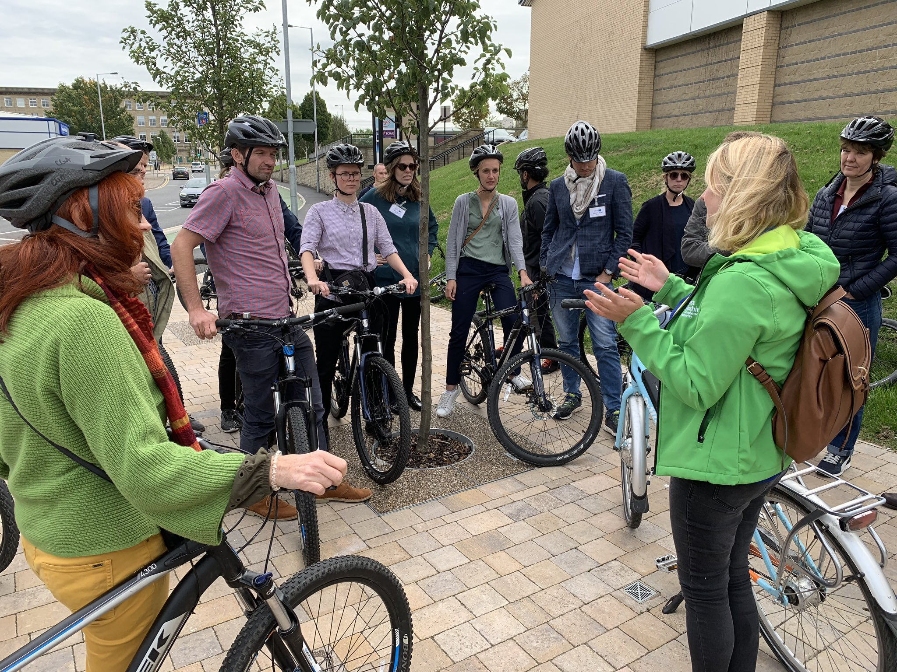

Day 2: Presentations on Bradford, site visit Canal Road and dinner
- BEGIN partners were welcomed by councilor Ross-Shaw who talked about the importance of BGI for the city of Bradford.
- The rest of the morning was filled with various presentations on Bradford, including its history, the importance of BGI, policy and the Canal Road. Bradford successfully managed to involve various departments and colleagues such as water management, highways, biodiversity, air quality and health. This enabled BEGIN partners to have a broad overview of all the different aspects of the case. Well done Bradford! The different presentations can be found in the Google Drive.
- Before lunch, EUR and IHE-Delft facilitated the second part of the policy brief workshop during which all BEGIN partners could reflect on the chosen barriers. Furthermore, BEGIN partners worked on the two remaining barriers.
- BEGIN partners had lunch and enjoyed a tour through Lister Park which includes various BGI elements.
- We discovered the Canal Road corridor by bike. On the way, colleagues from Bradford that were present during the morning explained about the project at several stops. In this way, BEGIN partners could experience what they heard in the morning in real-life. Again, well done Bradford!
- After the bike tour, BEGIN partners walked around Saltaire UNESCO World Heritage Site.
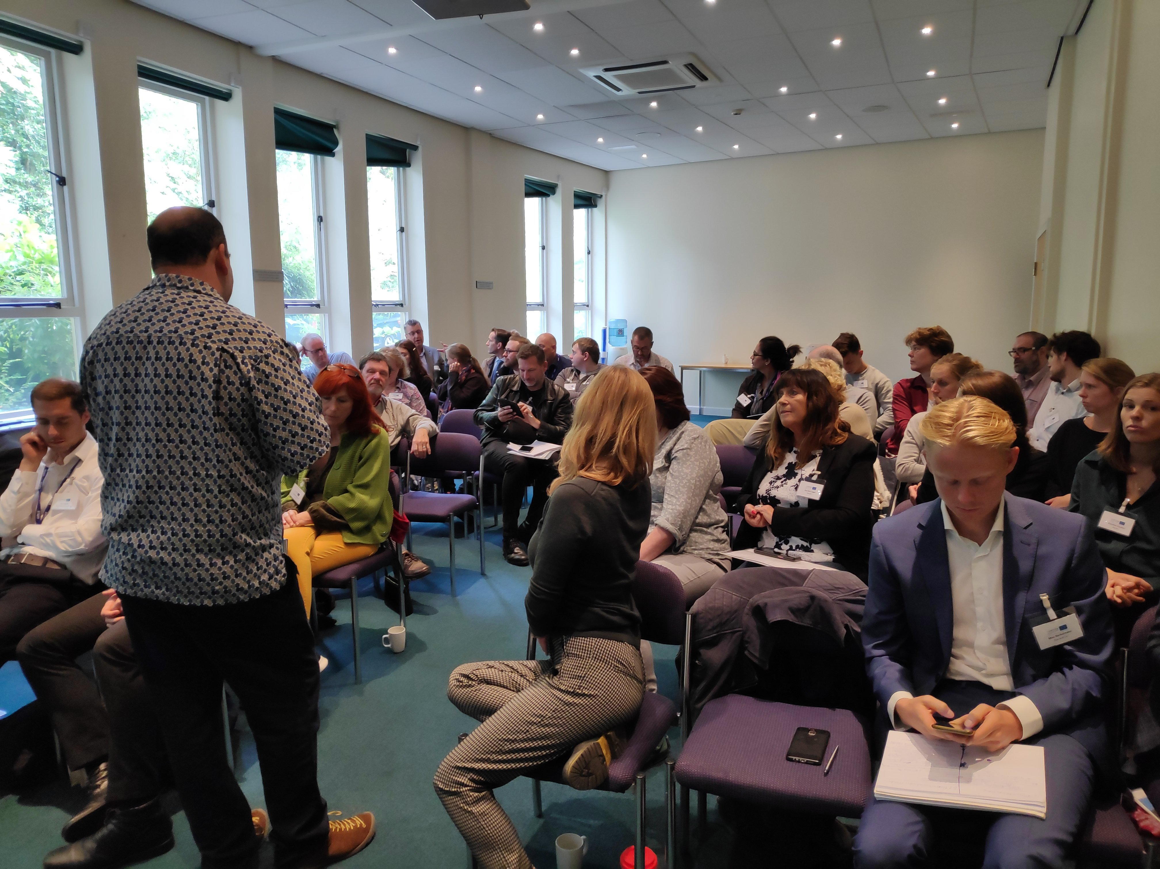
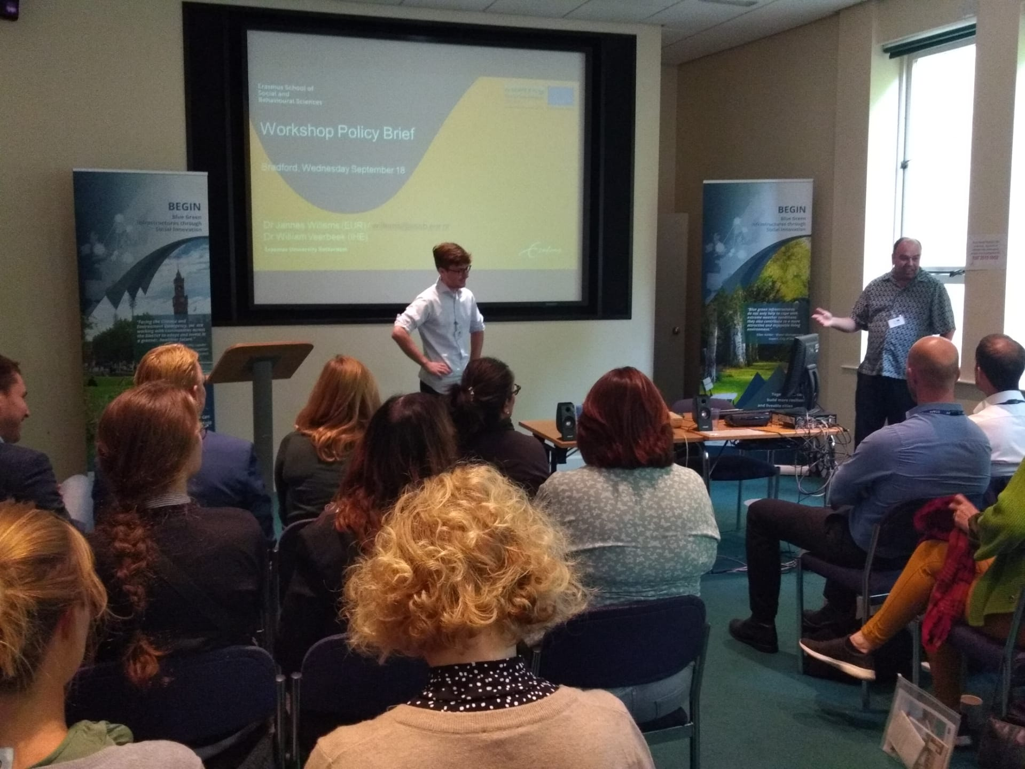
- BEGIN partners had dinner and a few drinks at the Great Victoria Hotel.

Day 3: Policy Instruments, partner presentations and project management
- Jannes Willems, Astrid Molenveld and Geert Brinkman (EUR) facilitated a three-hour workshop on policy instruments. After a short presentation on the various policy instruments, BEGIN partners identified which policy instruments they usually use, whether these are effective and whether they could make use of additional ones to foster BGI. BEGIN partners were very enthusiastic about the workshop as it enabled them to work on their own projects and discuss it with other cities. Many cities will take the lessons learnt and output back home to discuss with colleagues.
- After the workshop, BEGIN partners had lunch and enjoyed a lovely tour through city hall.
- Several BEGIN partners presented their work on BGI. The slides and a short summary of these presentations can be found in the Google Drive.
  - Ellen Kelder presented Dordrecht’s history, Blue Green Vision and its project: the Dordtwijkzone. Ellen explained how Dordrecht aims to engage with several sport parks in the zone to design and develop a common green and linear park.
  - Richard Ashley presented the research he did on the cases of Kent and Bradford. For each of the pilots, Richard presented the difference in benefits between the baseline scenario and situations with BGI. Richard presented valuable outcomes which link to various deliverables that all BEGIN partners should fulfill to such as stakeholder identification, monetization of multiple benefits and drafting a business case.
  - Irene Seijo presented Kent’s lessons learnt from its community engagement practices in various pilots (e.g. Bell Road, George Park etc.).
- BaxCo gave an update on project management, which included the following points
  - Besides from some minor issues related to the financial annexes of the reporting, reporting round 4 has been carried out well. BEGIN partners will receive their payments somewhere at the end of October 2019.
  - The next reporting round is coming up. The exact planning can be found in the slides. BaxCo will also send a reminder to all BEGIN partners soon.
  - The project extension requires all BEGIN partners to sign the new partnership agreement and send it to Dordrecht. Dordrecht needs both a hardcopy and an online version.
  - BaxCo ran through the deliverables and provided BEGIN partners with some suggestions on how to fulfill to these. In general, BEGIN partners strongly improved reporting on some deliverables that required additional work since the Bergen meeting. Please refer to the slides or reach out to Valenti or Max from BaxCo in case you have a question or need some advice regarding the deliverables.
  - In October 2020, Dordrecht will host a Blue Green Cities conference. Dordrecht foresees to engage with the Global Adaptation Summit. This event is hosted by the Global Centre on Adaptation and Global Commission on Adaptation (including Ban Ki-moon, Michelle Bachalet, Cristiana Figueres, Bill Gates and Patricia Espinosa). The event will take place in Rotterdam and attract around 2000 high-level politicians, policymakers, scientists etc. Our aim is to host a side-event or become a part of their programme, solely focusing on climate adaptation/the value of Blue and Green in the city. In the upcoming period, BaxCo will work together with Dordrecht to draft a programme and engage with other initiatives. During this event, we aim to present the lessons learnt and findings of BEGIN via the policy brief.

