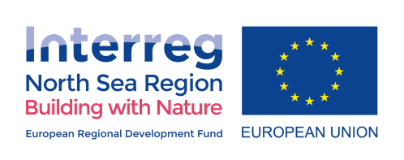
Version: 5.0
Datum: 5th August 2019
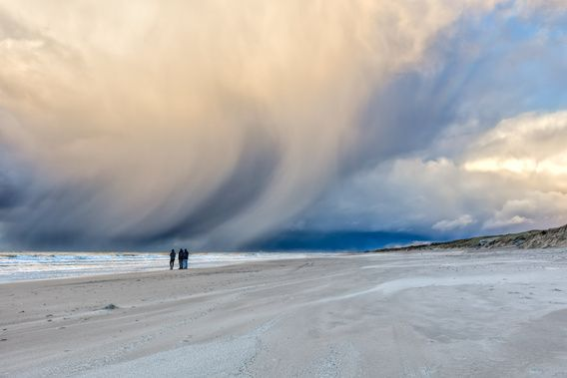

Building with Nature for flood resilience

A Policy brief from the EU Interreg North Sea Region project

Building with Nature

Introduction
This policy brief provides an overview of the needs and key policy requirements for wider dissemination and uptake of Building with Nature (BwN), or Nature-Based Solutions (NBS), to deal with flood risks in the European Union, while enhancing ecosystem services and other co-benefits.
Sense of urgency – It’s time to act now
Flooding is recognized as a major global challenge; the annual economic damage of climate change is expected to rise with 20 to 65 billion euros, depending on the temperature rise projections. Between 2002 and 2012, flooding contributed to 40% of climate-induced damage and 50% of the total affected population in Europe.

The wider, multi-disciplinary approach of BwN is key in addressing flood risk in a stable and sustainable way at both coastal and catchment scale. It creates multiple co-benefits that not only increase the quality of life of citizens; it also restores degraded ecosystems to secure long-term availability of natural resources and benefits from aquatic and marine ecosystems.

Since 2013, the EU has actively promoted NBS through different policies and actions, such as the EU Water Framework Directive, the EU Strategy on Adaptation to Climate Action, and the EU Floods Directive. The importance of ensuring the integrity of ecosystems is one of the core messages of the Paris Agreement (Article 7), and the Sendai Framework promotes transboundary cooperation on disaster risk reduction strategies along river catchments and coastlines.

However, widespread uptake of such measures has not followed the pace of policy promotion. Despite the huge potentials for BwN, they remain under-utilized both outside and inside Europe. BwN projects are still often framed as pilots, operating outside or at a distance from the current policy regime with extra capacity (in terms of finance, time and expertise) to give space for innovation and experiments. In some countries, the EU directives and regulations have contributed to momentum, such as in The Netherlands (for coasts and catchments) and Scotland (for catchments), but overall, more needs to be done.

The challenges
Although every country along the North Sea is different, there are challenges which can be recognized by every country. The partners in this project have identified four key barriers for the implementation of BwN in the North Sea Region:
- Knowledge gap; in which situations do nature-based solutions work; how do we optimize the benefits; how can we scientifically model BwN solutions?
- Barrier of understanding the local context and its stakeholders; do we fully understand the local situation?
- Barrier on bankable business cases; how to make a compelling business case?
- Governance gap; why is there a gap between global/European BwN ambitions and the translation of these ambitions into national and local policy and legal regulations?
These barriers and gaps are all interrelated and cross-linked. The overarching reason behind the existence of these barriers, is the need to compare NBS with traditional measures (e.g. a sea wall or dike strengthening). It is of crucial importance to know why, when and how a NBS can be a better option than, or go in a hybrid solution with, a conventional flood risk measure.
By working together on the concept of BwN, the partners, together with the Policy Learning Group of BwN, have formulated four recommendations to overcome these barriers and foster the implementation of NBS in Europe.
Policy recommendations

- Recommendation 1: Create a solid performance evidence base and a NBS assessment framework
- Recommendation 2: Get to know the local setting and the stakeholders involved
- Recommendation 3: Learn how to monetize multiple benefits and functions
- Recommendation 4: Support member states to implement BwN in national regulations.

Recommendation 1: Create a solid performance evidence base and a NBS assessment framework
The challenge: The dynamics of environmental benefits over long time scales, as well as the performance during extreme conditions, is often unclear;
The key to overcome this challenge is the development of performance indicators for BwN solutions, which comply with existing standards for traditional, grey solutions. The performance of BwN solutions change over time, and are more dependent upon the local physical and ecological conditions compared to grey traditional infrastructure. However, there is currently a lack of a practical and meaningful set of performance indicators to measure and understand this variable performance.
Monitoring of BwN performance and evaluation of the measures is crucial for building the evidence base to support wider uptake. More specifically, there is a need for assessing the performance of BwN solutions over the long-term, to prove the level of long-term maintenance, sustainability, resilience and adaptation to climate change of coasts or rivers and the transitions to green growth. The indicators and monitoring programs are needed for monitoring BwN effectiveness, also beyond the end of the project.
Illustrative example: innovative nourishment in the pilot project Sand Engine, The Netherlands
Coastal policy in the Netherlands is characterized by three scale levels. The smallest scale is aimed at the preservation of safety against flooding by maintaining a minimum dune strength; the middle- and large scales at preservation of sustainable safety and of functions in the coastal zone by maintaining the coast line, respectively the sand volume in the coastal foundation.
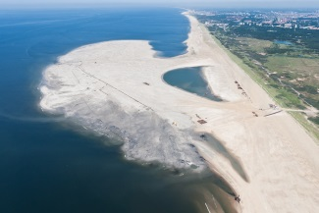
Along the Dutch coast, a innovative nourishment pilot has been developed: the Sand Engine. The pilot implies a mega-nourishment of approximately 20 Mm3 (~ 10.000 m3/m) on the coast near Ter Heijde. Considering the different indicators – i.e. residual dune strength, basal coast line and coastal foundation –, is it concluded that the large scale nourishments sets boundary conditions for the smaller scales. The Monitoring and Evaluation Programme (MEP) has been developed to monitor the Sand Engine over a long time scale using indicators. The lifetime of the Sand Engine will probably exceed twenty years, as after four years still 95 % of the sand is observed to be within the monitoring area. This emphasizes the large time-scales on which coastal NBS can be effective, and the consequent need for long-term monitoring programs. This kind of monitoring is essential to develop a solid performance evidence base in which we fully understand the system.
Recommendation 2: Get to know the local setting and the stakeholders involved
The challenge: local stakeholder involvement and alignment is more crucial for BwN solutions than for grey solutions.
The conclusions drawn from the EU Interreg BwN case studies stress the importance of continuous involvement of local communities and stakeholders in both the planning and design phase, as well as in the implementation and maintenance phase. As BwN projects are often larger in physical size and bridge between multiple disciplines, more stakeholders will typically be involved in all project phases. As the interests and power between stakeholders can be very different, it can be a challenge to align them all in a satisfied manner.
Local communities and stakeholders provide local knowledge, can be involved in community-based maintenance and play a vital role in the identification and valuing of multiple functions. Acknowledging these benefits in a cost-benefit analysis (CBA) calls for the involvement of the different stakeholders during all project phases. This has been proven to be crucial for the success of a BwN solution.
Illustrative example: The effectiveness of natural flood management measures in Scotland
The Scottish BwN catchment laboratory case study is the Eddleston Water
Project. This is a long-term research study on the cost effectiveness of natural flood management measures for flood risk reduction and habitat improvement in the Eddlenston Water. The project is a good example of stakeholder alignment and engagement, as collaboration has been sought with over 20 farmers and other key stakeholders. As a variety of local land management practices were implemented (e.g. high-flow log structures, storage ponds, woodland planting), understanding the local context is crucial.

Request to provide relevant, high-quality photo with local stakeholders on it (supplied by Eddleston/Chris Spray)
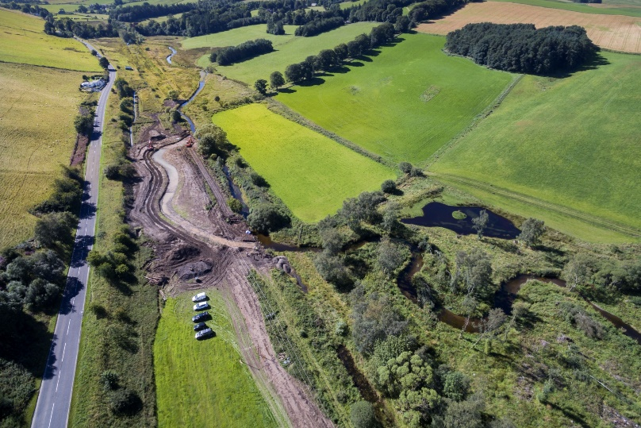
Recommendation 3: Learn how to monetize multiple benefits and functions
The challenge: BwN solutions provide multiple benefits which are often not taken into account in traditional cost-benefit analysis;
Effective uptake of BwN calls for business case tools which can appreciate the full range of co-benefits (such as ecosystem services and flexibility), while taking into account the negative environmental damage frequently observed for grey infrastructures. Therefore, national and local governments, financiers, engineers and other stakeholders should adopt an integrated and more multi-disciplinary appreciation of infrastructure. This requires a tailor-made approach with a detailed understanding of the local conditions.
The multiple functions and benefits could then be implemented in a quantitative appraisal framework that can assess the value of co-benefits, such as flexibility and ecosystem services across the whole flood protection system over the long-term. Traditional financing mechanisms should be optimized to make use of these wide benefits, as funding can often be found at the beneficiaries. Besides funds suitable for financing NBS (e.g. Green Climate Fund, European Fund for Strategic Investments, the Global Environment Facility), financing can be sought at beneficiaries for long-term maintenance. Funding should also take into account the variety in costs which are related to maintenance of BwN measures. NBS result in multiple co-benefits for health, the economy, society and the environment, and thus they can represent more efficient and cost-effective solutions than more traditional approaches.

Illustrative example: The multilayer water safety stimulated by the Government of Flanders

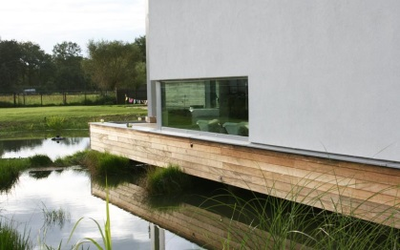
Constructing the necessary water buffers along rivers and watercourses and the necessity to avoid flood damage was a challenge for the Government of Flanders. The driver of creating resilience of sectors of society and citizens play a role to play in defending themselves against damage. The construction of flood plains, do not allow water excess to be kept adequately under control as a result of the increasing flooding risks due to climate change. So, the provision of a basic protection infrastructure by the authorities, legislation was enacted for new building projects that calls a halt to inappropriate or inadmissible construction in flood-prone areas. As multiple benefit the federal fire insurance legislation was expanded and is now striving for more individual protection of residential homes and buildings.
Insert relevant high-quality photo (supplied by VMM)
Source current photo: https://www.innovatief.be/nl/nieuws/bouwen/concepten/bouwen-in-overstromingsgevoelig-gebied/782

Recommendation 4: Support member states to implement BwN in national regulations.
The challenge: The geographic and social-economic condition in every country is different, asking for local tailor-made BwN solutions.

BwN measures should be executed by a wide, multi-disciplinary range of decision and policy makers at several institutional levels (i.e. locally, regionally and nationally) to secure a sustainable management of water resources. Generally, there is insufficient local governing of the water management, agriculture and forestry sectors from a river catchment management and climate adaptation perspective.

From this perspective, flood management and climate action plans need to be sufficiently implemented in local or national legislation by the municipalities as part of their spatial planning. In addition, the municipalities also need to integrate storm water management in the flood management and climate adaption.

Illustrative example: coordination for management of catchments in Sweden

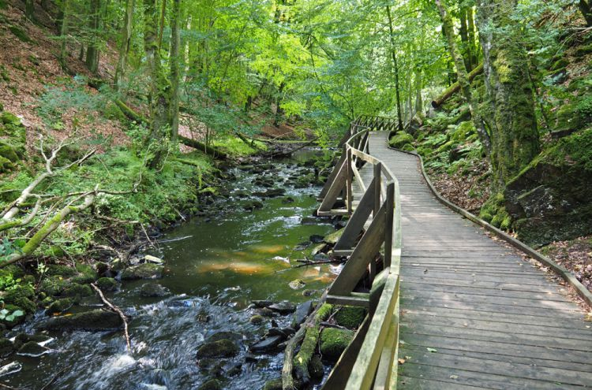
In the Nature project by Länsstyrelsen Skåne, Sweden, NBS projects are implemented in local spatial planning. In Skåne suitable areas for retaining water should be identified and designated from a catchment area perspective. In addition, the municipalities want to integrate storm water management in the flood management and climate adaption. The legislation regarding drainage companies is not in conjunction with the demands of climate adaption or the Water Framework Directive, so modification of the permits is needed to meet environmental conditions. Moreover changes of the traditional agricultural policy should be encouraged as paradigm shift to sustainable land use and measures that slow down climate adaption efforts in the future.

Request for relevant photo, supplied by Skane (high quality)

Next steps
The recommendations made in this policy brief and the products delivered by the BwN project, will help organizations to compare BwN measures with traditional ones. BwN can be one of the solutions to adapt to climate change, however, a well-documented solid evidence base is needed, as well as effective stakeholder engagement and the creation of compelling business cases for financiers. Furthermore, the global and European ambitions should be followed up by translation into national policy and legislation which will flow over in regional and local arrangements.

This will support the uptake of BwN solutions in decision-making processes on flood risk reduction and help mainstream BwN across the North Sea Region and beyond. Discussions of Interreg BwN will focus on the potential of existing EU instruments, and that of the Member States to further consolidate the knowledge and evidence-base for nature-based solutions.

Partners (new version is needed)

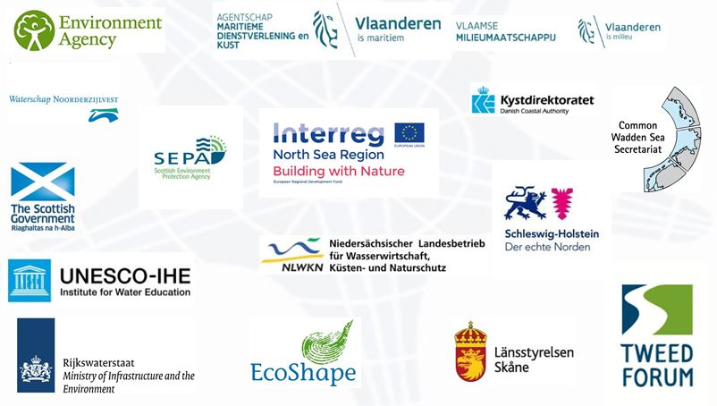

Contact
Further reading
Links to (1) factsheets, (2) national policy briefs, (3) research agenda
And Interreg website

