**[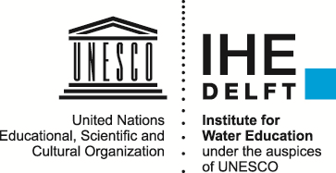](http://www.google.nl/url?sa=i&rct=j&q=&esrc=s&source=images&cd=&cad=rja&uact=8&ved=0CAcQjRw&url=http://adb-knowledge-partnership.unesco-ihe.org/&ei=aPZJVfbNNq3Y7Aawx4HYDQ&bvm=bv.92291466,d.ZGU&psig=AFQjCNGI4ubUEzC9Lq-JL2aNhoPzH13sPA&ust=1430996941959687)**

Building with Nature

Final Report

‘Upscaling’: Practice, Policy and Capacity Building. Insights from the Partners’ experience.

Authors:

Grazia Di Giovanni

Chris Zevenbergen

With contributions from:

Yen-Yu (Annie) Chiu

Raina Nidhi

Date: 3rd August 2017, updated on 19th September 2017 and 20 August 2019. Submitted on 20 August 2019.

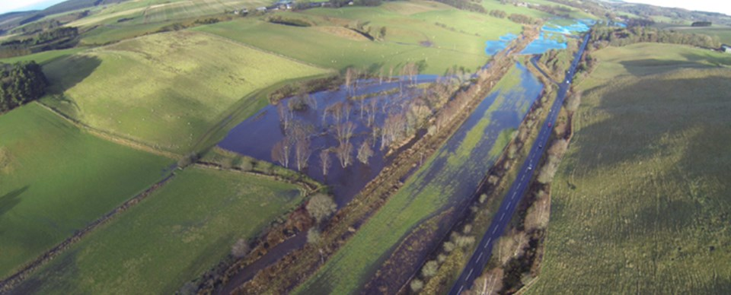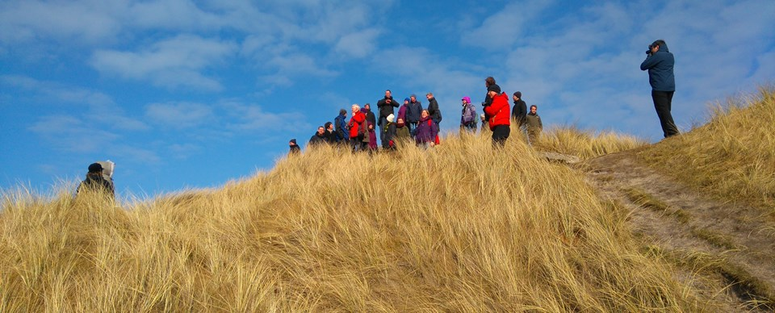 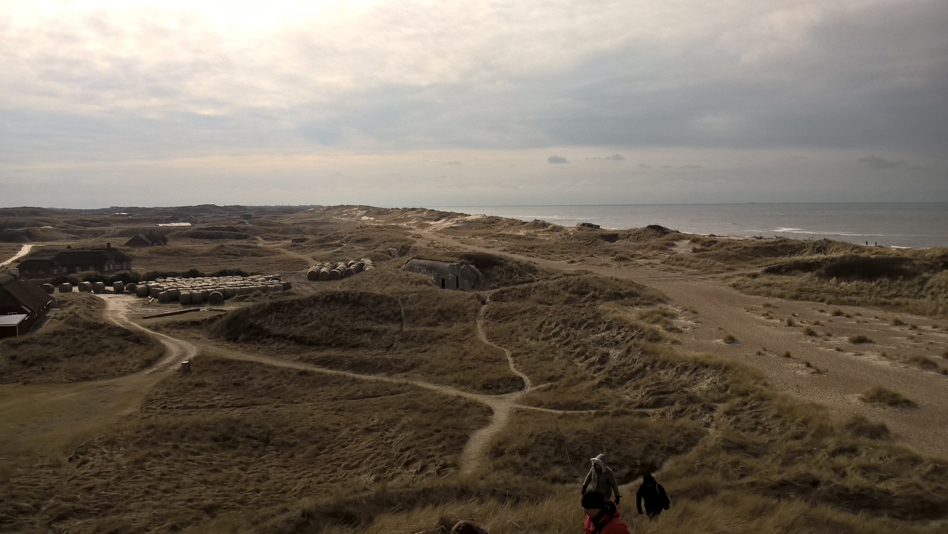

# Abstract



Different nature-related risks affect European territories: North Sea Region is particularly affected by flood risk, along its coasts and its catchments. Building with Nature (BwN) project – part of Interreg Vb Programme 2014-2020 for a “Sustainable North Sea Region” – joins up ongoing innovative experiences in the use of nature-based solutions, which exploit natural dynamics and materials to deliver flood risk and coastal erosion management whilst improving ecosystem services. BwN seeks for flood prevention through taking advantage of nature’s forces instead of constraining them, making coasts and catchments more resilient to climate change. This Interreg Programme conveys 15 parties (from Belgium, Denmark, Germany, Norway, Scotland, Sweden and The Netherlands) for four years, testing BwN concepts in 13 pilots (coastal and catchment scale sites) intended as “Living Laboratories”.

The aim of BwN is to generate evidence-base and enlarge multidisciplinary knowledge *about* nature-based solutions: on the one hand, for supporting knowledge transfer across partners and future users, to stimulate the application of BwN approach in Europe; on the other hand, to optimise and ameliorate the effectiveness of these solutions and consequently to justify investments on them.

To fulfil these goals, the program is composed of six Work Packages; this report is part of WP6 “Upscaling: Practice, Policy and Capacity Building” led by UNESCO-IHE. WP6 is oriented to support policy makers, institutions and practitioners through evidences that will help to design nature-based solutions and evaluate their benefits and effectiveness. Lessons learned in BwN Project will sustain training & capacity building programmes, analyses on governance barriers, seminars and workshops. In line with WP6 activities, UNESCO-IHE started a first campaign of interviews (grounded on literature on NBS, ecosystem services, and climate and disaster resilience): at the moment of writing, six semi-structured in-depth interviews have been conducted to collect solid evidence base about NBS performances by listening to BWN partners’ point of view and experience. The interviews focus on: pilots’ main features and goals; decisional processes supporting nature-based approaches; challenges and barriers in designing, implementing and monitoring NBS; lessons learned, upscaling opportunities, knowledge gaps; “resilient qualities” of NBS.

Main findings coming from the interviews and from BwN Coordination Meetings add important information about:

* + - the relevant “past” preparing the ground for the adoption of NBS
    - the crucial importance of a deep knowledge of local contexts, suggesting to upscale BwN “approach” firstly, and then the specific technologies
    - how NBS affect the governance of flood risk, shifting from “traditional engineering” towards a “resilience thinking” for flood risk reduction mixing hard and soft measures
    - the peculiar design and implementation of BwN solutions
    - the challenge of evaluating unconventional methods of intervention and multiple benefits, and the necessity to frame a specific way to monitor and evaluate NBS performances
    - the emerging topic of better investigate the relation between BwN pilots and local communities and local landscapes and ecosystems, recognising as essential the continuous involvement of stakeholders
    - the resilience of NBS, above all in terms of robustness, flexibility, resourcefulness and capability of responding to sudden events.

Appendix 1 and 2 contain the interview scheme and the background research on resilience and NBS.

Table of Contents

Abstract 2

1. Introduction to Building with Nature 4

2. Partners & Pilots 5

Natural Catchment Pilots (estuaries, rivers and lakes) 6

Coastal Pilots 7

3. BwN Work Package 6 8

4. The BwN Concept 8

5. The interviews 9

Results 10

6. Preliminary insights: enabling factors and challenges in BwN Projects 14

6.1 Stories & History behind NBS 14

6.2 Governance of flood risk 14

6.3 Lessons from the design of NBS 14

6.4 Monitoring & Evaluating BwN 15

6.5 The resilience of NBSs 16

6.6 Local communities’ involvement 16

6.7 Landscape & Environmental Impacts of NBS 17

7. Conclusions 17

8. Final remarks 19

Exchange among WPs 19

Seminar/Workshop proposal 19

Abbreviations 20

Appendix 21

1. The Interviews: Full Text 21

2. The “Resilient Attributes” 24

Preliminary Bibliography 28

# 1. Introduction to Building with Nature [1]

Flooding is the most important risk for loss of life and economic damage in the North Sea Region (NSR). In the light of climate change and increasing risks, the Building with Nature project (BwN) – part of Interreg Vb North Sea Region Programme 2014-2020, priority 3 “Sustainable NSR” – brings together partner and experiences about nature-based solutions (NBS) that utilize natural processes to deliver flood risk and coastal erosion management whilst enhancing ecosystem services. NBS represent an innovation in designing flood defences compared to traditional hard infrastructures: BwN seeks for boosting prevention from flooding taking advantage of nature’s forces instead of constraining them.

The aim of BwN is to enlarge knowledge about NBS, firstly providing transnational evidences about the effective performance of NBS in making coasts and catchments more resilient to climate change. This is pivotal both to optimise the effectiveness of the BwN solutions (e.g. through monitoring and analyses to develop improved designs and business cases), both to justify future investments (e.g. to incorporate BwN in national policies and investment programmes) and eventually to stimulate their application in Europe.

This Interreg Programme conveys fifteen parties from NSR (governments, knowledge institutions, foundations) for four years. BwN-based climate change adaptation solutions are tested in thirteen coastal and catchment scale sites. (See §**2** for further details).

Six Work Packages constitute BwN project structure:

* + - WP 1 - Project Management, led by Rijkswaterstaat
    - WP 2 - Communication Activities, led by Rijkswaterstaat
    - WP 3 - Resilient Coastal Laboratories, led by Rijkswaterstaat
    - WP 4 - Natural Catchment Laboratories, led by the Scottish Group
    - WP 5 - Business Case Development, led by EcoShape
    - WP 6 - Upscaling: Practice, Policy and Capacity Building, led by UNESCO-IHE

# 2. Partners & Pilots

Fifteen partners compose BwN Projects[2]:

* **Belgium**
* [Vlaamse Milieumaatschappij](http://www.northsearegion.eu/building-with-nature/partners/vlaamse-milieumaatschappij-vmm/) (Flanders Environment Agency - VMM)
* [Agentschap voor Maritieme Dienstverlening en Kust](http://www.northsearegion.eu/building-with-nature/partners/agentschap-voor-maritieme-dienstverlening-en-kust/) (Agency for maritime and coastal services - Coastal Division in Flanders - MDK-CD)
* **Denmark**
* [Kystdirektoratet](http://www.northsearegion.eu/building-with-nature/partners/kystdirektoratet/) (Danish Coastal Authority - DCA)
* **Germany**
  + [Niedersächsischer Landesbetrieb für Wasserwirtschaft, Küsten- und Naturschutz](http://www.northsearegion.eu/building-with-nature/partners/niedersaechsischer-landesbetrieb-fuer-wasserwirtschaft-kuesten-und-naturschutz/) (Water Management, coastal Defence and Nature Conservation Agency in Lower Saxony - NLWKN)
  + [Common Wadden Sea Secretariat](http://www.northsearegion.eu/building-with-nature/partners/common-wadden-sea-secretariat-cwss/) (CWSS)
  + [Landesbetrieb für Küstenschutz, Nationalpark und Meeresschutz des Landes Schleswig-Holstein](http://www.northsearegion.eu/building-with-nature/partners/landesbetrieb-fuer-kuestenschutz-nationalpark-und-meeresschutz-des-landes-schleswig-holstein/) (Agency for Coastal Defence, National Park and Marine Conservation in Schleswig-Holstein - ACNM-SH)
* **Norway**
  + [Norges vassdrags - go energidirektorat](http://www.northsearegion.eu/building-with-nature/partners/norges-vassdrags-go-energidirektorat/) (Norwegian Water Resources and Energy Directorate - NVE)
* **Scotland (United Kingdom)**
  + [Scottish Catchment Group](http://www.northsearegion.eu/building-with-nature/partners/scottish-catchment-group/) (SCO: Scottish Government - SG, Tweed Forum - TF, and the Scottish Environment Protection Agency - SEPA)
* **Sweden**
  + [Lansstyrelsen Skane](http://www.northsearegion.eu/building-with-nature/partners/lansstyrelsen-skane-the-county-administrative-board-of-skane/) (County Administrative Board of Skane - LS)
* **The Netherlands**
  + **(Lead Project Manager)** [Rijkswaterstaat](http://www.northsearegion.eu/building-with-nature/partners/rijkswaterstaat/) (Dutch Ministry of Infrastructure and the Environment - RWS)
  + [EcoShape](http://www.northsearegion.eu/building-with-nature/partners/ecoshape) (Foundation - ECOS)
  + [Waterschap Noorderzijlvest](http://www.northsearegion.eu/building-with-nature/partners/waterschap-noorderzijlvest/) (Waterboard Noorderzijlvest - NZV)
  + [UNESCO-IHE](http://www.northsearegion.eu/building-with-nature/partners/unesco-ihe/) (UNESCO Institute for Water Education - UIHE)

In BwN project, NBS for climate change adaptation are analysed and tested through Pilot Cases, defined as “Living Laboratories” [3]: they allow a direct multidisciplinary and transnational investigation of BwN concepts and solutions, for generating the evidence-base that is necessary to foster the adoption of BwN solutions policies and investment programs. Pilots are thirteen: **seven** **coastal target sites** in The Netherlands (NL), Germany (DE), Denmark (DK), Sweden (SE) – for sand nourishment at North Sea Coasts and Wadden Sea barrier islands – and at **six** **catchment scale sites** *(estuaries, rivers and lakes)* in Belgium (BE), Scotland (SCT), NL, SE – for river restoration. Norway (NW) is an observer partner of BwN. Names and locations of Pilots are shown in Figure 1.

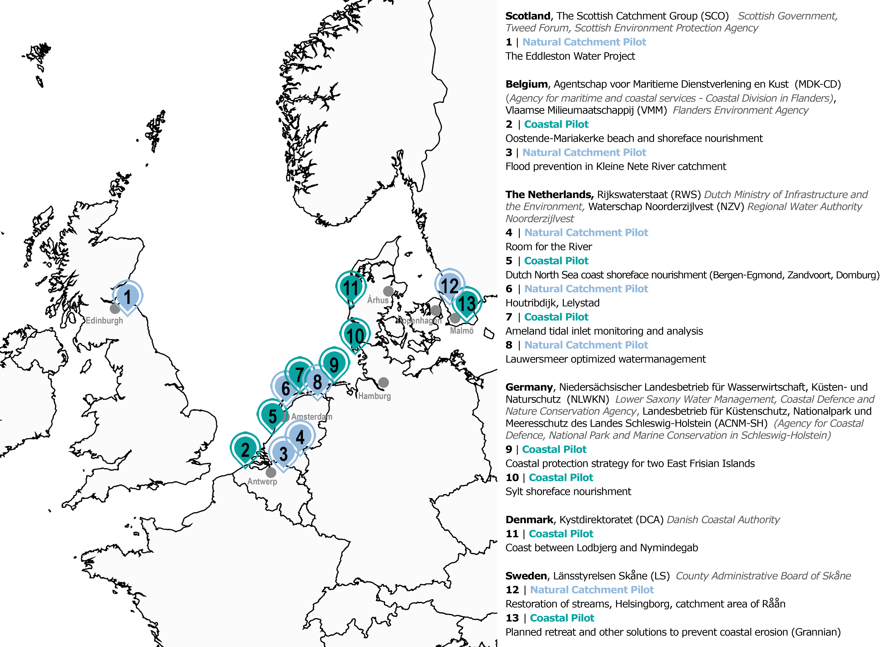

Figure 1. Interreg BwN Pilot projects. (Elaboration by Grazia Di Giovanni).

## Natural Catchment Pilots (estuaries, rivers and lakes)

1. The Eddleston Water Project (SCT)

*The Eddleston Water Project aims to reduce flood risk and restore the Eddleston water for the benefit of the local community and wildlife. Practical works (such as remeandering) are taking place throughout the Eddleston catchment as part of an overall plan to restore the river and valley. How changes in land management might reduce flood risk for will be explored as well.*

3. Flood prevention in Kleine Nete catchment (BE)

*The Klein Nete river recovery project aims to recreate ecological flooding zones and recreational areas: a more natural watercourse, to recovering water storage capacity, natural habitats and migration opportunities along the water system.*

4. Room for the River (NL)

*Dutch Room for the River Programme involves more than 30 locations: its goal is to redesign water courses and their surroundings giving more space to riverbeds and therefore to better manage higher water levels and flood safely.*

6. Houtribdijk

*Analysis of the morphological behaviour of the cross-shore profile of a sandy foreshore along the Houtribdijk.*

8. Lauwersmeer optimized watermanagement, North Netherlands (NL)

12. Restoration of streams, Helsingborg, catchment area of Råån (SE)

*The catchment has been target of multiple interventions to innovate flood management and reinforce ecological systems: reconstruction of wetlands (of different sizes) and ponds, together with the redesign and restoration of streams (and of their flora), contribute to increase the retention time of water in the landscape, diminish the transport of nutrient and improve biodiversity.*

## Coastal Pilots

2. Oostende - Mariakerke research program for beach and shoreface nourishments (BE)

*MDK-CD is performing a research program including the monitoring of a beach and shoreface nourishment pilot to understand the behaviour and effectiveness of both nourishments for coastal protection.*

5. Dutch North Sea coast shoreface nourishment (NL)

*Bergen-Egmond, Zandvoort and Domburg sites are included by RWS as coastal laboratories to understand the behaviour   
of shoreface and beach nourishments with respect to the sandy coastal management strategy and coastal characteristics.*

7. Ameland tidal inlet monitoring and analysis (NL)

*RWS wants to establish a research program concerning sediment management for tidal inlets of the Waddensea, and compare Ameland tidal inlet to other inlets of the Waddensea to come up with an overall sediment balance.*

9. Coastal protection strategy for two East Frisian Islands (DE)

*On the islands of Langeoog and Norderney, NLWKN wants to develop a better understanding of the natural processes in the shoreface and beach areas to optimize the coastal protection strategy using BwN principles.*

10. Sylt shoreface nourishment (DE)

*On the island of Sylt, ACNM-SH is maintaining the coast by regularly applying beach and shoreface nourishments, looking for a long-term balance in the nourishments with respect to the expected sediment deficits in the Waddensea.*

11. Danish North Sea coast (DK)

*Along the coast between Lodbjerg and Nymindegab, the DCA is seeking to optimize the sandy coastal strategy concerning beach and shoreface nourishments.*

13. Planned retreat and other solutions to prevent coastal erosion along the Swedish coast (SE)

*In Ystad a pilot beach nourishment is currently being monitored and under research. Besides this sandy solution, along the Swedish coast several pilot projects will be executed which investigate the use of ecosystem (grasses) in order to prevent coastal erosion.*

# 3. BwN Work Package 6

The aim of BwN project is to develop knowledge and stimulate a wider application of Building with Nature concept through the experience of ongoing pilot projects. The Work Package 6 “Upscaling: Practice, Policy and Capacity Building” (led by UNESCO-IHE) is oriented to support practitioners and policy makers through an evidence base that will help to define, design, calculate benefits and effectiveness of BwN measures. Studies on existing research on NBS solutions will be enriched with outputs from WP3 and WP4 (coastal and catchment laboratories). Lessons and guidance gained in BwN project will substantiate a training & capacity building programme, analyses on governance barriers, a policy-learning group and workshops. The activities of WP6 are closely aligned with WP5 (§**1**)[4].

In detail the activities in WP6:

* T1: Policy Learning Group
* T2: Evidence base: Collect lessons from BwN pilots projects prior to BwN
* T3+T4: Governance barriers, Policy debate and monitoring
* T5: Define Policy & Research Gaps
* T6: Continue policy learning and agenda setting
* T7: Capacity building programme
* T8: Research programme and future laboratories
* T9: Collaboration with FAIR and TopSoil projects

# 4. The BwN Concept

Briefly, “Building with Nature” is an emerging concept in the realm of integrated coastal and fluvial management and policy: BwN principles foster the use of natural dynamics and materials in providing effective flood management. More generally, NBS contribute to reduce flood risk offering integrated multiple benefits to both humans and ecological systems. The growing interest for BwN-related concepts and solutions suggest that attention towards more sustainable flood management will have influence over future debates and technologies in the field.

For an exhaustive review of BwN concept and the scientific literature about, please refer to Yen-Yu (Annie) Chiu’s “Building with Nature: Definition. Draft report” (August 2017), source of this paragraph as well.

# 5. The interviews

In line with T2 - T5 activities of WP6, and to support T1 preparation (§**3**), UIHE prepared a campaign of interviews for BwN partners. Literature on NBS, ecosystem services, and climate and disaster resilience has guided the definitions of a scheme of questions to discuss with BwN partners, moving from the shift towards a “resilience thinking” in many domains, and especially in engineering research and practices for flood risk reduction in North West Europe. (See **Appendix 1** for the full list of questions and **Appendix 2** for further readings on resilience and NBS).

Six semi-structured in-depth interviews[5] have been conducted between February and May 2017 with the purpose of gathering preliminary specific information about the role and performances of nature-based approaches from the partners’ point of view and experience.

This first survey campaign was conducted mainly via skype, based on open questions articulated in six parts:

* *Section 1* Experience of the partners in applying nature-based solutions and main features of pilot projects (goals, risk addressed, technological characteristics)
* *Section 2* The decisional processes fostering the adoption of nature-based approaches (history, rationale, aims, stakeholders)
* *Section 3* Challenges and barriers in designing and implementing NBS, and the performances of the pilot projects
* *Section 4* Monitoring NBS: evaluations of the experiences, benefits and externalities, innovation introduced
* *Section 5* Lessons learned, upscaling opportunities and limits, knowledge gaps
* *Section 6* Resilience and NBS: which “resilient qualities” characterise NBS? Do NBS seek for resilience?

Each interview has followed its own flow, summarizing the different aspects, giving diverse depth to the sections according to the peculiar characteristic of each context.

|  |  |  |
| --- | --- | --- |
| **Partner** | **Interviewee & Lab Typology** | **Date** |
| *The Netherlands*  EcoShape | Erik van Eekelen,  Programme manager | February 2017,  via Skype |
| *Belgium*  Vlaamse overheid-Agentschap maritieme dienstverlening en kust, Afdeling kust  Flemish government-Maritime and Coastal Agency, Section Coast | Daphné Thoon,  Project Engineer  Living Lab: *coastal* | February 2017,  via Skype |
| *Denmark*  Kystdirektoratet  Danish Coastal Authority | Anni Lassen,  Employee at Dept. Territorial Waters  Oliver Ries,  Coastal Engineer  Living Lab: *coastal* | March 2017,  Lemvig [6] |
| *The Netherlands*  Rijkswaterstaat  Ministry of Infrastruct. and the Environment | Quirijn Lodder and Rinse Wilmink,  Advisers coastal flood risk managem.  Living Lab: *coastal* | March 2017,  via Skype |
| *Scotland*  Tweed Forum | Luke Comins,  Director  Living Lab: *catchment* | April 2017,  via Skype |
| *Germany*  Landesbetrieb für Küstenschutz, Nationalpark und Meeresschutz des Landes Schleswig-Holstein  Agency for Coastal Defence, National Park and Marine Conservation in Schleswig-Holstein | Jennifer Ullrich,  Division Conceptual planning, analysis, information systems  Living Lab: *coastal* | March-May 2017,  written form |
| **Transmission of Explanatory Materials  *(no interview)***  *Sweden*  Lansstyrelsen Skane  County Administrative Board of Skane | Pär Persson  Planning Department | May 2017 |

## Results

An outline of the principal information arising from the survey follows:

Section **1** | **Experience of the partners in applying nature-based solutions and main features of pilot projects**

BwN projects are all related to long-term flood risk reduction ad management through different kind of intervention, mixing mitigation and adaptation measures. The interviews were mainly about coastal pilots (5 up to 6). Coastal protection is achieved, using complex nourishments (mixing beach and shoreface ones) and stabilizing dunes for reducing reduce coastal erosion and consequently to protect urbanized hinterlands. Fluvial projects aim at enlarging the space for water, re-meandering and enlarging the river beds. Together with these primary goals, the projects aim at ameliorate the ecological quality of local systems. The scale of intervention varies, but the pilots are generally parts of large or regional scale programs of intervention - even when implemented as localized actions. The chronology of the pilots varies a lot, but can be simplified as follows: their roots are mainly in in the ‘70s - ‘80s but the implementation in current forms date back to mid-2000s mainly. In all the interviews, previous traditions and experiences already ongoing in flood management fields, together with the emerging limitations of traditional techniques, seem to have guided towards more flexible, adaptable and environmental sensitive kind of actions. Similarly, ongoing long-term preservation policies, overriding plans and dedicated research have pushed the experimentation of NBS, together with some normative limitations to traditional engineering (such as in areas of nature conservation).

Section **2** | **The decisional processes fostering the adoption of nature-based approaches**

As partially introduced in Section 1, the preference for more sustainable, flexible and adaptable solutions seem resulting from a combination of aspects, mainly the pivotal role of ongoing research and experiences in each country to face floods since ‘70s-‘80s, together with the emerging limitations of traditional engineering techniques in facing dynamic changing conditions (exacerbated by a changing climate). The latter point has been related also to long-term cost-effectiveness by some interviewees: NBS are more dynamic and ductile than hard engineering infrastructures. In some case, normative limitations due to ecological preservation policies, have pushed towards the experimentation of NBS.

In all the cases, previous floods and storms have opens up the ground for dedicated strategies and wider considerations about the topic, leading also to the debate on BwN concept. The pilots were mainly top-down projects led by regional or national institutions, but open to multiple stakeholders, differently in each country: in some cases a deep involvement of landowners was indispensable to the feasibility of the project (SCT, DK); in other contexts forms of public *information* more than public *participation* were performed. Also the reactions of local communities is very context dependent, but more or less in all cases institutions needed to “persuade” local communities about the effectiveness of these new methods of intervention. Favourable partnerships between policy levels and academic research have been reported as well.

Asking which have been the “facilitator”, “enabling factors” of the decisional process, and the main barriers and challenges in opening up the process, some common elements are traceable. As facilitators: political/institutional engagement interest in the topic, and shared awareness on the potential role of NBS; wider strategies securing funding and opportunity for experimentation; accumulated knowledge on related kind of interventions (e.g.: beach nourishments and shoreface nourishments). Main challenges seem to be: consensus and funds for non-ordinary interventions (if not part of a wider strategies as stated earlier); landowners’ power in spatial transformations; landscape negative impacts of NBS themselves.

Section **3** | **Challenges and barriers in designing and implementing NBS, and the performances of the pilot projects**

Enabling factors and challenges in implementation phases do not differ deeply from the design phase (Section 2); moreover, it is not easy (or could even be inappropriate) to label rigidly the different phases (design and operational ones) for many kinds of NBS conceived mimicking natural dynamics. However, some emerging specific challenges of the implementation phase seem to be securing funding in the long run, both to maintain and to expand or replicate the pilots. To achieve this last goal, also bureaucracy and regulatory constraints can represent a strong obstacle. Some unexpected disservices are clearer after the implementation and will need further studies according to partners, such as some environmental negative impacts on local natural resources, or aeolian transportation of sands.

Asking what additional values can be provided by BwN systems both in day-to-day conditions, both when the “design limits” are exceeded (because of shocks or stresses), interviewees generally agree in recognising new local benefits in ordinary regime, above all about additional recreational uses of the spaces transformed by BwN pilots. They generally seem to well respond to stresses (even if not all pilot sites have experienced acute shocks yet). It doesn’t appear easy to assess differently the cumulative effect of positive day-to-day benefits in fulfilling the needs in extreme events regimes: this seems particularly clear remembering that BwN are generally soft measures reinforcing hard infrastructures or are parts of complex larger scale interventions.

Section **4** | **Monitoring NBS: evaluations of the experiences, benefits and externalities, innovation introduced**

The main innovations induced by the pilot are often the BwN measures themselves, in technological and governance terms. Floods are not blocked but slowed down and desynchronized, and to achieve these goals the pilots must involve larger territorial scales (directly or indirectly). Forms of innovative governance and peculiar relations with local communities are needed to truly implement this kind of interventions in future. In some countries these options are becoming the “new standards”.

Besides, these experimentations are widely observed and monitored: such operations are producing a virtuous system of enlarging knowledge, therefore “innovating the innovation”. For instance, how to effectively check the mutual relations between costs, benefits, added values and reduced risk is evidently a new testing ground to explore now, according to many interviewees. All the respondents affirm that the stakeholder involved in pilots didn’t change significantly from the projects’ planning beginning to implementation; on the contrary, their impressions and perception of the project changed after the execution, mainly positively.

Section **5** | **Lessons learned, upscaling opportunities and limits, knowledge gaps**

Answers to section 4 introduce directly this section: technological and governance innovations induced by testing BwN concepts and approach are stimulating further applications of nature-based interventions. In some realities, they are already out of “experimentation” and are recognised as “ordinary” ways of intervention. Also the participation to Interreg BwN Project is affirmed as very important for partners in this sense, because: it allows wide comparisons and knowledge exchange about methods, approaches, challenges; therefore, these programs reinforce general and “national” trust in these interventions, augmenting funding opportunities and so national upscaling chances as well (e.g. building national guidelines about NBS, introducing very long-time horizons in policies and frameworks of intervention). In fact, all the partners believe that BwN solutions can be up-scalable if grounded on solid knowledge of local contexts and meeting local requirements and specificities .

Some important knowledge gaps need future and larger attention: on the one hand, indicators and parameters to describe NBS peculiar performances are needed to support their diffusion, replication and funding. On the other hand, data and results from models and pilots can vary significantly when applied to different contexts or scales, due to NBS’ complexity and context-specificity. A key task is then how to build suitable methods for evaluating NBS, and test them, refusing to use traditional (here ineffective) assessment frameworks.

Section **6** | **Resilience and NBS**

A set of 7 “resilient attributes” was defined from academic and grey literature on resilience, flood risk reduction, ecosystem services, and has been tested through 5[7] in-depth interviews with BwN Project’ partners, asking which resilient attributes do play a role in planning, design and implementation of NBSs. (See **Appendix 2** for references and further details about the set of “resilient attributes”). The attributes proposed are: *Reflective, able to learn, uncertainty-ready*; *Robust & Persistent*; *Responsive*; *Redundant & Diverse*; *Flexible & Modular*; *Resourceful & Integrated*; *Inclusive & Collaborative*. Two graphs summarise the results: how each attribute is expressed in NBS is shown by Graph 1; Graph 2 displays the weight given to each attribute.

As shown by Graph 1, all the 5 interviewees confirm that *reflectivity*, *flexibility* and *robustness* shape the principal characteristics of NBSs, nevertheless the latter with very different weights (Graph 2. E.g.: *robustness* is “fundamental” for 2 respondents, “important” for 1, “minor” for 2). In particular, flexibility seem to be a common recognized strength, both in functional terms (also in the light of an uncertain changing climate), both in economic terms in some cases. NBSs, as applied in BwN pilots, can grow, adapt or be transformed by human hand more easily – and maybe even cheaper – than traditional infrastructures.

*Responsiveness* (the capacity to anticipate a disruptive event and to respond and reorganize quickly) and *inclusivity* (meant as social inclusivity, emphasising the engagement of a wide range of stakeholders and local communities) seem the attributes around which the respondents are more uncertain (Graph 1 shows 3 “yes” and 2 “no” in both cases), and more dependent on the specificities of single cases.

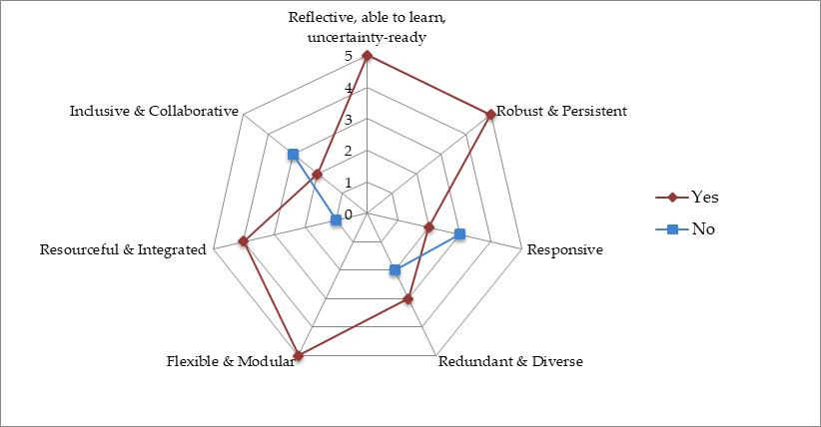

Graph 1. “Are nature-based solutions…?”. The scale 0-5 indicates the distribution of answers among 5 respondents.  
Elaboration of the authors.

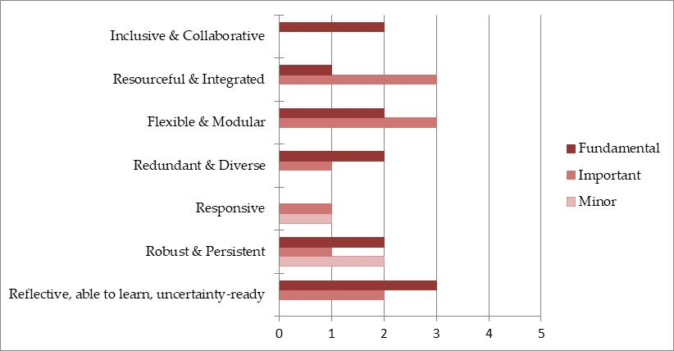

Graph 2. “If Yes, how would you weight the attribute?”. (The answer was provided only in case of YES to the previous question as shown in Graph 1). The scale 0-5 indicates the distribution of answers among 5 respondents. Elaboration of the authors.

# 6. Preliminary insights: enabling factors and challenges in BwN Projects

The discussions organized during the first two Coordination Meetings held in Sweden (Malmö, September 2016) and Denmark (Lemvig, March 2017) together with the first interview campaign (§**5.** The interviews) provide some preliminary insights about the implementation of NBS in the North Sea Region.

## 6.1 Stories & History behind NBS

The “enabling role” of **previous strategies** **or previous ruinous events** in helping the implementation of NBSs emerges quite widely in the stories of BwN projects, levering on accumulated experiences and skills, or on pre-planned scenarios where NBSs could find space for experimentations (e.g. NL in the first case, BE in the second). Looking at the very recent history, there’s an interesting advance in recognising of nature-based interventions as **“structural methods” for risk reduction** and for adapting to climate change thanks to such enlarged understanding and then to enhance a new approach to sustainable flood management (e.g. SCT).

## 6.2 Governance of flood risk

BwN projects are all wide and multi-faceted interventions. As expressed during interviews and meetings, up to now the recurrent crucial aspects about BwN governance involve: *weight of stakeholders*; *regulatory framework*; *policy continuity and overcoming of the pilot stage*.

1. The different **weight of local stakeholders** **and the regulatory framework** in each country represent a very interesting point to debate in the light of upscaling opportunities. The often conflictual roles of private ownership and public actors, and the responsibility of both in risk reduction represent a crucial factor to explore, for a better understanding of BwN pilots, and for a better agenda setting (e.g. confronting the DK case, where the responsibility for flood protection is up to the private owners, that represent a very strong stakeholder even compared to public administrations, with the BE case, where central authorities have a much stronger presence). The stakeholders’ dissimilar weights have clear consequent roles on negotiations for experimenting NBSs (e.g. the DK case again, where the role of national funds was instrumental to foster the dune restoration)
2. Coherently with what aforementioned about the role of pre-existing risk reduction strategies and accumulated experiences (§**6.1**), the **continuity in policies and funding** opens up wider opportunities allowing a failure-safe space for experimentations.
3. “**How to go beyond the pilots**”? Partners stress the institutional/administrative barriers to move from pilots towards more extensive actions or programs, which do not or cannot “fit” with existing rights, procedures, praxis. This constraints highlight the need of active partnerships between policy levels & research activities to break such barriers. Besider, NBS are *per se* oriented to long-term results, and the short-medium temporal term can be a frustrating and challenging phase.

## 6.3 Lessons from the design of NBS

BwN projects highlight how NBS are “different” from “traditional” flood mitigation in aims and technological approaches, and so they shouldn’t be object of one-to-one comparisons. NBS take advantage of natural dynamics and forces already present in the ecosystems offering an “approach-shift”: from working against nature to working with nature. Relying on local natural dynamics, and mixing hard and soft infrastructures, the design for NBSs sometimes move from a very indicative preliminary project, that is focused and targeted later, during the implementation phases, also because:

* Systems’ behaviours can never be perfectly modelled in advance
* Since these are long-term integrated policies, the different phases cannot be so rigidly labelled.

Nature-based solutions (NBSs) involved in BwN Project seem to represent a “mixed method” for flood defence: they merge hard and soft infrastructures (and mitigation and adaptation goals) not being capable to substitute traditional interventions. Soft measures often act reinforcing hard ones, adding environmental benefits. These NBSs act at multiple time-scales – with the aim of reducing flood risk in the medium-long term – as well as at multiple spatial scales and need to be planned, implemented and evaluated embracing a system perspective. Due to the wide scope of these interventions, in all the cases the local land uses have been affected, re-shaping the existing ones or adding new uses.

Consequently, BwN projects stress the need of a **deep, clear knowledge of local contexts**, being NBSs based on local natural dynamics. The necessity of exhaustive initial comprehension of the systems seems even more important for designing BwN than for standardized solutions. This statement should affect consequently also:

* Observation and evaluation of NBS’ performances and costs (§**6.4**) (e.g. huge difference of costs among Belgium and The Netherlands seem to emerge for similar typology of intervention)
* The framing of upscaling activities

For the previous reasons, in some cases NBSs are going to stand as “the only allowable” solution for implementing transformation projects, for instance for normative constraints as in the BE case (as explained in Lemvig’s coordination meeting) in protected areas or natural reserve, or for accumulated experience and collective appraisal about them (NL).

## 6.4 Monitoring & Evaluating BwN

The interviews prove the crucial importance of the monitoring & evaluating process, both as in-house activity (to test the projects’ performances and guide future actions), both as interinstitutional and international learning process thanks to the consultation with external partners. Some forms of structured monitoring systems seem to be in place already; in other cases they seem based more on “experiential-based” evidences.

The well-known process of monitoring and evaluating large transformation projects seem here even more fundamental, as tested through BwN projects. The processes both of internal monitoring, both of exchange and comparisons with partners allow to:

1. Collect information and experiences about the peculiar transformations **occurring *in situ*** **after** a NBS is in place, in physical, social and institutional terms.
2. **Provide data-based evidences** about (technical and economic) “effectiveness” of the projects. This monitoring represent:

* An opportunity to gain grounded information that are recognized as a crucial key absence in the realm of NBS (European Union, 2015)
* Consequently, it can represent a moment to ameliorate methodologies and guidelines. Such amelioration should be considered both in technological terms, both as instrumental to foster innovative approaches in risk reductions

1. A robust monitoring process represent a propaedeutic step to **raise more opportunities for  
   funding**, making possible a larger understanding and testing of NBSs, above all about maintenance costs (currently still unclear).
2. BwN projects are the results of mixed methods and approaches between hard and soft infrastructures: they represent an “unconventional” infrastructure. Consequently, they seem to need a “different” *ad hoc* way to be analysed and evaluated. This seems furthermore important once assuming that BwN solutions are generally soft measures reinforcing traditional infrastructures, or belong to larger scale interventions.
3. Costs – benefits – added values need to be assed in mutual relation, as Prof. Chris Spray suggested in his presentation in Lemvig: BwN measures are successful if you use a **multiple-benefits matrix of evaluation**. Concentrating the analysis only on the flood management/climate change adaptation “goal”, there are positive signs but not “clear results” or self-evidences of their performances.

Concluding, **a strong monitoring and evaluation of BwN can open to “virtuous upscaling circle”** which can support technological upgrades, open up to a new tailored way to “monitor & assess” complex infrastructures, expand funding opportunities.

## 6.5 The resilience of NBSs

European Commission describes NBS “actions inspired by, supported by or copied from nature. […] These NBSs ideally are resilient to change, as well as energy and resource efficient” (European Union, 2015). The concept of resilience is object of wide discussion in many fields, inside and outside academia; while early definitions of resilience were more outcome-oriented (resilience as capability of “bouncing back” to pre-existing conditions), current interpretations are shifting towards more process-oriented interpretations, looking at resilience as attribute of systems’ behaviours in response to uncertain events through complex paths (among many others: Davoudi et al., 2012; Matyas & Pelling, 2014).

NBS in BwN Programme address multiple environmental-related challenges in the realm of adaptation to extreme events. The resilient capabilities of NBS[8] – as proposed and clustered by the authors with regard to expert literature about resilience – are recognized by BwN Partners and stated as due to a combination of facets and multiple benefits produced by NBS, such as their multi-functionality and their flexible design easy to adapt and re-adapt. **NBS support and integrate existing methods** of risk mitigation and reduction, **while outlining new perspectives** inspired by ecosystem processes. BwN pilots can be considered examples of the shift from the “mitigation and recovery” paradigm (predict and control) to “adaptive and transformative” paths to cope with nature-related risks (Davoudi et al., 2012; Wamsler & Pauleit, 2016).

## 6.6 Local communities’ involvement

The involvement and reaction of local communities to NBSs is evidently very context-dependent, but often **local communities need to be persuaded** of the “validity/effectiveness” of these pilots, in technological and economic terms. Moreover, sometimes local communities doubt about the landscape impact of NBSs (see 6.7 Landscape & Environmental Impacts of NBS).

While implementing some BwN Pilots, new social groups emerged as stakeholders (e.g. kite-surfers in Dutch cases). The necessity of a clear and effective communication and involvement of local groups is now culturally recognised and required while deploying territorial transformation, but it’s also a way to build trust and consequently to reduce resistance in the long run.

## 6.7 Landscape & Environmental Impacts of NBS

Landscape and environmental impacts of NBS, maybe underestimated until now, seem to be a growing topic of discussion while implementing NBS. Landscape transformation after the implementation of the project represents a topic of discussion with local communities. (e.g. along some coastal cases in BE, citizens didn’t want to lose their domestic romantic landscape with waves clashing on the cliffs because of the nourishment of the beach). Possible negative externalities on local ecosystems and resources are now investigated.

# 7. Conclusions

NBS in BwN Interreg offer an innovative application of knowledge about nature: levering on features and complex system processes, these soft, flexible, living engineering solutions can contribute to a new way to reduce flood risk reduction and cope with climate change. NBS, as testified by BwN pilots, can provide multiple benefits, largely differently from the approach of traditional engineering for flood defence. In fact, for a fruitful implementation of NBS, multiple systems must be involved in a synergetic approach, goal that requires openness to new approaches (as well as to mutual compromises) and the will in building a strong network of social, economic and institutional actors (as well as efforts to keep them involved in the long run) through cross-sectoral forms of cooperation.

At the moment, the main intertwined elements emerging from the experiences of BwN Partners – providing insights about upscaling and policy learning – seem to be:

1. **The importance of local contexts and boundary conditions** in physical, social, ecological and regulative aspects. An efficient and deep contexts’ knowledge, firstly about local ecosystems’ dynamics, is instrumental for any NBS. Distinctive legislative frameworks and landowners’ powers and rights as well represent key issues to be understood since the first planning phases. Institutional and administrative praxis (e.g. procedures, standards, regulations) can represent strong challenges to foster extensive interventions; however, if the performances of traditional measures are not appropriate, they can push towards new solutions (e.g. interventions in protected areas).
2. Interestingly, **BwN interventions can add vulnerabilities** to the system and consequently some additional environmental impacts, moving forward the investigation about the “sustainability” of NBS themselves (e.g.: how to make BwN solutions energy-efficient or neutral; how to achieve “sustainable” sand excavations or sediments additions; which negative externalities on local ecosystems and resources emerge after the implementation of the project, etc.).
3. BwN pilots seem all to be **part of longer traditions of “soft interventions” or of pre-existing preservation strategies or research programs**. This common characteristic suggests the weight of a forerunning fertile ground to better promote NBS; in the same time, nowadays some kind of interventions – such as beach nourishments – are already so widely documented and experimented in many countries to be considerable a “standard” way of intervention in coastal protection.
4. In the light of the multiple benefits and values provided by NBS, social benefits included – basal pillar of NBS-related strategies and policies – the **continuous involvement of local communities and stakeholders is essential** since the planning of the intervention. This aspects has been discussed also at the North Sea Conference (July 2017), as reported below in BwN website:

***“Social added value.*** *The projects realize that they won’t make it with technical solutions alone. The technique has to work, but users must also be able to use them efficiently. In addition, both the workplace and management must endorse its importance. An important aspect is therefore to uniformly identify the social added value of the measures. This allows users to get hard data about soft values ​​like recreation and nature. This gives users insight into the various benefits within the projects so they can make a correct decision. By working together, we want to put together the issue of climate change and provide overarching solutions”*

Source: <http://www.northsearegion.eu/building-with-nature/news/cooperating-on-climate-adaptation-in-the-north-sea-region/> (accessed on 31st July 2o17)

1. A shift from “traditional engineering” towards a “resilience thinking” for flood risk reduction is evident in many domains, and especially in North West Europe. **NBS seem to be actually “resilient”** according to the recent process-oriented interpretation of resilience, as complex capability of systems’ behaviours and performances and as transformative response to uncertain events through composite paths. The resilience of NBS lay mainly in their robustness, flexibility, resourcefulness and capability of responding to sudden events. **How to “assess” the resilient attributes** recognized by the interviewees represent a decisive future challenge to undertake.
2. An **upscaling of the nature-based “approach”** more than of nature-based “specific solutions” seems necessary firstly, and even more feasible to open the path. *Generic* qualities and methods related to the adoption of NBS need then to be always shaped on the domestic characteristics and assuming specific *local* qualities.
3. NBS seem a sort of a **“mixed method”** for flood risk reduction, complementarily reinforcing traditional schemes with “soft” solutions (e.g. shore-face nourishments) and adding new environmental benefits, but not able to entirely substitute traditional interventions. In this sense, it’s important to underline that in some contexts, such as special areas of conservation or natural reserves, **NBS can represent the “unique” factual way of intervention.** It’s necessary to **improve the understanding** of NBS through building a stronger basis of rock data and scientific evidences about; a better understanding is instrumental to:
   * Increase long-term flood resilience and long-term adaptation strategies for climate change
   * Enlarge the knowledge about unexpected negative externalities of NBS
   * Put forward the experiences gained in terms of technological outputs and governance outcomes
   * Influence policy making and persuading current/future stakeholders and funders
4. **Monitoring NBS performances and evaluation of ongoing pilots** represent a key phase for the aforementioned needed improvement of understanding: a serious wide debate is desirable to optimize the knowledge already gathered and address the gaps to contribute to the debate. This seems to be especially true for economic parameters (costs, benefits, life-cycles, etc.) which seem to be still the more unclear: forms of comparison with control groups (not applying NBS) could enrich this understanding.
5. **How to value NBS benefits?** NBS represent non-ordinary forms of infrastructures for flood risk reduction, therefore they shouldn’t be assessed like if they were traditional flood defences, be object of one-to-one comparisons or of strict cost-benefits analyses. Consequently, NBS need the definition of a suitable “multifactorial” approach for evaluating their performances, values, costs and multiple benefits. Ordinary frameworks based on fix design standards are not sufficient for a factual understanding of these new approach of intervention. It’s necessary to extend the “evaluation matrix”: NBS represent the hotspot of this knowledge gap and need, that is evident also in other forms of spatial transformation nowadays.

# 8. Final remarks

## Exchange among WPs

The assessment/evaluation of the projects (§**6**) represent an important aspect also for WP6 goals for setting a more solid Research Agenda, and defining forms of policy learning and upscaling. It is an area of investigation where a more structured **dialogue and exchange with** **other WPs** seem particularly promising. The research of WP4 *“BwN flood risk management legislation, policies and practice: governance lessons for effective implementation of catchment-based natural flood management”* is an example. In fact, data about these issues represent a source of additional information about enabling factors and barriers actually faced during/after the implementation of the projects. This regards the eventually ongoing forms of economic/financial evaluation as well.

The interviews have been essential to define the first assumption explained in this report; it’s evident that we need **more colloquia and interviews** *(only 6 interviews have been carried out)* to better substantiate and enlarge the findings obtained by the first group of interviews. It’s important to remind BwN partners the importance of their contribution also in WP6.

## Seminar/Workshop proposal

To move further the research, it’s important to define cooperatively how to proceed and overcome the difficulties of interviewing and exchanging information, difficulties due to technical and time limitations for all the partners. A **seminar/workshop** gathering the partners could be a moment of significant collective learning, targeted to peculiar aspects that seems peculiarly promising and indeed valuable of

a deeper examination. A proposal of four core topics to further debate together:

* ***Scope and decisional process behind NBS [9]***

Why NBS instead of more traditional or conventional approaches? Which key-drivers factors,

interests, opportunities, supported these choices? Vice versa, which were the main barriers and challenges in opening up the process?

* ***Implementing pilots***

Which were the fundamental “enabling factors” and the main “difficulties, barriers and challenges” of applying NBS? Which differences with the planning phase?

* ***Innovative contribution and lessons learned***

Which are the main innovations induced by the pilot, also in the light of traditional approaches, in technological and governance terms? How is it contributing to add knowledge about flood risk reduction and climate change adaptation?

* ***Upscaling***

How to replicate or upscale these experience? How to go beyond the pilot phase? Which are (or could be) the main challenges? Which knowledge gaps and needs are emerging from this point of view?

The same issues could be addressed with a second round of interviews, if a workshop wouldn’t be feasible.

# Abbreviations

ACNM-SH: Landesbetrieb für Küstenschutz, Nationalpark und Meeresschutz des Landes Schleswig-Holstein (Agency for Coastal Defence, National Park and Marine Conservation in Schleswig-Holstein, Germany)

BE: Belgium

BwN : Building with Nature

CWSS: Common Wadden Sea Secretariat (Germany)

DCA: Kystdirektoratet (Danish Coastal Authority, Denmark)

DE: Germany

DK: Denmark

ECOS: EcoShape (Foundation, The Netherlands)

LS: Lansstyrelsen Skane (County Administrative Board of Skane, Sweden)

MDK-CD: Agentschap voor Maritieme Dienstverlening en Kust (Agency for maritime and coastal services - Coastal Division in Flanders, Belgium)

NBS: Nature-based solution

NL: The Netherlands

NLWKN: Niedersächsischer Landesbetrieb für Wasserwirtschaft, Küsten- und Naturschutz (Water Management, coastal Defence and Nature Conservation Agency in Lower Saxony, Germany)

NSR: North Sea Region

NVE: Norges vassdrags - go energidirektorat (Norwegian Water Resources and Energy Directorate, Norwey)

NZV: Waterschap Noorderzijlvest (Waterboard Noorderzijlvest, The Netherlands)

NW: Norway

RWS: Rijkswaterstaat (Dutch Ministry of Infrastructure and the Environment, The Netherlands)

SCO: Scottish Catchment Group (Scotland)

SCT: Scotland

SE: Sweden

SEPA: Scottish Environment Protection Agency (Scotland)

SG: Scottish Government (Scotland)

TF: Tweed Forum (Scotland)

UIHE: UNESCO-IHE (UNESCO Institute for Water Education, The Netherlands)

VMM: Vlaamse Milieumaatschappij (Flanders Environment Agency, Belgium)

# Appendix

## 1. The Interviews: Full Text

List of questions for partners involved in pilot projects. (See §**5**for further details).

**Section 1 – Main characteristics of the pilot**

1.1 Which are the primary and secondary scopes of the pilot, and involving which “spatial scales”? Please prioritize the goals.

1.2 Is the project addressing the causes of risk (probability times impact), or the impact, or both? Would you define it a “mitigation project”, an “adaptation project”, or applying a “mixed approach”?

1.3 Please indicate briefly the main technological aspects of the pilots, especially about: if and how it was inspired by previous experiences or existing techniques - good practises (and which ones); why it is a “nature-based” solutions; how it differs from conventional techniques

1.4 Describe the “chronology” of the pilot, explaining in which main phase the pilot currently is:

* decisional/planning phase: From … To …
* design phase: From … To …
* implementation phase: From … To …
* operation and management phase: From … To …

About the conception of the pilot: were there pre-existing related strategies or projects in which this pilot is rooted?

**Section 2 – Scope and decisional process of the pilot**

2.1 Why was the experimentation of a nature-based solution (NBS) preferred to more traditional or conventional approaches? Which were the key-drivers factors of the decision? Which were the added benefits or reduced disadvantages expected?

2.2 Did any previous event (such as a flood) influenced the decisional process related to the pilot? Were there pre-existing strategies or projects which opened up the ground for the debate?

2.3 Which stakeholders were involved in the first decisional phase? And who would you indicate as “initiators of the pilot”, if any?

2.4 Thinking of the beginning of the pilot: which elements would you indicate as “facilitator”, “enabling factors” of the decisional process? On the contrary, which were the main barriers and challenges in opening up the process? Please explain your answer, suggesting also on the typology and nature of both elements.

**Section 3 – Design and implementation of the pilot**

3.1 We ask you now to focus on the design and implementation of the pilot project. Similarly to question 2.4, we would investigate which were the fundamental “enabling factors” and the main “difficulties, barriers and challenges” of applying NBS. Probably they were not the same of the decisional - planning steps, or maybe you could recognize similarities, synergies, etc. Please explain your answer, suggesting also on the typology and nature of both elements.

3.2 With this question and the following ones, we would like to focus on the pilot’s emerging performances, with the purpose of understanding better some peculiar outcomes of NBS. There is a growing interest in how design and implementation take into account what additional values can be provided by infrastructure systems in their different performances – both in day-to-day conditions, both when the “design limits” are exceeded due to particular shocks or stresses –. Here we ask you if: Does the pilot take into account the different performances during these different domain? Is the Pilot adding new values or providing multiple benefits in the “day-to-day” and “standard” regimes, compared to traditional approach? Which are the “design limits” of your NBS?

3.3 Following the previous point, does the pilot address its goals by replacing a “standard model” and providing similar performances *(maybe adding other positive effects or controversial externalities that you could describe us)?* Or is the pilot showing alternative, different system performances? And which ones?

3.4 As well, is the pilot occurring in unexpected disservices or challenges?

**Section 4 – Monitoring and evaluating the pilot, its goals, the innovation induced**

4.1 Which are the main innovations induced by the pilot, also compared to traditional approaches?

4.2 Following the questions 1.1 - 2.1 - 3.2 about the pilot’s goals, benefits and outcomes, we would discuss the eventual monitoring process of the pilot. Are you evaluating and monitoring it, in general or specific terms *(or are you planning to do it)*? Which goals, benefits or trend are at the core of your monitoring activities?With which families of indicators and data? Do you have any results?

4.3 In your opinion, did stakeholders, goals and approaches change from the first steps of the pilot to the current phase?

**Section 5 – Lessons learned, legacy and upscaling opportunities**

5.1 We would like to know your opinions about the main lessons the pilot is teaching, in technical, social, economic and institutional terms. How is it contributing to add knowledge about climate adaptation and about other fields?

5.2 In your opinion, can this new knowledge and this experience be transferred to other contexts or projects? Could the pilot be replicable or upscalable, and which could be the main challenges? Any example?

5.3 Could the experience gained with the pilot have a longer-term influence on the mechanisms of the institutions/groups involved, going beyond the “experimentation phase”? If yes, how?

5.4. We would ask your contribution on the issue of “knowledge gaps” related to NBS. Assuming that knowledge gaps are strongly correlated to the “knowledge needs”, which kind of knowledge needs & gaps have you experienced or are emerging from the pilot? Please indicate the main ones, and if and how they have been addressed.

**Section 6 – The “resilience” of nature-based solutions**

In your experiences, which resilient attributes do play a role in planning, design and/or implementation of NBS? How would you weight these attributes?

|  |  |  |  |  |  |  |
| --- | --- | --- | --- | --- | --- | --- |
| 1. Are NBS **reflective and uncertainty-ready** **systems**, able of evolution and self-learning? |  | Yes |  | No |  |  |
| If **YES**, weight the attribute |  | Minor |  | Important |  | Fundamental |

*Comments: … … …*

|  |  |  |  |  |  |  |
| --- | --- | --- | --- | --- | --- | --- |
| 2. Are NBS **robust and persistent**, able to easily resist during and after a shock? |  | Yes |  | No |  |  |
| If **YES**, weight the attribute |  | Minor |  | Important |  | Fundamental |

*Comments: … … …*

|  |  |  |  |  |  |  |
| --- | --- | --- | --- | --- | --- | --- |
| 3. Are NBS **responsive,** able to anticipate problems and self-organize to respond to disturbances? |  | Yes |  | No |  |  |
| If **YES**, weight the attribute |  | Minor |  | Important |  | Fundamental |

*Comments: … … …*

|  |  |  |  |  |  |  |
| --- | --- | --- | --- | --- | --- | --- |
| 4. Are NBS **redundant,** do they presents spare components to ensure the system’s functioning? |  | Yes |  | No |  |  |
| If **YES**, weight the attribute |  | Minor |  | Important |  | Fundamental |

*Comments: … … …*

|  |  |  |  |  |  |  |
| --- | --- | --- | --- | --- | --- | --- |
| 5. Are NBS **flexible**, able to quickly adapt? |  | Yes |  | No |  |  |
| If **YES**, weight the attribute |  | Minor |  | Important |  | Fundamental |

*Comments: … … …*

|  |  |  |  |  |  |  |
| --- | --- | --- | --- | --- | --- | --- |
| 6. Are NBS **resourceful, integrated,** able to fully mobilise their resources? |  | Yes |  | No |  |  |
| If **YES**, weight the attribute |  | Minor |  | Important |  | Fundamental |

*Comments: … … …*

|  |  |  |  |  |  |  |
| --- | --- | --- | --- | --- | --- | --- |
| 7. Are NBS **inclusive,** involving various stakeholders, from institutions to local communities? |  | Yes |  | No |  |  |
| If **YES**, weight the attribute |  | Minor |  | Important |  | Fundamental |

*Comments: … … …*

**Glossary**

*1. Reflective, able to learn, uncertainty-ready*: Reflective systems accept inherent uncertainties and changes. They have mechanisms to (continuously) evolve, being able to enrich and modify standards or norms; people and institutions examine and learn from their past experiences, and leverage this learning to avoid repeated failures, improve performances, and inform decision-making.

*2. Robust & Persistent:* Robust systems include strong, well-conceived, constructed and managed assets, capable to withstand the impacts of disruptive events keeping the essential functions and without significant damages. Robust design and skills are ready to anticipate potential failures in systems, ensuring that failure is expectable, safe, controlled.

*3. Responsive:* It’s defined as the capacity to organize and reorganize, ability to identify problems, anticipate and prepare for a disruptive event or failure, and to respond and reorganize quickly in its aftermath when an existing structure can no longer afford to keep systems functional.

*4. Redundant & Diverse:* Redundancy and diversity refer to multiple and spare components and abilities purposely created within systems, so that the entire complex system does not fail when one component does. An example can be a variety of options for service delivery, to achieve a need or fulfil a function, but should be intentional and cost-effective, and not be the result of an inefficient design.

*5. Flexible & Modular:* Flexibility implies that systems can perform essential tasks under a wide range of conditions, evolve and adapt in response to changing circumstances. This may favour modular and relatively anonymous approaches to infrastructure or ecosystem management, but ensuring their interconnections.

*6. Resourceful & Integrated:* Resourcefulness implies that people and institutions are able to efficiently manage and fully mobilise human, financial and physical resources during a shock or when under stress, integrating multiple systems and functions. Integration overcomes “silo-ed” approaches and promotes mutual-support and consistency in decision-making.

*7. Inclusive & Collaborative:* Inclusion emphasises the need for broad consultation and engagement of a wide range of stakeholders as well as of local communities, including the most vulnerable groups. An inclusive approach contributes to a sense of shared ownership and to build joint visions.

## 2. The “Resilient Attributes”

(See also §**5** and §**6.5**).

BwN objective is to examine nature-based interventions to make coasts and catchments in NSR more resilient to climate change. The European Commission is 2015 describes NBS “actions inspired by, supported by or copied from nature. […] These NBSs ideally are resilient to change” (European Union, 2015). Both the notions of resilience and of nature-based solution are object of wide discussions in numerous fields, inside and outside academia, and especially in the realm of nature-related risk reduction and adaptation to a changing climate, to widen existing methods, as well as outline new perspectives and approaches. NBS, an clearly the BwN pilots, can be considered examples of the contemporary shift from the “mitigation and recovery” paradigm (predict and control) to “adaptive and transformative” paths to cope with nature-related risks (Davoudi et al., 2012; Wamsler & Pauleit, 2016). Assuming NBSs as interventions which rely on or mimic environmental dynamics to address environmental-related challenges such as flood risk, multiple potential added values and co-benefits are expected by their implementation: while improving (or not negatively impacting) the ecosystem processes involved in the transformation, they should provide diverse functions, promote innovative forms of governance, boost social and economic advantages .

While early definitions of resilience were more closely outcome-oriented (resilience as capability of “bouncing back” to pre-existing conditions), current interpretations of these notions shifted towards larger and more process-oriented interpretations, looking at resilience as attribute of systems’ behaviours in response to uncertain events through complex paths (among many others: Davoudi et al., 2012; I.P.C.C., 2014; Manyena, 2006; Matyas & Pelling, 2014). NBS in BwN Programme are complex systems with the primary goals of coping with river and coastal flood risks, addressing (and preventing) events through short and long-term responses. All the capacities of systems in the realm of disaster risk reduction are here involved: recovery capacity, adaptive capacity, transformative capacity. Some obviously more dependent on ecological and technical systems put in place, other more influenced by human agents and their organizations .The peculiar characteristics and capabilities that substantiate the debate on resilience represents a cutting-edge and holistic lens through which look at NBS (Kabisch et al., 2016; Naumann, Kaphengst, McFarland, & Stadler, 2014; Nesshöver et al., 2017).

Supported by academic and grey literature on NBSs and resilience, a set of “resilient attributes of NBSs” has been proposed to guide some direct investigations on BwN case studies and be tested through them in the same time. The attributes are: reflective, uncertainty-ready, able to learn; robust & persistent; responsive; redundant & diverse; flexible & modular; resourceful & integrated; collaborative and inclusive.

* *Reflective, uncertainty-ready, able to learn*

Reflective systems accept inherent uncertainties and changes. They have mechanisms to (continuously) evolve, being able to modify standards or norms; people and institutions examine and learn from their past experiences, and leverage this learning to avoid repeated failures, improve performances, inform future decision-making (Chelleri & Olazabal, 2012; The Rockefeller Foundation & ARUP, 2014a, 2014b; Tyler & Moench, 2012).

* *Robust & Persistent*

Robust systems include strong, well-conceived, constructed and managed assets, capable to withstand the impacts of disruptive events keeping the essential functions and without significant damages. Robust design and skills are ready to anticipates potential failures in systems, ensuring that failure is expectable, safe, controlled (Chelleri & Olazabal, 2012; The Rockefeller Foundation & ARUP, 2014a, 2014b).

* *Responsive*

It’s defined as the capacity to organize and reorganize, ability to identify problems, anticipate and prepare for a disruptive event or failure, and to respond and reorganize quickly in its aftermath when an existing structure can no longer afford to keep systems functional Chelleri & Olazabal, 2012; Tyler & Moench, 2012).

* *Redundant & Diverse*

Redundancy and diversity refer to multiple and spare components and capacities purposely created within systems, so they can accommodate shocks or pressures because the entire system does not fail when one component does. It includes the presence of multiple pathways and a variety of options for service delivery, to achieve a given need or fulfil a particular function. Redundancies should be intentional, cost-effective and prioritised, and not be an externality of inefficient design (Godschalk, 2003; The Rockefeller Foundation & ARUP, 2014a, 2014b; Tyler & Moench, 2012).

* *Flexible & Modular*

Flexibility implies that systems can perform essential tasks under a wide range of conditions, evolve and adapt in response to changing circumstances and safe-to-fail. This may favour modular and relatively anonymous approaches to infrastructure or ecosystem management, but ensuring their interconnections (Allan & Bryant, 2011; The Rockefeller Foundation & ARUP, 2014a, 2014b; Tyler & Moench, 2012).

* *Resourceful & Integrated*

Resourcefulness implies that people and institutions are able to efficiently manage and fully mobilise human, financial and physical resources during a shock or when under stress, and find different ways to achieve their goals or meet their needs. Integration overcomes “silo-ed” approaches and promotes consistency in decision-making, ensuring that all investments are mutually supportive (The Rockefeller Foundation & ARUP, 2014a, 2014b).

* *Collaborative and inclusive*

Inclusion emphasises the need for broad consultation and engagement of a wide range of stakeholders as well as of local communities, including the most vulnerable groups. An inclusive approach contributes to a sense of shared ownership and to build joint visions (Godschalk, 2003; The Rockefeller Foundation & ARUP, 2014a, 2014b).

As suggested by the work of Tyler and Moench (2012) on urban climate resilience, three general components contributes to build resilience in a complex system: its infrastructural and ecological subsystems, its agents, its institutions. This interpretation has inspired the investigation BwN Pilots and NBS: the resilient attributes explained before characterise Systems, Agents and Institutions shaping their “resilience capabilities” in managing shocks, recover and adapt to risks (Figure 2):

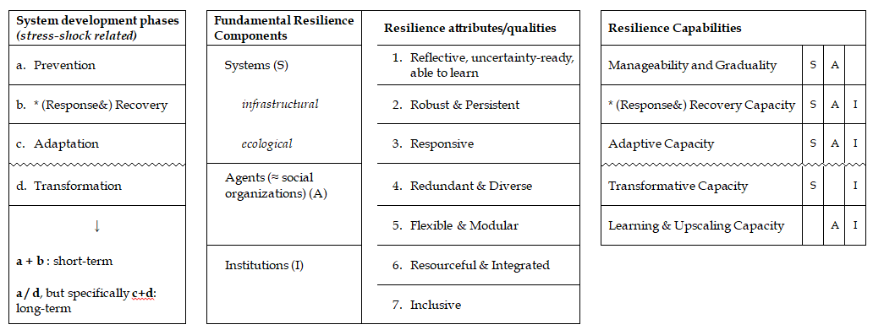

Figure 2. De-structuring resilience to investigate NBS. Elaboration of the authors.

The “Resilient Capabilities” introduced in Figure 2 are below explained through broad quotations from expert academic literature on resilience:

* *Manageability and Graduality*

According to De Brujin, the reaction of a system to a disturb is defined by multiple facets: threshold, amplitude of reaction, graduality in increasing the reaction itself. “The amplitude or *magnitude* of the reaction is equal to the economic, social, psychological and ecological impact of floods. It depends on: Hydraulic parameters that are related to the flood event […]; Socioeconomic parameters that determine the corresponding damage […]; Ecological parameters such as the types of ecosystems, the presence of refugee locations and the connectivity with other ecosystems. The *graduality* relates to the increase of flood impacts with increasing flood waves. The graduality depends on the same parameters as the reaction amplitude, but is also strongly influenced by the physiography of the area and the flood defence infrastructure of embankments […], bypasses, detention areas etc., and their operational management” (De Bruijn, 2005, pp. p.33-34).

* *Recovery Capacity*

The recovery capacity is a common element of literature on risk reduction and on disaster resilience. Two definitions are here proposed: “The *recovery rate* indicates how fast a system returns to its former state or former development pattern, or to a development pattern comparable to systems that were not disturbed. It is not necessary that exactly the same state is achieved, as long as the most important characteristics return” (De Bruijn, 2005, p. 34). “*Recovery* is mainly related to system shocks (internal or external) and rooted in the engineering resilience view (i.e. bouncing back to a normal safe state after, in this case, a flood). […] although recovery is related to shocks, disasters and emergency, structural long-term transitions can also result from the reconstruction process” (Chelleri, Waters, Olazabal, & Minucci, 2015).

* *Adaptive Capacity*

“Adaptation is understood as the processes of adjustment to actual or expected changes and its consequences, disregarding system boundaries by moving thresholds in order to make the system persist within the same regime. However, adaptation can accommodate change in very different ways, and so potentially overlap with transformative long-term processes” (Chelleri et al., 2015).

* *Transformative Capacity*

“A third approach is longer-term structural transformation (transitions), which refers to the alteration of fundamental attributes of the system, which will allow it to enter a new regime. Shifting adaptation toward this transition to new regimes is a critical and complex socio-political choice, and usually happens once the system is approaching dangerous thresholds” (Chelleri et al., 2015).

* *Learning & Upscaling Capacity*

Learning and upscaling capacity represent a peculiar point of view in enlarging the debates on risk reduction strategies. To better explain this capacity: “Both preventive adaptations and recovery processes can, in the middle-term, reveal learning capacities […] and can lead to system adaptations […] or even to transformations beyond the equilibrium view of urban resilience” (Chelleri & Olazabal, 2012, p. 70). The *capacity to learn* is “the ability to internalize past experiences, avoid repeated failures and innovate to improve performance; as well as to learn new skills” (Tyler & Moench, 2012). “Once the existing local efforts and capacities for risk reduction and adaptation are assessed, the possibility of encouraging and scaling up effective coping strategies and community-based approaches can be assed. Examples include […] upscaling of local methods or local learning mechanisms […]; establishment of regulatory frameworks that ease local risk reduction and adaptation […]; recognition and support of individuals, group, communities, local organizations that demonstrate leadership and innovation” (Wamsler, 2014, pp. 264-266).

# Bibliography

Allan, P., & Bryant, M. (2011). Resilience as a framework for urbanism and recovery. *Journal of Landscape Architecture*, 6(2), 34-45. doi:<http://dx.doi.org/10.1080/18626033.2011.9723453>

Chelleri, L., & Olazabal, M. (2012). *Multidisciplinary perspectives on urban resilience: A workshop report*. Bilbao: Basque Centre for Climate Change.

Chelleri, L., Waters, J. J., Olazabal, M., & Minucci, G. (2015). Resilience trade-offs: addressing multiple scales and temporal aspects of urban resilience. *Environment and Urbanization*, 27(1), 181-198. doi:<http://dx.doi.org/10.1177/0956247814550780>

Davoudi, S., Shaw, K., Haider, L. J., Quinlan, A. E., Peterson, G. D., Wilkinson, C., . . . Porter, L. (2012). Resilience: a bridging concept or a dead end? “Reframing” resilience: challenges for planning theory and practice. Interacting traps: resilience assessment of a pasture management system in Northern Afghanistan. Urban resilience: what does it mean in planning practice? Resilience as a useful concept for climate change adaptation? The politics of resilience for planning: a cautionary note. *Planning Theory & Practice*, 13(2), 299-333. doi:<http://dx.doi.org/10.1080/14649357.2012.677124>

De Bruijn, K. M. (2005). *Resilience and flood risk management: a systems approach applied to lowland rivers*. Delft University Press. Retrieved from <http://resolver.tudelft.nl/uuid:e4c67684-e4d1-4796-b37c-0b451ebec3d4>

European Union. (2015). *Towards an EU Research and Innovation policy agenda for Nature-Based Solutions & Re-Naturing Cities*. Final Report of the Horizon 2020 Expert Group on 'Nature-Based Solutions and Re-Naturing Cities'. European Commission.

Godschalk, D. R. (2003). Urban hazard mitigation: creating resilient cities. *Natural hazards review*, 4(3), 136-143. doi:<http://dx.doi.org/10.1061/(ASCE)1527-6988(2003)4:3(136)>

I.P.C.C. (2014). *Climate Change 2014: Impacts, Adaptation, and Vulnerability. Part A: Global and Sectoral Aspects. Contribution of Working Group II to the Fifth Assessment Report of the Intergovernmental Panel on Climate Change*. Cambridge, United Kingdom and New York, NY, USA:

Kabisch, N., Frantzeskaki, N., Pauleit, S., Naumann, S., Davis, M., Artmann, M., . . . Bonn, A. (2016). Nature-based solutions to climate change mitigation and adaptation in urban areas: perspectives on indicators, knowledge gaps, barriers, and opportunities for action. *Ecology and Society*, 21(2). doi:<http://dx.doi.org/10.5751/ES-08373-210239>

Manyena, S. B. (2006). The concept of resilience revisited. *Disasters*, 30(4), 434-450. doi:<http://dx.doi.org/10.1111/j.0361-3666.2006.00331.x>

Matyas, D., & Pelling, M. (2014). Positioning resilience for 2015: the role of resistance, incremental adjustment and transformation in disaster risk management policy. *Disasters*, 39(s1), s1-s18. doi:<http://dx.doi.org/10.1111/disa.12107>

Naumann, S., Kaphengst, T., McFarland, K., & Stadler, J. (2014). *Nature-based approaches for climate change mitigation and adaptation*. Bonn, Germany: German Federal Agency for Nature Conservation (BfN).

Nesshöver, C., Assmuth, T., Irvine, K. N., Rusch, G. M., Waylen, K. A., Delbaere, B., . . . Wittmer, H. (2017). The science, policy and practice of nature-based solutions: An interdisciplinary perspective. *Science of The Total Environment*, 579, 1215-1227. doi:<https://doi.org/10.1016/j.scitotenv.2016.11.106>

The Rockefeller Foundation, & ARUP. (2014a). *City Resilience Framework. City Resilience Index*. The Rockefeller Foundation.

The Rockefeller Foundation, & ARUP. (2014b). *City Resilience Index. Research Report Volume 1. Desk study*. The Rockefeller Foundation.

Tyler, S., & Moench, M. (2012). A framework for urban climate resilience. *Climate and Development*, 4(4), 311-326. doi:<http://dx.doi.org/10.1080/17565529.2012.745389>

Wamsler, C. (2014). *Cities, disaster risk and adaptation*. London and New York: Routledge.

Wamsler, C., & Pauleit, S. (2016). Making headway in climate policy mainstreaming and ecosystem-based adaptation: two pioneering countries, different pathways, one goal. *Climatic change*, 1-17. doi:<http://dx.doi.org/10.1007/s10584-016-1660-y>

1. The paragraph summarizes information available from Interreg NSR official website, retrieved from the following links (all accessed on 30th July 2017):

   <http://www.northsearegion.eu/sustainable-nsr/>

   <http://www.northsearegion.eu/media/1282/priority-3-project-summaries-final.pdf>

   <http://www.northsearegion.eu/building-with-nature/>

   <http://www.northsearegion.eu/building-with-nature/news/partnership-agreement-building-with-nature-signed/>
2. List from <http://www.northsearegion.eu/building-with-nature/partners/> (accessed on 31st July 2017)
3. All the following description of the pilots are from <http://www.northsearegion.eu/building-with-nature/living-laboratories/> (accessed on 31st July 2017)
4. Information retrieved from BwN Action Plan.
5. Each interview was about 45-60 minutes long; notes taken during the talk have been sent back to the interviewee in confirmation.
6. The interview misses Section 6
7. The interviews are 6, but in one case Section 6 on resilience was not answered.
8. See **Appendix 2** for references and further details.
9. Information about the initial decisional process that led to adopt a NBS are not always graspable through the interview, because often the roots of the projects are too far in the past, or because the current partners are engaged in the present implementation or monitoring of the projects, comprehensibly without a deep knowledge of the beginning of the programs.