Amsterdam International Water Week - Resilient City Leaders Forum
4 November – 10:00-11:30

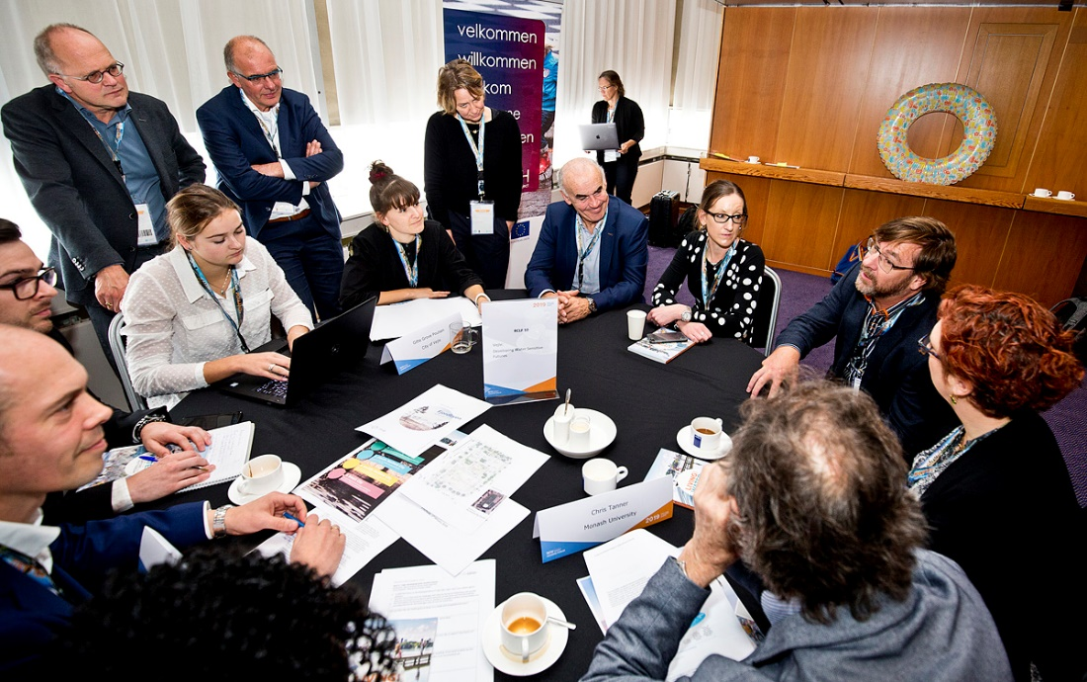

General speaker: Janet Long, Pinellas County, Florida, USA.
Talked about the major problems in Tampa, namely sea level rise and climate change. Hurricane Irma in 2017 was highlighted as a disastrous example. This was a category 4 and most dangerous US storm in history. An emergency meeting was held in Tampa whether or the county should be evacuated. In the end an evacuation was executed.

It was clear that Tampa bay should become more resilient. 30 regional governances in the Tampa bay area were united and signed a regional coastal resilience coalition for the years 2020 - 2022. This regional coastal resilience coalition had to find better ways to deal with hurricanes such as Irma in 2017. For example more gas should be available, more food should be stored and people should not get stuck on the interstate when they want to leave the area or when the area is being evacuated.

Book launch: Living with water: Lessons From Singapore and Rotterdam.
Speakers: Elaine Tan Sze Hui, Centra for Liveable Cities (Singapore) and Johan Verlinde, City of Rotterdam.

3 key learning points for Singapore from Rotterdam.
- Rotterdam has a systemic approach to governing of water management.
- Rotterdam saw the need to have an ongoing involvement of policies and programs in order to face the water problem. (Private sector, communities and water authority are working together, in doing so they achieve good results).
- Rotterdam involved their communities (water buffers, green roods, rain gardens, rain barrels etc.).

Learning points for Rotterdam from Singapore.
- Singapore as a port city develops in such a green way. Rotterdam can learn from that.
- Circularity of water in Singapore. In the Netherlands we want to get rid of water. However, water will become more precious over time due to drought.

Round tables RCLF themes:
- Houston (US) and Rotterdam (NL): A Tale of Two Resilient Cities
- Inclusive Manila Bay (PH) Sustainable Development Master Plan (MBSDMP): “Towards a safe and livable Manila Bay”
- Chennai (IN): Water as Leverage – RISECHENNAI: Rising waters, raising futures
- Miami Beach (US): Challenges of a low elevation barrier island
- Wuhan (CN): Nature Based Sponge Cities
- Tirana (AL): Inclusive, Child Friendly and Green Cities
- Cape Town (SA): Drought Learning Initiatives
- Rotterdam and Amsterdam (NL): Failures and Lessons Learned in Community Engagement for Climate Adaptation
- Vejle (DK): Developing water sensitive futures
- Monterrey (MX)

Resilient City Leaders Forum 2019: from resilient city cases to bankable projects in developed and developing countries

The Resilient City Leaders Forum (RCLF) will focus on local level adaptation. The implementation of solutions should not follow a ‘top-down’ approach, but instead, adopt a more inclusive collaboration where civil society is a main stakeholder. Future flood protection measures should feature nature-based solutions and the use of an integrated approach, which involves multiple sectors, spatial planning and a business case accounting for both public and private interests. Simultaneously, effective master plans are needed to support progress towards a circular water economy and reflect the long-term nature of climate adaptation. In order to facilitate this process, cities need a central coordinating organization. This also requires involvement of potential financiers and investors from the start of project development, which is key for generating bankable propositions with sound financial structures. This can be blended finance mechanisms to make use of public and/or private financing.

At the RCLF, leaders from various cities around the world will present the efforts undertaken, and the challenges encountered, in improving their cities climate resilience. The RCLF will present ten cases from across the world. Global network organizations and financial institutions will also present their activities and facilities.

Table 9: Vejle Developing water sensitive futures
Moderator: Nanco Dolman (Royal Haskoning DHV)
Case presenter: Gitte Grove Poulsen (Vejle)

Following its Resilience Strategy (2016), the city of Vejle is working on social and institutional solutions to facilitate its transition to a water-sensitive future. Like Vejle, cities in the North Sea Region (NSR) mainly focus on dealing with too much water and flooding. However, prolonged heat and dryness during the recent 2018 summer led to drought in many countries across Europe, including the NSR. This was an instant wake-up call for cities in the NSR which must also consider adaptation to more severe droughts and water scarcity. In a project similar to CATCH, a network of six Australian cities, including the city of Townsville, is developing ‘Water sensitive city visions and transition strategies’. Bearing in mind the differences in regional water challenges, this roundtable will look at the experiences and lessons learned from both ‘water sensitive future’ pilots in the NSR and Australia, which are applicable to the water challenges experienced by cities around the world.

Invited Participants
Chris Tanner Monash University
Emily O'Donnell University of Nottingham
Fraser Ramsay Meridian Urban
Noel Roberts Water New Zealand
Enrico Moens Sweco
Kimberly Foster Tulane University
Anne Fleur Weusthuis Water Authority Vechtstromen
Piet van Erp Water Authority Vechtstromen
Susan Lijzenga Reeleaf
Eric Schellekens Arcadis

Welcome by Nanco Dolman.
Brief introduction of the participants at the table. Participants from Denmark, Australia, New Zealand, United Kingdom, the Netherlands, America and Africa.

Case introduction by Gitte Grove Poulsen:
The Danish city of Vejle is vulnerable to climate change due to flooding from the Grejs Å river. The stream crosses a hilly area and during extreme rainfall events the water is running very fast into the city of Vejle. In combination with a high water levels in the fjord and of the groundwater, this situation leads to flooding risks in the inner city of Vejle. To reduce the risks and damage caused by flooding, the city investigated three locations in both the eastern and western part of the city. With the tools from CATCH the city council choose the location where measures will have the biggest impact on the urban water system and the resilience of the city. This location will be transformed into an area: where water can be temporarily stored; streams can be established to solve high ground water levels in city areas and water can be transported via cloudburst roads. Besides enlarging the storage capacity, the location will be a green meeting place for the citizens and will support the creation of a new/improved identity of the neighbourhood. Using the CATCH tools the following measures will be taken: environmental effect and impact assessment, design, connecting and lowering area for temporarily water storage and furniture for meeting places.

Australian experience with water sensitive cities (Townsville, Chris Tanner)
- Every 2-3 years there is a flood in the city of Elwood. In the eyes of the Elwood community members this problem needs to be fixed by the government. However, the government was not able to fix this. Three till four years ago the Elwood community decided that the floods are also a problem of the community. As a result they brought the councils together. Because of this cooperation several adaptation strategies were implemented, such as building houses with higher levels so that there will always be a level of the house above the flood level. This example illustrated the importance of a more inclusive collaboration where civil society is a main stakeholder.

- There are nutrients in the waterways in the Australian city of Townsville. The bay became shallow and filled with mud. Townsville came up with a healthy water ways report. This report initiated a competition between different councils about who got a better idea, plan, solution for the problem. Unfortunately, the competition was not broad enough in the end, which resulted that the competition stopped. There is now an indexing method which is much broader. It includes the community and has a self-scoring model. As a result there is more discussion between people, who would otherwise not talk or diffuse ideas with each other.

Several questions were raised:
- Q: How are you going to make the CATCH tool more concrete?
Water is central to the identity of the citizens of Vejle. So, building a dam is not going to add any value to the community. We should protect the citizens and use water as an asset at the same time. The CATCH tool is seen as a good way to make a transition to become a water sensitive city. So, living with water and protecting the citizens at the same time will be possible in the end.

- Q: What is the CATCH project in detail for the city of Vejle?
The CATCH project is one of the three projects within a broader project to establish three basins. The CATCH project site used to be a football pitch and was the most accessible place to play after school. It is located downhill. The three basins will have multiple functions so that every community member can use these areas. The first basin will overflow in the second and will eventually spill over to the last. The implementation will start in September 2020.

- Q: Will this project in Vejle be the kick-start of similar projects?
It is important that we do not make concrete basins in the future. We want to make solutions that create value for citizens to let them be happier and healthier. This will not happen when we make concrete basins. So, hopefully this project will be the kick-start of similar project in the future.

- Q: Will the nutrient rich water in the waterways/basins be filtered before it enters the fjord?
Yes, the water will be filtered before it enters the fjord.

- Q: Will the catchment areas in Vejle also serve as a harvesting area of water as CATCH is focusing on too much water?
We are not yet thinking about this topic as there is a high level of ground water, so drought is not really a topic for Vejle. But there is a high chance will have to transition to think in such a way in the future.

- Q: Is the aspect of water sensitivity part of the spatial planning of the city?
The CATCH project is a pilot so it is not embedded in any policy. But the resilient strategy is embedded in most of our policies and plans.

Summary:
The main topic of this table at the Resilient Cities Leaders Forum was water sensitive futures. There was a dialogue with the experiences in Australia. The Vejle case was discussed. The CATCH project, where Vejle is part of uses the Water Sensitive Cities (WSC) theory as the source of inspiration. The principles of this theory are derived from the Dutch Ecopolis model, further elaborated in Australia and are now developed into a theory usable also for Northern European situations. Vejle focuses on floods, not on drought as there is more than enough water in and surrounding Vejle. However, it should be noted that we need to think about the future, when it is not that obvious that we have too much water. The summers of 2018 and 2019 were very dry and there was a major water shortage in some parts of Europe.

Recommendations:
- Bring in a kind of competition Australian example indexing methods of benchmarking to get more people involved in providing solutions for problems.
- It is about all parts of water. Not only about floods but also about droughts.
- Transparency is necessary to help strive competition and make progress.

