Depaving in the Toeffaertstraat in Gentbrugge

CONTEXT
The city of Ghent has worked in 2017 on an communication strategy to encourage the Gentians to depave their private domain and make it greener.
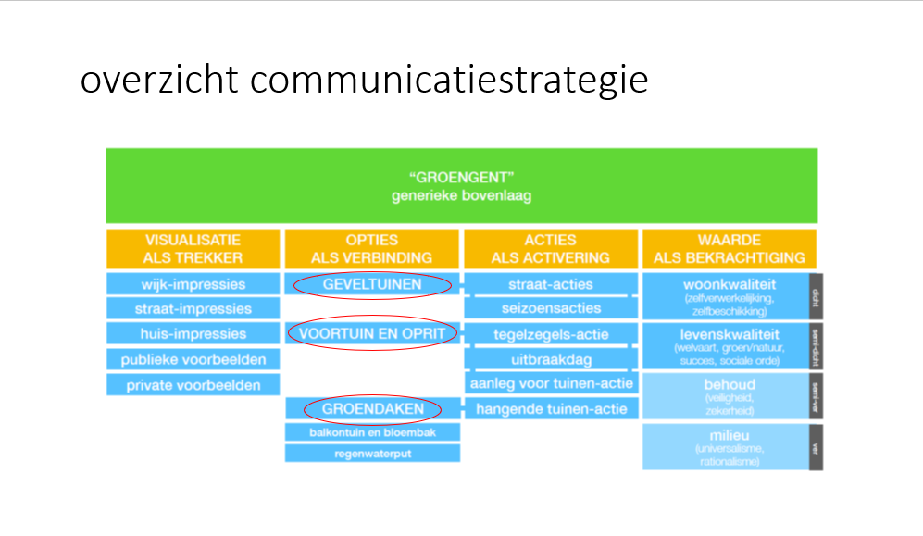
Instead of tackling all the different elements at once, which is not feasable, we wanted to start with a pilotproject were we focus on the depaving of frontyards by citizens.
In 2018 the city of Ghent wanted to find out which hurdles the citizens have to pass before they realize the depaving of their front yard. Do they know about climate change and think it’s important? Do they accept they also have a responsability to helpe and solve the problem ? Do they they know what they can do ? Do they think it’s possible to tackle it themselves? Do they want help ? Do they think it’s expensive ? What other factors play a role in the decision ? How can the city help to diminish the obstacles ?
In the same period Gents Milieufront (GMF), an environmental organisation in Ghent is looking for new ways to help with the greening of Ghent. With a citizens-budget provided by the city of Ghent the ‘Geveltuinbrigade’ from GMF constructed already more than 700 facade gardens in the previous year and more are on the waiting list. They are hungry for more.
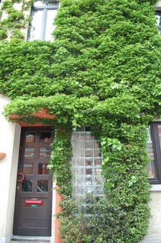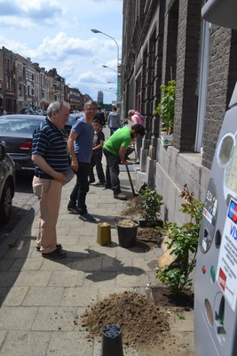

CASE
The Toeffaertstraat in Gentbrugge is a street in a residential area. The inhabitants have no frontyard in the classic meaning, but they each do own a strip of the pavement in front of there house.
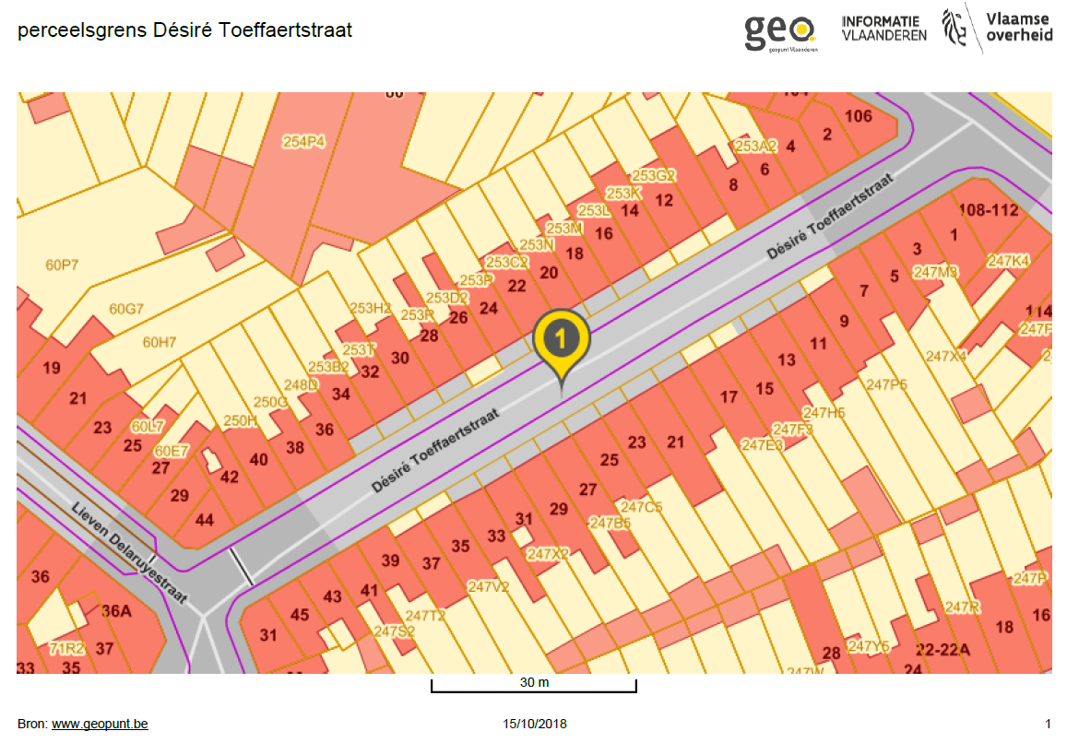
One of the neighbours asked GMF if they could help him to green up this privately owned but publicly laid out part of the street. An idea was born.

OBJECTIVES
Depaving as much as possible in “frontyardstrip” in the Toefaaertstraat
Analyse the different steps people have to take to actually depave their private land.
Test which steps the city can support by information, practical guidance, financial support, a.o.

BENEFITS
Fourteen families from the Désiré Toeffaertstraat in Gentbrugge participate in the project to transform their façade or paved front garden into a green gem.

6 families chose to realise a green frontyard, 8 others chose a green wall on the facade of their house.
In total 77 m2 was depaved in the Toeffaertstraat
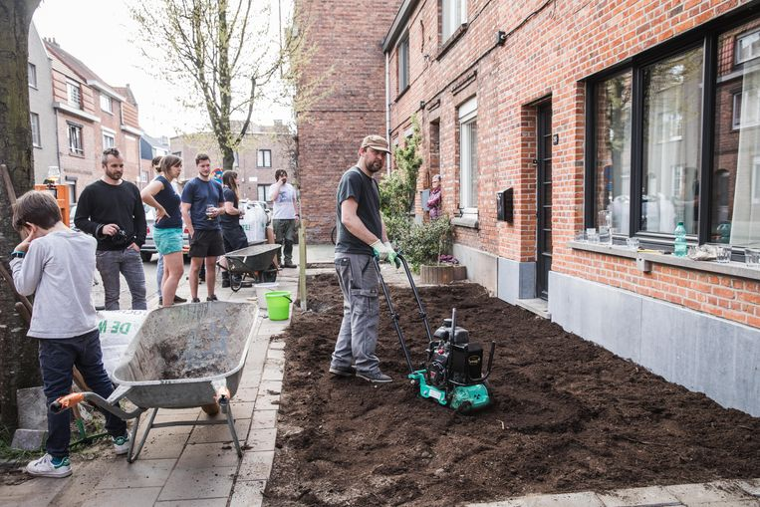

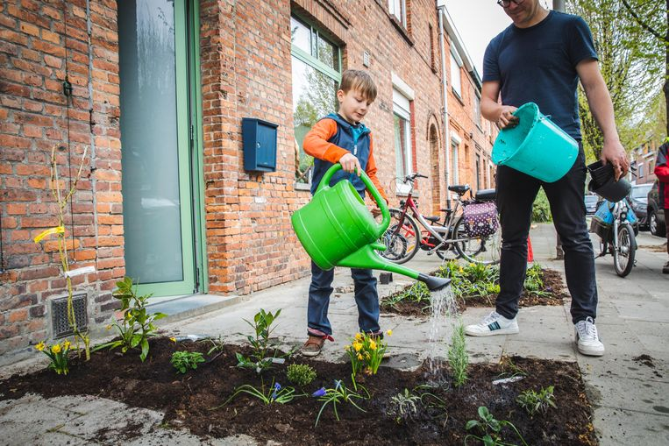

COSTS
For the Toefaertstraat the city and GMF invested about 6700 euro , this is with an undervaluation of the work that was put in by GMF. The costs were made for:
- Organisational meetings
- Meeting with the inhabitants
- Door to door convincing of the neighbours to participate
- Appointing a garden designer
- Personal guidance of the participants by the garden designer
- Hiring a skip
- Bying plants
- Providing tools
- Interviews with the neighbours

UPSCALING FOR GHENT ?
Financially it’s not feasible to transform all the streets of Ghent in this way. Maybe one example street in each of the 25 neighbourhoods is more achievable.

We interviewed the inhabitants of the Toeffaertstraat afterwords to find out how they experienced the proces in their street.

Who didn’t participate in the depaving ? People who
- rent a house,
- had just invested in new paving
- had just put in a new rainbarrel on the front of their house
- wanted first to isolate the front facade
- with physical difficulties

Comments on the proces:
Communication flow Toeffaertstraat:
Meeting of the projectteam // FB call on the street page + handing out invitations an d going door-to-door // Information moment about the project (clear intitiator and examples required) // participants make homework for design // speed date with designer // meeting participants around practical agreements
Point we learned: People need time to decide, but the project should not last too long (ideally no longer than 3 or 4 months between start and end) + Quiet place for information sessions, such as a living room or a school in the evening + inhabitants must have the opportunity to decide to participate up to a week before implementation
Necessary: a contact person in the street (a kind of ambassador, sponsorship, confidential advisor)

Benefits mentioned by participants:
• I used to have large puddles in front of the door, now not anymore.
• Passers-by have less insight now that I have a front garden. I can sit longer with my curtains open at night and no one can look inside.
• Clear advantage through upscaling with a street approach.
• A vertical garden or front garden means 'own' greenery if you don't have a backyard. More desire to sit in the front. More contact with the neighbors if you want to.
• Green makes happy, cozy neighbourhood, brings life, gives dynamism, makes driving through our street more cheerful, creates a certain atmosphere. A vertical garden is robust, not a problem if you don't water it for a few days.

Disadvantages mentioned by the participants:
• I can no longer use my window when I move house.
• Splashing soil in the beginning when it rains.
• Dogs and birds come to scratch in the sand.
• I thought people would throw trash in it, but that's not the case.
• Maintenance, but I don't think about it too much yet.

