Proof WP 2

- Värmland County Administrative Board - Älvgruppen
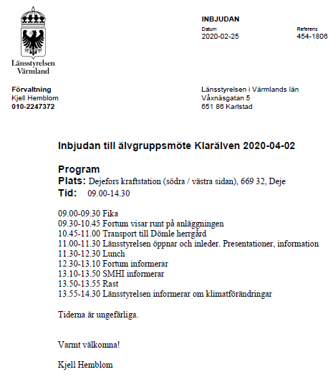

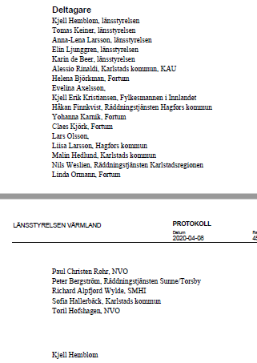

- Värmland County Administrative Board - News letter
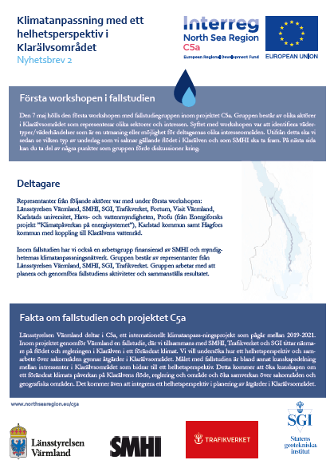

- Work package 2 leader – Värmland County Administrative Board
Explanatory graphic and a short video
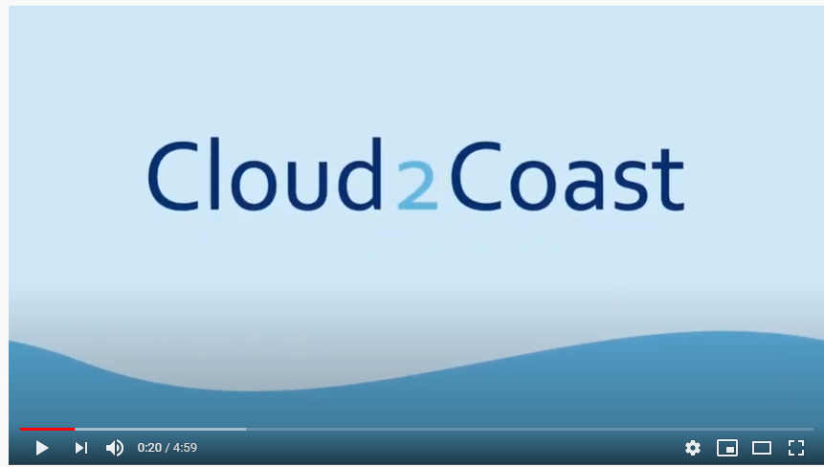
https://youtu.be/qndpyHDaFHE
- Work package 2 leader – Värmland County Administrative Board
C5a Website

