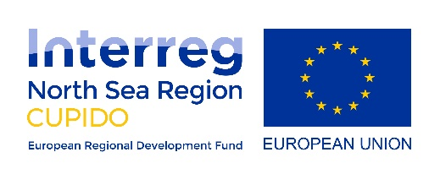

CUPIDO Multistream Testbed Report 2020
In response to the demands caused by the Covid-19, Region Värmland conducted a webinar on the topic “How to Create and stream your Cultural event on digital platforms”, within the CUPIDO project. The webinar was published on Facebook, 8 April and reached 2400 viewers. 75-80 viewers were active in the stream chat and the interaction was handled through moderation and questions was answered by the hosts David and Linn from both the technical and cultural perspective. David is a filmmaker with experience of live-stream events and Linn is a dance choreographer. We evaluated the event and came to the conclusion that important aspects of what we explored happened in the preparation of the event. During the event we underestimated the importance of the interactive aspect.
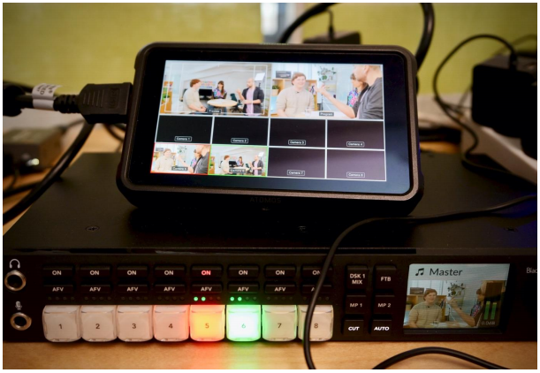

Testbed 2.0.
We decided to further explore the potential for cultural events, streamed on digital platforms by cross publishing the same livestream, to different accounts and platforms a.k.a multistreaming in order to explore interactivity between different streams created when events are shared on social media platforms. The event was made available to the public, simultaneously on Twitch, Facebook and YouTube. It was a cultural and technological exploration. A regional dance crew, EC Clique, was mentored by Ana Strandberg and Andre Forsström, while the street artist Henric Thåg created a mural. The interactivity was handled by Linn Eriksson.
A regional dance crew, EC Clique, was mentored by Ana Strandberg and Andre Forsström, while the street artist Henric Thåg created a mural. The interactivity was handled by Linn Eriksson. A film of the event can be seen at: https://www.facebook.com/filmregionvarmland/videos/483436279017315/
We also streamed all the preparations and interacted with the viewers who could participate in the creation of the event. The results of the events were very encouraging. We reached over 5000 viewers of the event. It generated new collaborations between participating companies. The skills and knowledge have later been vital when utilized by regional companies in order to stay in business during the corona period.
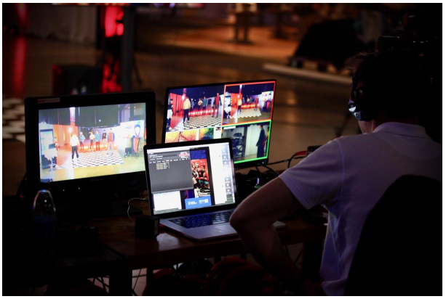

Theater Performance “Körkarlen”
The third and final testbed focused on increasing the quality of the content and quantity of the impact. We decided to collaborate with Västanå Teater in Rottneros. A testbed where traditional theatre converges with digital innovation. Västanå Theater has redefined what Scandinavian theater is and continues its journey on digital platforms. The event was produced with support from the Region Värmland, Värmland County Administrative Board (VCAB), Rottneros Park and Sunne Municipality, all the regional partners in Värmland.
The theater performance “Körkarlen” was adapted to be multistreamed onto all the participating partners social media platforms, with a special focus on exploring the logarithms of Facebook’s new livestreaming feature.
The testbed reached 40 000 views and generated a 60 % increase in followers to Västanå Teaters social media platforms. The three combined testbeds generated new digital opportunities for the regional SMEs that enabled them to navigate through the increased challenges the pandemic caused.
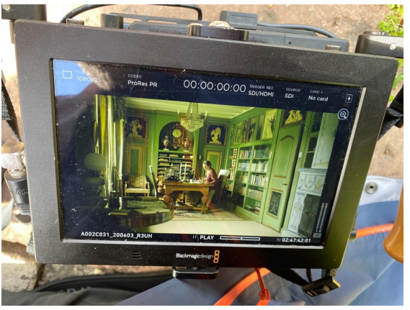
Picture from the famous author Selma Lagerlöfs home, in Sunne, Värmland

