|  |  |
| --- | --- |
| **Project acronym:** | WASP (Wind Assisted Ship Propulsion) |
| **Project full title:** | Run Wind Propulsion Technology real life trials on sea going ships in operation>showcase proven concepts>market adoption>green sea transport |
| **Project No.** | 38-2-6-19 |
| **Coordinator:** | Netherlands Maritime Technology Foundation |

**D2.4c Best Practice Manual** 

**Deliverable data**

|  |  |  |
| --- | --- | --- |
| **Deliverable No** | D2.4c | |
| **Deliverable Title** | Best Practice Manual | |
| **Work Package no: title** | WP2 Communication | |
| **Deliverable type** | Exchange of information | |
| **Lead beneficiary** | Netherlands Maritime Technology (NMT) | |
| **Responsible author** | IWSA / Gavin Allwright | |
| **Co-authors** | n/a | |
| **Date of delivery** |  | |
| **Approved** | **Name (partner)** | **Date [DD-MM-YYYY]** |
| Peer reviewer 1 | SSPA | May 2023 |
| Peer reviewer 2 | KLU | May 2023 |

|  |  |  |
| --- | --- | --- |
| **Document history** | | |
| **Version** | **Date** | **Description** |
| 0.1 | 17-7-2022 | First draft |
| 0.2 | 30-3-2023 | Second draft after first internal revision by WP leaders. Layout updated. Actions set out to experts for filling in the gaps. |
| 0.x |  | Internal revision |
| 0.3 | 30-05-2023 | Review, minor changes |
| 0.x |  | Amendments following review |
| 0.4 | 27-05-2023 | Final version |

**Best Practice Manual – WASP Project**

The WASP Project

The WASP (Wind Assisted Ship Propulsion) project is funded by the Interreg North Sea Europe programme, which part of the European Regional Development Fund (ERDF), to the tune of €5.4 million.

The project brings universities and wind-assist technology providers together with ship owners to research, trial and validate the operational performance of a selection of wind propulsion solutions on five vessels with a view to enabling wind propulsion technology market penetration and contributing to a greener North Sea transport system through harvesting the regions abundant wind potential.

This fully aligns with the wider programme objective of promoting the development and adoption of products, services and processes to accelerate the greening of the North Sea Region.

The WASP project has the following objectives:

* Wind Propulsion Technology proven concepts lead to the greening of NSR sea transport.
* Identify the viable business cases for (hybrid) wind propulsion technologies.
* Facilitate a level playing field for WPT with policy instruments.

The WASP project is a four-year project designed to install, test and validate five wind propulsion systems on five different vessels in the North Sea region. While this sample of systems and vessels is limited, the project has generated a large amount of performance data and contributed much to the overall understanding of how these systems are installed, operated and optimised.

Contents

1. Introduction 6

1.1. Purpose and Scope 6

1.2. Terms and Definitions 6

2. Technologies in the WASP project 7

2.1. ECO FLETTNER Flettner Rotor 7

2.2. NORSEPOWER Flettner Rotor 8

2.3. ECONOWIND VentiFoils 8

2.4. ECONOWIND TwinFoils 9

2.5. ECONOWIND Flatrack VentiFoils 10

3. Ship Profiles 11

3.1. Annika Braren 11

3.2. Copenhagen 12

3.3. Ankie 12

3.4. Tharsis 13

3.5. Frisian Sea 14

4. Technology Selection 15

4.1. Selection Process 15

4.2. Cost Benefit Analysis 16

4.2.1. Expectation Management 16

4.2.2. Drivers 17

4.2.3. Barriers 18

4.3. Feasibility Studies & Simulations 19

4.4. Reference Materials 19

5. Vessel Preparation 22

5.1. Foundation & Materials 22

5.2. Time & Project Management 22

5.3. Reference Materials 24

6. Installation 24

6.1. Engineering 22

6.2. Procedure 24

6.3. Integration 26

6.4. Reference Materials 27

7. Personnel 28

7.1. Perceptions & Acceptance 28

7.2. Training 28

7.3. Safety 28

7.4. Reference Materials 29

8. Operations 30

8.1. General Procedures 30

8.2. Loading/Unloading 30

8.3. Heavy Weather 31

8.4. Reference Materials 32

9. Monitoring & Evaluation 33

9.1. Monitoring 33

9.2. Evaluation 33

9.3. Sea trials 34

9.4. Reference Materials 40

10. Maintenance & Repair 42

10.1. Regular procedures 42

10.2. Repair 42

10.3. Predictive maintenance 42

10.4. Reference Materials 43

11. Upgrades & Optimisation 44

11.1. Adjustments 44

11.2. Recommendations 44

11.3. Routing/Operations changes 44

11.4. Reference Materials 45

12. Life Cycle Analysis 46

12.1. Materials 47

12.2. Lubricants 47

12.3. Circularity 48

12.4. Reference Materials 48

13. Risk analysis 49

13.1. Risk table 49

13.2. Reference Materials 50

14. Business Considerations 51

14.1. Finance/subsidy applications 51

14.2. Fuel/Savings/Tax 52

14.3. Reference Materials 53

# Introduction

## Purpose and Scope

This document is the Best Practice Manual covering the technology selection, installation and operation of a variety of wind-assisted technologies on five different vessels.

This document has been developed to aid shipowners and other entities that are interested in installing or otherwise engaging with WASP systems. While this manual doesn’t aim to be a comprehensive and definitive guide to the process, it does offer a set of processes, best practice approaches and procedures that address many of the issues that have been raised during the WASP project, based on real life experiences from ship owners.

Each chapter has a few pages that cover feedback and insights from shipowners, technology providers and the other partners and vendors involved with the project. Each chapter also has a series of links to additional external reference materials, websites of technology providers etc. The technical work packages 3 (engineering of wind propulsion technologies), 4 (policy and viable business), and 5 (operation of wind propulsion technologies and performance measuring) provide valuable input to this document.

## Terms and Definitions

|  |  |  |  |
| --- | --- | --- | --- |
| Air draft | The distance from the surface of the water to the highest point on a vessel. | LNG | Liquefied Natural Gas |
| BC | Black carbon | MGO | Marine gasoil - a high quality marine fuel that consists exclusively of distillates. |
| Beaufort scale | A scale from 0-9 indicating wind speed based on a visual estimation of the wind's effects | MPA | Marine Protected Area |
| CII | Carbon Intensity Indicator (IMO) CO2 emissions per ton/mile rating from A-E | OEM | Original Equipment Manufacturer |
| DWT | Deadweight tonnage - a measure of how much weight a ship can carry. | Primary Wind | Wind propulsion is the primary propulsion energy for that ship. |
| EEDI | Energy Efficiency Design Index (New build ships) | Rig | A wind propulsion system |
| EEXI | Energy Efficiency eXisting ship Index | Rotor sail  (Flettner Rotor) | Rotating cylinder operated by low power motors that use the Magnus effect (difference in air pressure on different sides of a spinning object) to generate thrust. |
| Embedded  Energy | the sum of all the energy required to produce any goods or services | SOG | Speed-over-ground |
| ESG | Environmental, social, and governance | STW | Speed -through-water |
| EU ETS | European system of GHG Emissions Trading System | VOC | Volatile organic compounds - a variety of chemicals often with climate and health impacts. |
| Flatrack | specialised cut down container with walls only at the short ends of the container | WASP | Wind-assisted ship propulsion |
| Fuel EUMaritime | European regulation as part of the Fit for 55 package directed at shipping. | Weather routing | Optimising a ship’s voyage taking into consideration weather conditions (wind, wave, current) |
| GHG | Green House Gases | Well-to-Tank | The process from fuel production, and delivery prior to the use onboard the ship and all emissions produced therein. |
| GPS | Global Positioning System | Well-to-Wake | The entire process from fuel production, and delivery to using onboard ships and all emissions produced therein. |
| GRP | Glass Reinforced Plastic. It is also called fibreglass, composite plastic or FRP. | Wind-assist | Wind propulsion system delivers on average less than 50% of the propulsive power to the ship at a given commercial speed |
| GT | Gross tonnage - the volume of all the space within a ship | Wingsail | A rigid or hard sail |
| GWP | Global Warming Potential - a measure of the impact of a given emission relative to CO2 | WPT | Wind Propulsion Technology |
| IMO | International Maritime Organization – UN specialised agency with responsibility for safety, security and prevention of pollution from ships. | Ventifoil  (Suction wing) | Non-rotating wing with vents and internal fan (or other device) that use boundary layer suction for maximum effect. |
| LCA | Life Cycle Assessment |  |  |

# Technologies in the WASP project

In this chapter, the main characteristics of the technologies used in the WASP project will be provided, with pictures. For more detailed information, please follow the links to the technology suppliers’ web pages.

## ECO FLETTNER Flettner Rotor

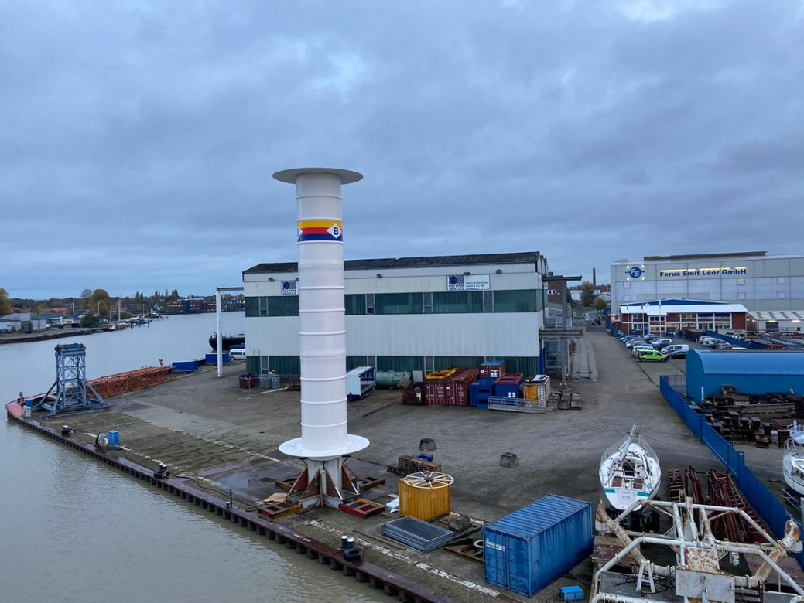

Figure 1 The ECO FLETTNER Flettner Rotor before installation.

|  |  |
| --- | --- |
| **System** | Rotor Sail |
| **Rig dimensions** | A single bow mounted 18m high x 3m diameter rotor sail |
| **Material** | GFP rotor with a steel foundation |
| **Description** | A large, fixed, bow-mounted rotating cylinder operated by low power motors that use the Magnus effect (difference in air pressure on different sides of a spinning object) to generate thrust for the vessel |
| **Company** | ECO Flettner  Mühlenweg 5  26789 Leer (Ostfriesland)  Germany  <https://ecoflettner.de/> |
| **Installation** | April, 2021 |
| **Applied on** | MS Annika Braren (Rederei Braren) |
| **Video** | [LINK](https://www.youtube.com/watch?v=IfyBvbyIK_0) |

## NORSEPOWER Flettner Rotor

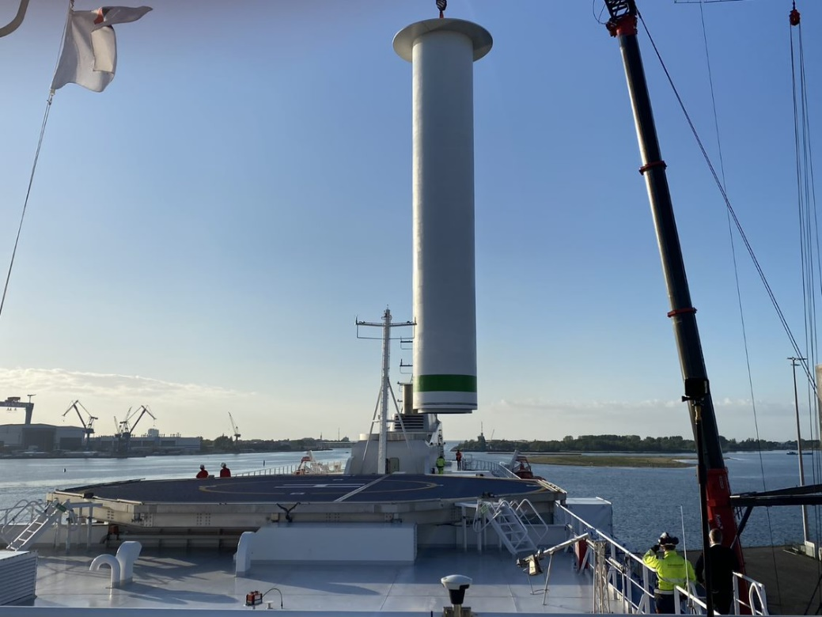

Figure 2 The NORSEPOWER Flettner Rotor during installation.

|  |  |
| --- | --- |
| **System** | Rotor Sail |
| **Rig dimensions** | A single 30m-high rotor, diameter 5m |
| **Material** | Composite |
| **Description** | A large, fixed, midship/top deck-mounted rotating cylinder operated by low power motors that use the Magnus effect (difference in air pressure on different sides of a spinning object) to generate thrust for the vessel |
| **Company** | Norsepower Oy Ltd  Tammasaarenlaituri 3  FI-00180 Helsinki  Finland  <https://www.norsepower.com/> |
| **Installation** | May, 2020 |
| **Applied on** | Ro-Ro Ferry Copenhagen (Scandlines) |
| **Video** | [LINK](https://youtu.be/CDscf6Zl2_k) |

## ECONOWIND VentiFoils

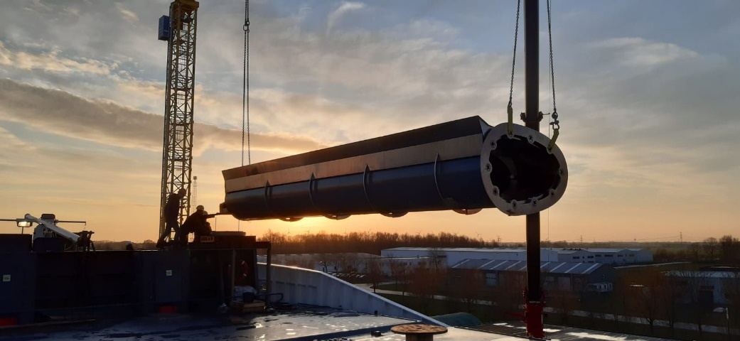

Figure 3 One of the ECONOWIND VentiFoils during installation.

|  |  |
| --- | --- |
| **System:** | VentiFoils (Suction Wings) |
| **Rig dimensions** | Initial installation 10m, extended to 13m |
| **Material** | Aluminium wings with steel foundations |
| **Description** | Folding, fixed bow mounted suction wings. The VentiFoils are non-rotating suction wings with vents and internal fans that uses boundary layer suction for maximum effect to generate thrust for the ship. |
| **Special Features** | The rig can be lowered during periods of headwind or extremely high winds or during port operations if required. |
| **Company** | Econowind  Leonard Springerlaan 7 9727KB Groningen The Netherlands  <https://www.econowind.nl/> |
| **Installation** | February, 2020 |
| **Applied on** | Ankie (van Dam Shipping) |
| **Video** | [LINK](https://www.youtube.com/watch?v=DMBYprA0_3w) |

## ECONOWIND TwinFoils

Figure 4 One of the ECONOWIND Twinfoils during installation.

|  |  |
| --- | --- |
| **System** | TwinFoil (Multi element Wing) |
| **Rig dimensions** | Initial installation 8m |
| **Material** | Aluminium wings with steel foundations |
| **Description** | The TwinFoils are non-rotating multi element wings with main wings and adjustable slotted flaps to generate thrust for the ship. |
| **Special Features** | The rig can be lowered during periods of headwind or extremely high winds or during port operations if required. |
| **Company** | Econowind  Leonard Springerlaan 7  9727KB Groningen  The Netherlands  <https://www.econowind.nl/> |
| **Installation** | October, 2021 |
| **Applied on** | Tharsis (Tharsis Shipping) |
| **Video** | [LINK](https://youtu.be/0L8UAzOyCvU) |

## ECONOWIND Flatrack VentiFoils

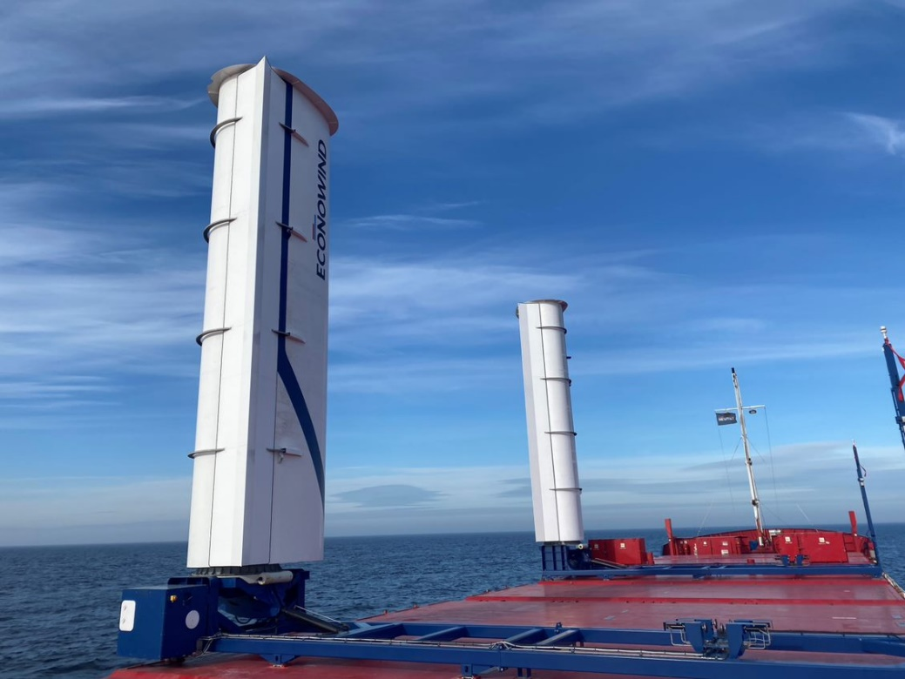

Figure 5 The ECONOWIND Flatrack VentiFoils shortly after installation.

|  |  |
| --- | --- |
| **System** | Flatrack VentiFoil |
| **Rig dimensions** | 10m |
| **Material** | Aluminium wings with steel foundations |
| **Description** | Flatrack folding and movable suction wings, stowable and moved by hatch crane. The Ventifoils are wing shaped elements creating high propelling force relative to its size. Smart suction is integrated in the wings, resulting in double the force of the VentiFoils, while reefing when needed. |
| **Special Features** | In heavy and/or unfavourable wind conditions the Ventifoils can easily be folded and locked onto the flatrack. |
| **Company** | Econowind  Leonard Springerlaan 7  9727KB Groningen  The Netherlands  <https://www.econowind.nl/> |
| **Installation** | January, 2021 |
| **Applied on** | Frisian Sea (Boomsma Shipping) |
| **Video** | [LINK](https://youtu.be/NpscwA__TrQ) |

# Ship Profiles

The information provided in this chapter is publicly available information[1]. The pictures are from the WASP project media database. You can track the location of each vessel in real time on the WASP project Fleet Page - [LINK](https://northsearegion.eu/wasp/our-fleet/)

## Annika Braren

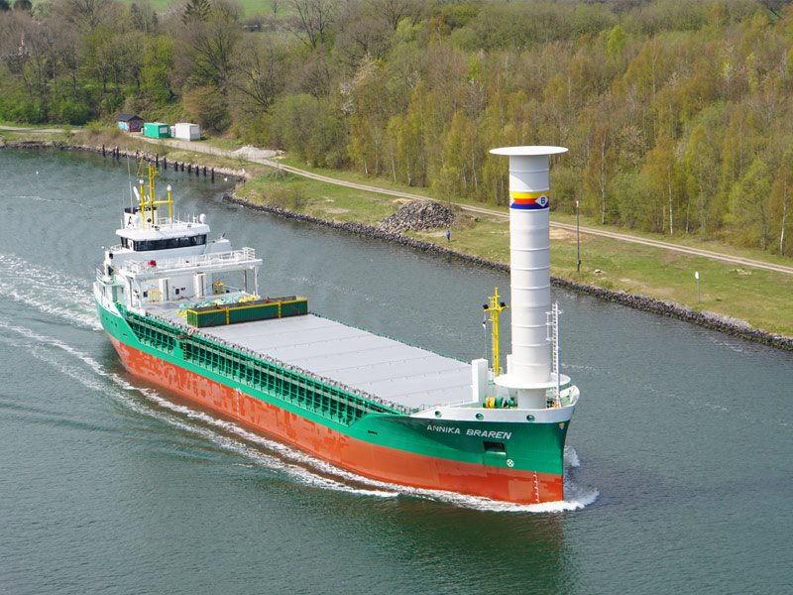

Figure 6 Reederei Rörd Braren's Annika Braren.

|  |  |
| --- | --- |
| **Vessel name** | *Annika Braren* |
| **Owner** | Reederei Rörd Braren |
| **Built** | 2020 |
| **Vessel type** | General Cargo (minibulker) |
| **Dimensions** | L: 85m  B: 15m DWT: 5,023  GT: 2,996 |
| **Ship Speed** | Top speed: 12.6kn  Average speed: 11.5kn |
| **Operation** | Various |
| **Cargo** | Various |

## Copenhagen

Figure 7 Scandlines' Copenhagen.

|  |  |
| --- | --- |
| **Vessel name** | Copenhagen |
| **Owner** | Scandlines |
| **Built** | 2012 |
| **Vessel type** | RoPax Ferry |
| **Dimensions** | L: 169m  B: 25m DWT: 5,088  GT: 24,000 |
| **Ship Speed** | Top speed: 16.5kn  Average speed: 15.8kn |
| **Operation** | Regular route between Rostock (Germany) and Gedser (Denmark) |
| **Cargo** | Motor vehicles & foot passengers |

## Ankie

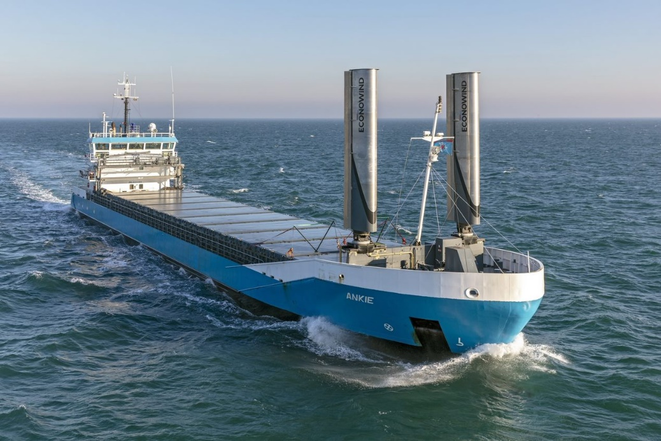

Figure 8 Van Dam Shipping's Ankie.

|  |  |
| --- | --- |
| **Vessel name** | Ankie |
| **Owner** | Van Dam Shipping |
| **Built** | 2007 |
| **Vessel type** | General Cargo |
| **Dimensions** | L: 90m  B: 13m  DWT: 3,638  GT: 2,528 |
| **Ship Speed** | Top speed: 7.3kn  Average speed: 6.4kn |
| **Operation** | Various |
| **Cargo** | Various |

## Tharsis

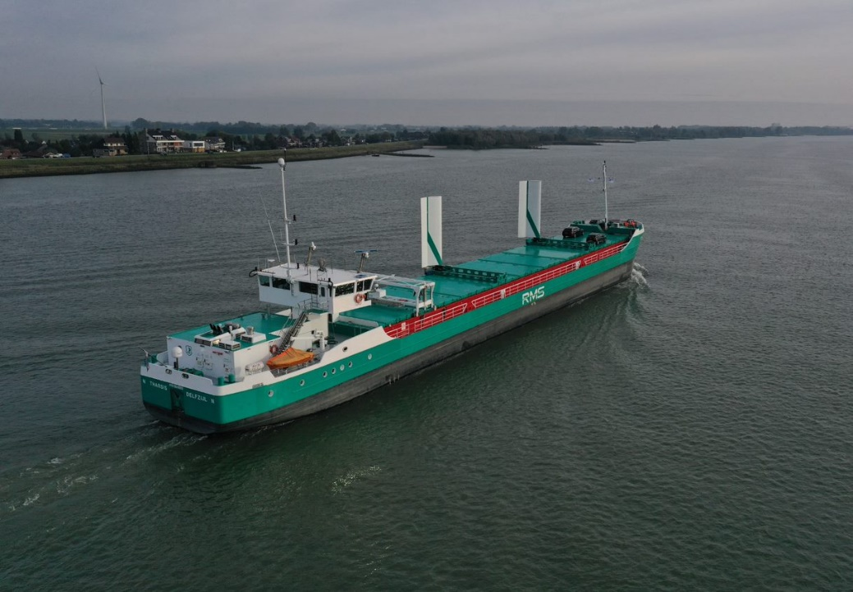

Figure 9 Tharsis Shipping's Tharsis.

|  |  |
| --- | --- |
| **Vessel name** | Tharsis |
| **Owner** | Tharsis Shipping |
| **Built** | 2012 |
| **Vessel type** | General Cargo |
| **Dimensions** | L: 88m  B: 11m  DWT: 2,300  GT: 1,801 |
| **Ship Speed** | Top speed: 10.3kn  Average speed: 7.8kn |
| **Operation** | Regular routes – sea and river |
| **Cargo** | Various |

## Frisian Sea

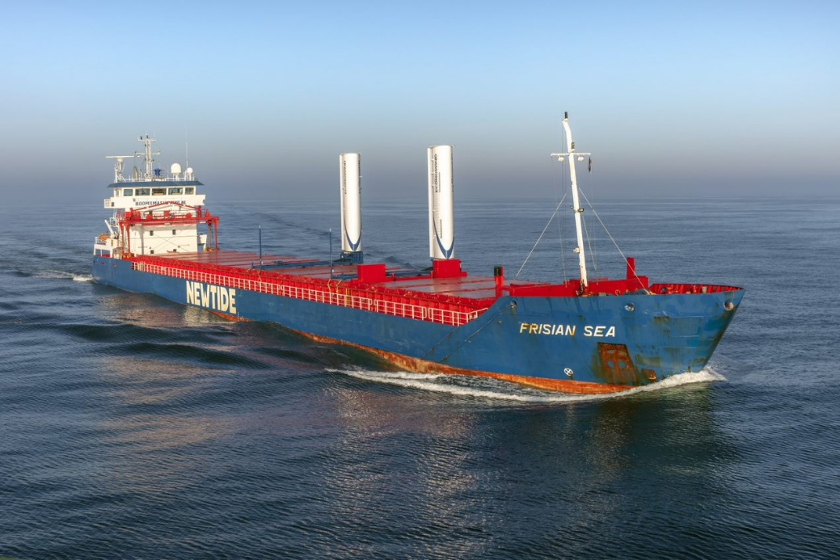

Figure 10 Boomsma's Frisian Sea.

|  |  |
| --- | --- |
| **Vessel name** | Frisian Sea |
| **Owner** | Boomsma |
| **Built** | 2013 |
| **Vessel type** | General Cargo |
| **Dimensions** | L: 118m  B: 13m  DWT: 6,477  GT: 4,298 |
| **Ship Speed** | Top speed: 10.5kn  Average speed: 9.5kn |
| **Operation** | Various |
| **Cargo** | Various |

# Technology Selection

## Selection Process

The selection of systems for this project is not necessarily indicative of how selections are made for future installations. However, there are benefits derived from prior knowledge of, and working relationships with, the technology provider especially when the system is a bespoke installation.

With bespoke installations on this project, there were elements of co-design between the external Original Equipment Manufacturer (OEM) supplying the equipment and the partner shipowners. There was a broad exchanging of ideas and processes, and system applications have been modified. This flexibility is also a consideration and usually built on trust and experience in working together.

|  |  |
| --- | --- |
|  | *Example: The development of the flatrack system with Boomsma Shipping and the technology supplier eConowind. Boomsma Shipping wanted a non-fixed system. However, the existing (containerised) option was not an appropriate solution for the MV Frisian Sea due to the container’s size/flexibility in handling. The redesign and reengineering were done by eConowind in collaboration with Boomsma Shipping, pushing innovation further.* |

The engagement with local providers reduced the decision-making process and all interactions were done in a shared language and understanding for the small vessel owners. For larger shipowners, a more detailed and systematic approach would be adopted with a full tendering process in place.

As wind propulsion systems, installation processes and operations become increasingly standardised the need for close relationships with the technology provider is loosened and the relationship becomes far more of a standard contractual supplier/customer relationship which was closer to the process that was undertaken by Scandlines and Norsepower.

Having a third-party resource for the assessment and selection of technology systems will be an important step forward as the market develops.

|  |  |
| --- | --- |
| **Step** | **Key points** |
| Preliminary screening | General identification of available technologies (including alternative investments alongside WPT)  General comparison/assessment done with other fuel saving systems available  Assess ship/fleet route  Set up functional and operational requirements |
| Investment shortlist | Comparative assessment of WPTs – tech, business model etc.  Third party engaged to assist with assessment (consultant/class) |
| Due diligence | Initial engagement with vendors or tender, local suppliers often being preferred  Performance assessment using physical simulations or CFD  Selection of WPT  Cost benefit analysis |
| Investment decision | Contract with performance criteria included |
| Iterative learning | Key learning points from procurement, installation & systems integration feed back into the selection process. |

**Classification Society Guidelines**

This process is informed by classification society guidelines that are available for wind-assist systems and are undergoing updates and revisions as an increased number of demonstrator and commercially installed systems are feeding back into the process:

ABS Guidelines: [Download](https://ww2.eagle.org/content/dam/eagle/rules-and-guides/current/other/315_gn_wind_assisted_propulsion_system_installation/wind-asisted-propulsion-guide-aug21.pdf)   
Bureau Veritas Guidelines: [Download](https://erules.veristar.com/dy/data/bv/pdf/206-NR_2021-02.pdf)   
ClassNK Guidelines are downloadable from [www.classnk.com](http://www.classnk.com)  
DNV Guidelines: [Download](https://www.dnv.com/news/dnv-rules-for-ships-july-2022-edition-227477)   
Lloyds Register Guidelines: [sail assisted ships](https://www.lr.org/en/rules-for-sail-assisted-ships/) / [rotors](https://www.lr.org/en/guidance-notes-for-flettner-rotor-approval/) / [masts spars and rigging](https://www.lr.org/en/guidance-notes-for-masts-spars-and-standing-rigging/)

## Cost Benefit Analysis

### Expectation Management

While the WASP project is a subsidised project and thus an artificial construct in the way of technology selection and operation, there are clear findings from the experiences of the shipowners and technology wind propulsion technology suppliers.

It is important for shipowners to have a clear set of expected results and that parameters are set to help manage those expectations. Ideally, these parameters would be delivered in consultation with the vendor/OEM/wind propulsion technology supplier or other knowledgeable/certified third parties that can provide a neutral evaluation such a classification societies or other consulting bodies. These parameters can be established through a series of questions, examples include (which are by no means collectively exhaustive):

* Why are you installing the system?
  + Fuel savings
  + Compliance with current rules & regulations
  + Future proofing
  + Pioneering/first mover spirit
  + Marketing/publicity
  + Green agenda
  + Customer pressure
* Are there any significant constraints on the WPT that increase costs from standard systems?
  + Required heavy or non-standard foundations.
  + Height/weight restrictions
  + Required retractability or movability for cargo handling etc.
* Which performance indicators will you use?
  + Power delivered.
  + Propulsion element of fuel saved or total fuel saving.
  + EEXI/CII
  + Uptime
  + Increased speed
* Are you willing to adjust your operational profile to enhance WPT performance?
  + Motor vessel operation profile vs wind vessel operation profile
  + Use of weather routing
  + Operational schedule changes time of year/day
  + Speed changes
  + Fuel saved vs speed maintained.
* How much down time or restricted time does the vessel have, will the system have?
  + Number of days at sea
  + Number of days operating on short routes/long routes
  + Non-windy stretches, like inland waterway, canal operation, or mandated non-WPT operational segments.
  + Port call durations
* How is my vessel currently performing?
  + Statistical understanding of current operational profile
  + Fuel consumption in weather/speed/ballast
  + Performance spread
  + Likely routes

As part of the WASP project, a technical assessment tool has been developed by HHx Blue - [LINK](https://hhx.blue/eu-projects/web-tools/technical-selection)

The management of expectations has been highlighted as a key issue when selecting and assessing the systems performance and the delivered power/fuel saving. Shipowners should be careful to use average performance data, especially when only a small number of installations have been performed and a detailed analysis using the above list of questions will be important along with the technical assessment tool along with the financial modelling tool also developed by HHx Blue - [LINK](https://hhx.blue/eu-projects/web-tools/financial-model) .

Certain issues can cause variations in performance that are difficult to isolate/quantify. A number of these issues were highlighted by the shipowners in this project, including:

* Drag is a possible issue in unfavourable wind conditions if the installation is not retractable/foldable.
* Operational times don’t necessarily match best wind times.
* Speed and route variations increase uncertainties in preinstallation performance assessment.
* Operational constraints on routes
* Other changes made to the vessel as well as the WPT increase uncertainty in performance assessment.
* Crew training and willingness to operate the WPT.
* Downtime due to maintenance/repairs.

### Drivers

The drivers behind the decision to install WPT are also an important factor in ascertaining the benefit-side of the decision. These drivers can clearly be split into two sections: tangible and intangible with short- and longer-term implications. For each shipowner these will have a different weighting depending on the operations, customers, ownership structure etc.

**Tangible**: these are concrete economic or compliance issues, such as:

* Regulatory compliance (EEXI, CII) or future regulations (Fuel EU Maritime etc.) [future proofing]
* Fuel costs: current and future fuel prices, price volatility [future proofing]
* Carbon pricing (possibly credits): with the EU ETS coming into force in 2024 at a 40% of the total level climbing to the full level by 2027 (50% for ships entering EU ports from a non-EU port and 100% for inter-EU voyages for all vessels above 5,000GT)
* Availability of subsidies: this was a clear driver in the WASP project, especially at a time where bespoke, individual system installations were costly and not yet fully optimised to ensure higher performance/savings.
* Customer pressure: although this was not currently highlighted as a driver from participants in the WASP project, shipowners acknowledged that this could become a factor in decision making in the future.
* Best in Class considerations: Although the lower emissions of WPT installed vessels is a clear benefit, this does not translate into higher charter rates for the cargo ships involved in the project. However, it may increase their ‘charter ability’ as ‘best in class’ options and thus ensure more work and more asset usage in the future.

**Intangible:** these are less defined and more complex to quantify issues that can however deliver a strong driving effect in the decision process, especially when the vessel owner is a small entity with a short decision chain.

* Climate concerns.
* Green/ESG interest.
* Pioneering spirit.
* Marketing benefits/brand value enhancement.

### Barriers

In these types of early market installations there are likely to be higher than usual barriers and unexpected costs. These come from the lack of standardisation of systems and installation processes and additional requirements from shipowners that wind propulsion technology supplier’s and the yards may be unfamiliar with. These increased costs and the potential for extended operational downtime are an obvious barrier as they increase the pressure on creating a viable business model. (Section 14)

*Example: Before making their investment decision, Tharsis Shipping defined a set of requirements.*

*These requirements narrowed the field of technologies that could be selected and a thin foil system that could be folded onto one another was selected. The system has fewer moving parts and while sacrificing some performance over a suction wing system, the WPT is able to have a larger surface area and relatively low maintenance.*

*The foils selected by Tharsis Shipping can be lifted with a hatch crane and need 2-5 mins to stow the system. The vessel has an electric drive train which enables the vessel to maintain quite slow speeds to maximise the use of the WPT and the requirement for low weight was specifically important as the vessel operates both at sea and on draft limited river stretches. The weight of 2 x 2.25 tonnes = 4.5 tonnes total for the foils was a strong deciding factor over the 2 x 8.0 tonnes = 16.0 tonnes for a dual suction wing system.*

## Feasibility Studies & Simulations

The use of a full feasibility study is desirable. However, this is a time consuming and costly activity for small shipowners. Therefore, these companies are likely to rely more heavily on the relationship with the technology supplier and on securing average or standard data so as to assess the system by using the aforementioned assessment tools or additional information supplied from a reputable third party. Larger companies will do this as a standard approach with multiple technologies and vendors being included in the process.

The assessment tool software will continue to be under development with the need for additional datasets from vessels and technology performance, and these will continue to assist with the design, technology selection, business modelling and route/performance assessment and this process will become more standardised and accurate.

## Reference Materials

**WASP assessment tools**

* HHx Blue - Technical Selection Assessment: [Technical Selection](https://hhx.blue/eu-projects/web-tools/technical-selection)
* HHx Blue - Financial Assessment: [Financial Model](https://hhx.blue/eu-projects/web-tools/financial-model)
* KLU – Decision Support Tool: [Decision Support Model](https://www.the-klu.org/faculty-research/research-collaboration/research-centers/hapag-lloyd-center-for-shipping-and-global-logistics-csgl/cargo-ship-calculator)

**WASP recordings**

* Wind Assisted Propulsion Challenges and Perspectives – Recording <https://www.youtube.com/watch?v=VpI_ss5XgyQ>
* WASP Best Practices Exchange: Linking technological capabilities to the business case for WASP <https://www.youtube.com/watch?v=lQhuX3KFGVA>
* Tharsis Interview [LINK](https://youtu.be/AJNMboKDO4E)

**WASP documents – chapters/sections**

* New Wind Propulsion Technology - A Literature Review of Recent Adoptions
* Review of adoptions (Chapter 4), fuel savings of several technology simulations (Chapter 5), technology-specific considerations (Chapter 7)
* <https://vb.northsearegion.eu/public/files/repository/20210111083115_WASP-WP4.D5B-NewWPTALiteratureReviewofRecentAdoptions-Final.pdf>

**Educational material**

* Considerations for WASP (page 9)
* Barriers for WASP technology (page 14)
* Viable business case (page 20)
* <https://vb.northsearegion.eu/public/files/repository/20210423144255_WASP.WP4.Act2B-Educationalmaterials_1_.pdf>

**Barriers and overcoming strategies for accelerating the uptake of WASP**

* Barriers (Chapter 3)
* [https://vb.northsearegion.eu/public/files/repository/20210423144255_WASPWP4.D5B BarriersandovercomingstrategiesforacceleratingtheuptakeofWASP.pdf](https://vb.northsearegion.eu/public/files/repository/20210423144255_WASPWP4.D5B%20BarriersandovercomingstrategiesforacceleratingtheuptakeofWASP.pdf)

**External documents/websites**

* Blue Route (Marin): <https://blueroute.application.marin.nl/> This website is developed to show the benefits of wind assisted shipping for custom sailing routes all over the world.
* EU ETS in Shipping <https://climate.ec.europa.eu/eu-action/transport-emissions/reducing-emissions-shipping-sector_en>
* F. C. Gerhardt, S. Werner, A. Hörteborn, O. Lundbäck, J. Nisbet, T. Olsson, Horses for Courses: How to select the 'right' wind propulsion system and how to make the business case, In the Proceedings of the RINA Conference Wind Propulsion, 2021, London, UK <https://www.sspa.se/en/making-business-case>
* Seaman simulations <https://www.sspa.se/tools-and-methods/seaman-simulations>
* Classification Society Guidelines

ABS Guidelines: [Download](https://ww2.eagle.org/content/dam/eagle/rules-and-guides/current/other/315_gn_wind_assisted_propulsion_system_installation/wind-asisted-propulsion-guide-aug21.pdf)   
Bureau Veritas Guidelines: [Download](https://erules.veristar.com/dy/data/bv/pdf/206-NR_2021-02.pdf)   
ClassNK Guidelines are downloadable from [www.classnk.com](http://www.classnk.com)  
DNV Guidelines: [Download](https://www.dnv.com/news/dnv-rules-for-ships-july-2022-edition-227477)   
Lloyds Register Guidelines: [sail assisted ships](https://www.lr.org/en/rules-for-sail-assisted-ships/) / [rotors](https://www.lr.org/en/guidance-notes-for-flettner-rotor-approval/) / [masts spars and rigging](https://www.lr.org/en/guidance-notes-for-masts-spars-and-standing-rigging/)

# Vessel Preparation

## Foundation & Materials

The selection of fixed foundations or movable structures is a critical issue and the materials used for bespoke applications are important considerations due to the longevity required for the WPT and for the other systems on the vessels. With the moveable structures, there was a need to ensure that hatches were watertight, that the frames were strong enough to handle the forces delivered by the WPT.

Below examples offer a comparison between WPT foundation preparation on newbuild versus retrofit vessels.

|  |  |
| --- | --- |
|  | *Example: For the Reederei Rörd Braren installation, the decision to install a rotor sail was already considered during the newbuild process for the vessel the year before. This allowed the foundation to be integrated into the newbuild. While the additional costs of foundation and reinforcing work were not specifically calculated, these were deemed to be negligible compared to the overall installation costs. Additionally, only slight changes were required in the standard design for a vessel of this type. The entrance to the bow thruster room needed to be adjusted and while the 3.5-4m foundation is below deck this basically takes up the bosun room space.* |

|  |  |
| --- | --- |
|  | *Example: For the Scandlines installation, as a full retrofit rotor sail this was a far more significant aspect of the installation. The complexity was higher due to the need to secure the WPT to the superstructure of the ferry (as opposed to the lightweight deck), and the costs were higher in means of a percentage of the total cost (in the order of 20%+). Operational vibration was initially identified as an issue after installation which was solved but required remedial action at some additional cost. However, the remedies for these issues have been incorporated from the beginning in the later installation on Scandlines’ Copenhagen’s twin vessel MV Berlin.* |

## Engineering

In the WASP project and due to the relatively bespoke WPT installations, the engineering required was undertaken in close consultation between the shipowner and the supplier. Complexity and costs at this stage were understandably higher with non-standard, moveable systems and their foundations, whereas when these activities were undertaken at the build stage, as with the *Annika Braren* vessel, then these issues and costs were minimised.

Examples of the additional engineering requirements included:

* Deck reinforcement.
* Strengthening of flatrack frame (Boomsma shipping installation).
* Minor movement/adjustment of navigation lights/mast.
* Hydraulic upgrade.
* Integration in the hybrid propulsion systems.

## Reference Materials

**WASP recordings**

* WASP Webinar: Engineering <https://www.youtube.com/watch?v=TCXuAXeZEvM>
* WASP Webinar: Digital Twins <https://www.youtube.com/watch?v=uXhRdUyjh6Y>
* Rord Braren Foundation Video [LINK](https://youtube.com/shorts/fgaURm25P8Y?feature=share)

**External Documents**

* Classification society guidelines (links in Section 4.1)

# Installation

The complexity of the installation of wind propulsion systems will, of course, vary according to the following criteria among others:

* Ship type.
* Ship size.
* Type of WPT.
* Weight/size of WPT.
* Foundation requirements.
* Movable/retracting/hinged.
* Location of the WPT unit on the vessel.
* Operational requirements of the vessel.
* Obstacles and interaction with other deck equipment (hatches, cranes, winches etc.).

## Yard selection

The selection of an appropriate shipyard or engineering company will, of course, be affected by operational schedules, existing contracts and/or established relationships between the ship owner and the yard and other standard commercial considerations. However, during the WASP project installations there was the additional consideration of the capacity to handle new, innovative technologies. Therefore, there was naturally a far higher engagement from the OEM side to ensure the smooth installation and integration of the systems.

As these procedures are standardised and there is a fair amount of technology knowledge dissemination and experience in installing various systems then the choice of yards, engineering companies and suppliers will increase.

Therefore, with these issues in mind, the key points highlighted among shipowners and OEMs were:

* Shared language.
* Local facilities & capacity.
* General engineering expertise & skills.
* Flexibility to work with non-standard systems.
* Existing relationships.
* Space/availability.
* Aligned schedule.
* Cost.

## Procedure

In the following table, pictures from the Rörd Braren installation are as an example however, the information in this table is generic and applicable to all installations.

|  |  |  |
| --- | --- | --- |
|  | **Step** | **Key points** |
|  | Equipment delivery | Yard (space) availability  Timely delivery  Completeness check |
|  | Foundation check | Foundation works done in time  Foundation/reinforcements in line with expectations  Connection points in line with expectations |
|  | Rig lift & affixation | Adequate crane available  Partner (yard, subcontractors, tech supplier, ship owner) availability  Specialised personnel requirements? |
|  | Electronics | Specialised personnel requirements?  Subcontractor availability  Hard- and software integration in ship systems |
|  | Test & adjustment | Tests in collaboration between ship owner and technology supplier  Onboard observations and adjustments by technology supplier  Weather for testing and/or sea trials |
|  | Class certification | Early class involvement to smooth the process |

## Time & Project Management

Good time and project management is always important for any retrofitting process and each shipowner has their own constraints over the amount of downtime available and the cost of that. All of the WASP project shipowners identified that selecting a technology provider that you could work well with along with sub-contracted engineering companies were critical issues. Yard selection, availability and timing was also flagged, although no issues were reported on this.

Potential causes of delay:

* Miscommunication or misalignment between partners or teams.
* Misalignment between deliveries of components, or other supply chain issues.
* Subcontractor delays or lack of capacity/knowledge.
* Vessel operational changes.
* Yard unavailability, flexibility & timing.
* System/software integration challenges.
* Classification certification issues.
* Any external issues such as geopolitical issues or pandemics etc. (e.g., in the WASP project delays were observed due to the COVID-19 pandemic between 2020 and 2022 and the Russian-Ukrainian war from 2022 onwards)

*Example: The foundation work on Scandlines’ Copenhagen vessel was undertaken a number of months in advance during standard maintenance/yard time and took a few days to complete. The lifting and fitting of the rotor sail was then undertaken during an overnight stop during the regular operations of the ferry, with only a seven-hour window to complete the installation. This was completed in time and then followed by the rotor being tested and systems confirmed over the coming days of standard operation.*

## Integration in Ship Systems

The control system and weather station integration are fairly straight forward as these are designed together and installed by the wind propulsion technology supplier and fitted as standard. This stand-alone installation has its own interface and depending upon the installation and wind propulsion technology supplier this will be semi or fully automated. Additional challenges however, are evident when the system needs to be fully integrated into the ship’s energy management system which needs to be planned for well in advance.

*Example: Tharsis Shipping, after initially considering the standard stand-alone approach, concluded that they wanted to fully integrate their wing sail installations into their touchscreen HMI systems. This turned out to be more complex than initially thought and thus costs also rose slightly (but this was the responsibility of the shipowner). To integrate the systems, they needed to bring together quite a few sub-contracted software partners with additional cabling and internet coverage required at sea to test the system. Had the software system been fully tested on land beforehand, this process would have been smoother and less costly.*

## Reference Materials

**WASP – Shipowner interviews recordings:**   
Van Dam Shipping interview [LINK](https://youtu.be/dTGnv580y1Y)  
Rord Braren interview [LINK](https://youtu.be/6ZL2RpJjeQI)  
Boomsma interview [LINK](https://youtu.be/Urqg99GbjzI)  
Tharsis interview [LINK](https://youtu.be/AJNMboKDO4E)  
Scandlines interview [LINK](https://youtu.be/6dBFL4rm14U)

**Tharsis Installation Videos**

Tharsis installation (1) [LINK](https://youtu.be/Treb2RfJZlA)  (2) [LINK](https://youtube.com/shorts/5hlhi-O1Bic?feature=share)  (3) [LINK](https://youtube.com/shorts/FbFtmnb1IFE?feature=share)

**External Documents**

* Classification society guidelines (links in Section 4.1)

# Personnel

The involvement and acceptance of the crew is naturally an important consideration and due to the novelty of the installations as part of the WASP project, this ensured a high level of engagement from crew members and shore staff. This engagement level will likely be less or will dissipate quicker once installations of WPT become more frequently seen, standardised and their operations normalised.

## Perceptions & Acceptance

All shipowner partners on the WASP project reported a high level of interest, positive crew and shore staff perceptions of the WPT equipment and a level of pride that they were involved in a pioneering project and that their input and feedback was valued.

The acceptance of these systems is based on a number of key issues:

* Relative ease of operation.
* Automation level of the systems.
* Relatively low levels of maintenance required.
* Few moving parts/relatively simple design – easy to understand.
* Safe stowing/powering down in high winds/seas.
* Low level of additional training required.
* No negative impact on navigation or typical cargo operations.

One of the ship owners even reported a sort of competitiveness between crews, each trying to get the most savings out of the wind propulsion technologies.

## Training

The training requirements are relatively light, with a general system overview training session undertaken with all crew members. With systems that had further innovative aspects, e.g., flatrack system, then additional training and wind propulsion technology supplier involvement with the initial testing and trialling of those systems led to a faster understanding and optimisation of the usage of the WPT system, for example reducing the time taken by 50% for the stowage process over a three-month period.

In addition to training for the crew, user manuals are distributed as a reference material for the crew, however the main engagement that the crew have with the systems is through regular maintenance routines and with the stowage of the flatrack Ventifoil system.

As the systems are increasingly automated and can be distance monitored, the requirements for training in the future should be minimised, however crew members have expressed the interest to understand the WPT systems more and a desire to keep a feedback loop to help improve processes and the systems themselves.

## Safety

As with all deck equipment there are standard safety protocols to observe however, the special requirements for the WPT are minor. Both of the rotor systems rotate and therefore clearance around the rotor is important. However, the rotors themselves are monitored at a distance, and thus any technical issues are quickly identified, and the crew notified. All of the systems can be powered down (in the case of rotors) or retracted (in the case of ventifoils and twin foils) in extreme weather conditions and all systems comply with the class stability, navigation and fire safety standards.

A list of safety considerations (though not exhaustive) is provided below.

* Crew safety.
* Fire safety.
* Lightning protection.
* Stability considerations.
* Navigation safety (bridge visibility, radar blind sector, navigation lights).
* Hazardous areas of the vessel.
* Manoeuvrability.
* Safe WPT stowage during port operations.

## Reference Materials

**WASP – Shipowner interviews recordings:**

Van Dam Shipping interview [LINK](https://youtu.be/dTGnv580y1Y)  
Rord Braren interview [LINK](https://youtu.be/6ZL2RpJjeQI)  
Boomsma interview [LINK](https://youtu.be/Urqg99GbjzI)  
Tharsis interview [LINK](https://youtu.be/AJNMboKDO4E)  
Scandlines interview [LINK](https://youtu.be/6dBFL4rm14U)

**WASP - Crew videos**

Scandlines: part 1 [LINK](https://youtube.com/shorts/i5x6K0ITN98?feature=share)  / part 2 [LINK](https://youtu.be/PRxPX-NTuxA)

**Barriers and overcoming strategies for accelerating the uptake of WASP**

* Strategies for implementing technological innovations (Chapter 4) – page 16 4.2.2 Management’s role [https://vb.northsearegion.eu/public/files/repository/20210423144255_WASPWP4.D5B BarriersandovercomingstrategiesforacceleratingtheuptakeofWASP.pdf](https://vb.northsearegion.eu/public/files/repository/20210423144255_WASPWP4.D5B%20BarriersandovercomingstrategiesforacceleratingtheuptakeofWASP.pdf)

**External documents**

* Rotor sails: putting a new spin on shipping? - Interview study with shipowners, technology providers and the crew of a rotor ship was performed to investigate the impact of wind propulsion on operations and crew and uncover clues to unlocking the full potential of this technology.  [SSP-Report3-WP2 activity 3-01.11.2020.docx (northsearegion.eu)](https://vb.northsearegion.eu/public/files/repository/20220202135153_SSPA_Article_NavalArchitect.pdf)
* NORVENT project: This project is underway to establish a state-of-art needs and procedures

used for WPT performance assessment to help deliver shared reliable guidelines. The

DIGI4MER – WP2 project will deliver an online theoretical training in wind propulsion for

seafarers. The projects are led by the IWSA Europe-Atlantic hub. (www.wind-ship.fr)

<https://www.economie.gouv.fr/plan-de-relance/digi4mer-projet-moderniser-formations-industries-mer>

# Operations

Operational flexibility is an important consideration and the optimisation of the WPT will be affected by the ability of the vessel to change course or follow weather optimised routes. These are not always permissible (or desirable) and for shorter periods at sea these limitations can reduce the efficiency of the WPT. The timing of departure/arrival (onshore/offshore winds) and the amount of river navigation could also be factors effecting deployment times, especially when total journeys are short.

## General Procedures

Step-by-step use of WPT

|  |  |
| --- | --- |
| **Procedure Step** | **Key points** |
| In-port manoeuvring | WPT are usually in stowed or idle position  If installation is not stowed, it will have a slight influence on manoeuvrability. WPT then typically have an idle mode to reduce the drag of the WPT  WPT is usually initiated after leaving port |
| Initiating WPT | WPT usually have an auto-mode, initiating the WPT if conditions are favourable  WPT can also be initiated (or turned off) manually |
| Adjustment of System | WPT adjustment of system is fully automated. During operation, no effort from crew is required |
| Powering Down Procedure/Emergency Shut Down | When in auto-mode, WPT will automatically turn off if conditions are favourable  WPT can also be turned off manually  WPT have local emergency buttons (at WPT location) and on the bridge |
| Stowing/Idling System | Although the rotors used in the WASP project are not stowable, newer versions of rotors do have a hinging option, although this probably means additional requirements in terms of foundation.  WPT typically have an idle mode, in which case they limit their drag while not creating any lift.  Stowing WPTs is a process which typically takes between 2 and 10 minutes. |
| Loading/Unloading | With fixed rotor the loading/unloading care to be taken with crane. |
| Air draft Considerations | Are there any air draft considerations on the vessel route (e.g., bridges)?  Does the vessel have a fixed route or does the operational profile require some flexibility in air draft? |
| Inland route/Restricted channel | Are there any restrictions in the potential geographical scope of the vessel? |

## Loading/Unloading

There are always loading considerations with fixed systems on cargo vessels (not so for the Scandlines ferry where the rotor is fixed but in an elevated position). With bow installed systems this issue is minimised as cranes are able access hatches and holds without much of a restriction (see Annika Braren discharging video [LINK](https://youtube.com/shorts/smva9-fQmBM?feature=share)). The installations on flatrack systems can be moved or stowed as highlighted in the example below.

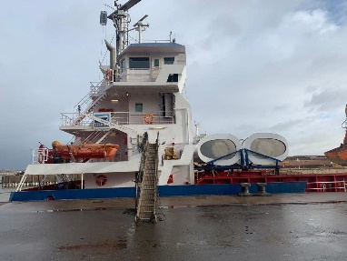

*Example: Boomsma Shipping’s Flatrack system enables the WPT to be moved from hatch to hatch by the onboard hatch crane. The system is also stowable in front of the bridge for ease of access when necessary. Initially this was fairly tricky to complete, however the crew quickly mastered the process and can now fully stow the two foils within 5-7 minutes.*

## Heavy Weather

Each system within the WASP project is certified for certain environmental conditions, with a maximum of Beaufort 7. In fact, the systems are likely to be operable at higher wind speeds so these parameters are likely to be adjusted as increased experience and datasets become available, in collaboration with classification societies. During extreme weather conditions all WPT systems can be powered down (reefed) or retracted quickly thus reducing any risks to stability. The amount of exposure to green water on deck is also an issue for all deck equipment. Suitably robust construction and protection of WPTs and their stowage systems are important to counter the potential impact from green water and/or the long-term damages due to e.g., salinity.

Besides the wind force on the WPTs, the ship accelerations in heavy weather may also have an impact on the installations. Limits will be different per WPT type.

*Example: As with other systems, the Eco Flettner rotor has an automated monitoring and control system: The patented performance control algorithm allows optimal performance taking wind conditions and ship propulsion parameters into account.  
In any case of emergency the rotor shall be shut off immediately. Therefore the “Emergency Stop” Button on the Main Switch Board located on the bridge shall be activated. The rotor will be stopped by an electric brake independent of the electric supply.*

*Side forces produced by the rotor are to be regarded as a load on the ship’s stability comparable to other loads on stability (e.g., wind load, centrifugal forces in a turning circle). They have to be kept in limits to avoid excessive heeling angles and the risk of capsizing. Therefore, the ship’s stability has to be checked before commencing the voyage. Additional stability criteria have to be fulfilled by ships carrying and operating sail systems as required by rules of classification and/or the flag state administration. The ship’s Intact Stability Booklet is complemented with information and data enabling the Master to check if the stability is sufficient for the safe operation of the rotor throughout the voyage.*

Ice accumulation on the system is also a consideration with ice build-up on top of rotors or wings, and regular checks are needed on hydraulics and moving parts to ensure optimal use but also ensuring quick response for emergency shut down.

*Example: On Scandlines’ Copenhagen ice accumulation on the top disc of the rotor sail initially was a serious safety concern, especially given the Copenhagen is a passenger vessel with outside passenger-accessible decks. A de-icing approach and system were adopted, which has solved this issue.* *For the EcoFlettner system on the Anika Braren, the de-icing function is a manual heater on the top of the upper end disk has to be used. In general, it can be said that icing in mist, spray and rain occurs at temperatures between 0ºC and -15ºC, particularly often around -5ºC. If the outside temperature is <5 ° C, the crew have to acknowledge that the rotor is free of ice.*

## Reference Materials

How easy it is to use Wind assist: MS Annika Braren with EcoFlettner rotor [VIDEO (1)](https://www.youtube.com/watch?v=ya6D-dbytHA)  // [VIDEO (2)](https://www.youtube.com/watch?v=OFhKCkk_11s) // [VIDEO (3)](https://www.youtube.com/shorts/F5cSsD8dsNA) // [VIDEO (4)](https://www.youtube.com/shorts/o0kcvHX4GC8)

Video – MS Annika Braren Discharging – [LINK](https://youtube.com/shorts/smva9-fQmBM?feature=share)

[WASP - Scientific research paper: Technical key performance indicators for wind-powered ships](https://vb.northsearegion.eu/public/files/repository/20230405083500_WernerGerhardtKontos-TechnicalKeyPerformanceindicators.pdf)

WASP Technology Suppliers Operation Manuals

WASP Best Practice Meetings 2021-2022

**External Documents**

* Classification Society guideline (links in Section 4.1)
* MEPC79/INF.21 <https://www.wind-ship.org/wp-content/uploads/2022/10/MEPC-79-INF.21-Wind-Propulsion-Finland-France-Saudi-Ar....pdf>

# Monitoring & Evaluation

The ongoing monitoring of both the WPT and operations is an important activity to ensure both that the system is functioning correctly and to assist with predictive maintenance. The monitoring of the operational profile and fuel consumption and other parameters will also assist with the optimisation of the wind system, for potential upgrades, and for further iterations of these wind propulsion systems.

## Monitoring

An automatic logging system for performance monitoring is standard in all shipping segment. To follow up and improve the WPT it is recommended to include the following data to the logging system and data assembly:

* Active/idling mode of WPT
* Power consumption of active devices
* WPT settings (RPM of rotors, sheet angles of wings)
* Calibrated wind measurements. The standard anemometer of cargo vessels is often not well calibrated or maintained. Moreover, it is often positioned such that the flow field is disturbed by the ship itself. Therefore, it can be a very useful to calibrate the anemometer using a (temporary installed) Lidar.

It is important that these data signals are added to the ships performance monitoring data and sent to the ship owners/operator, and not only handled by the WPT provider. In this way all parties can follow up on the operability and optimisation.

Advance measurements:

* Force transducers to measure the propulsion of each wind units. This type of measurements is expensive and complex to calibrate. The experience with this technique is very limited for commercial shipping. It must be regarded as a technology for research. Perhaps in the coming years it will be developed to become a robust and reliable method for performance monitoring.
* Strain, fatigue loads monitoring could be relevant for powerful installations.

*Example: The Scandlines ferries are in 24hr operation throughout the year, thus these vessels require constant monitoring service to ensure the highest possible operational readiness for the WPT. Thus, remote monitoring in combination with a real-time service contract is very important, whereas cargo vessels may require less time sensitive monitoring contracts.*

## Evaluation

To use long term performance monitoring data for confirmation a moderate fuel saving from a WPT is hard for several reasons:

* The uncertainty and scatter of in-service logging data is in general very high. Very long time periods are needed to get reliable trends. This means that within the course of the test period with and without the wind assistance technology (e.g., before and after installation), the fuel consumption may be affected by other factors, for example hull fouling, docking, hull cleaning, engine maintenance. There is a risk that this influences on the conclusions.
* The issue above can be avoided by instead deliberately in-activate the wind assistance device for test periods between periods of active use. In that case the ship operator misses out a large portion of potential fuel saving!
* For ships that do not operate on a fixed and regular trade, the logging periods with and without wind assistance will never be similar. Loading condition, wind, waves, current, temperature and so on may heavily disturb the comparison even when to corrected for.

For those reasons, we recommend using short, dedicated tests for accurate saving confirmation (see next section). However, long term follow-up of the WPT installation is very important from other aspects:

* Operability. The portion of time at sea that the WPT has been in use, or not. This has turned out to be one of the most important factors that distinguish the different technologies. Understanding the reasons for not activating WPT even when weather permits is of course the key to increase the operability.
* Power consumption of active devices as function of wind speed and direction. This is useful to confirm that the initial assumption is valid.
* Settings (rmp or angle to the wind) as function of wind speed and direction. It is important to verify that the control system reacts as intended.
* Failures and unexpected repairs are important to note for future business case calculations, and to feed back to technology provider for product development.
* Hazards and concerns from the crew should be registered in systematic way.

## Sea trials

The sea-trialling of WPT require specific conditions and procedures and the process of standardising these is underway within International Towing Tank Conference. The following outlines the trial procedures developed in the WASP project.

### Initiation

When the ship has reached the trial area:

If the WPT power consumption will be measured indirectly via shaft generator: if possible, avoid other large consumers on this PTO.

Register the true wind direction relative north by reading wind instrument and if possible, by making a turn through the wind.

### Trial trajectory

The runs are carried out in pairs, with and without the WPT applied. The runs in a pair are done in a sequence with constant heading.

Figure K. A run pairs. WPT is first activated and then deactivated.

### Run duration

Each run should be 15 minutes.

### Wind directions

The trial should include at least 5 pairs of runs distributed over the range of wind angles where the WPT is expected to generate thrust.

Figure L. Example generic WPT force at ships speed 15 knots

### Ship’s speed

The runs with WPT should be done at approximately around the reference speed Vref which will be used for the normalised result.

### Approach and time between runs

The trial approach shall be long enough to ensure a steady state ship’s condition prior to commencement of each speed run. During the approach run, the ship shall be kept on course with minimum rudder angles.

No fixed approach distance can be given. In order to verify that the vessel reached the steady ship’s condition the measured values of shaft rotation rate, shaft torque (if available) and ship’s speed at the control position shall be monitored. When all three values are stable the ship's condition shall be deemed "steady".

### Power setting

A WASP trial can be conducted either with constant power setting between the run pairs, or with constant speed between the two runs.

Constant power

The power setting, shaft rpm and propeller pitch, is kept untouched between the two runs in a run-pair.

This option is preferable if there is no accurate power meter and the power is estimated using fuel flow.

Constant speed

The speed of the second run in a pair is aimed to be the same as that of the first run by adjusting engine power.

This option reduces the need for correction. It can therefore be advantageous if the speed-power curve is uncertain. I practice it is difficult to reach the same average speed by instant visual reading of speed log, and therefore some corrections will be required anyway.

The disadvantage is that the trial takes longer time. This is because it takes longer time to adjust and reach a new stable condition.

### Test sequence

For option ‘Constant power setting’:

1. Start with WPT activated, with its automatic control system on.
2. Run with constant heading at one of the target windangles.
3. Adjust power setting such that ship speed is around the reference speed Vrer.
4. Wait for stable speed is reached.
5. Run for minimum 15 minutes.
6. Deactivate WPT. Do not touch power setting.
7. Wait for stable speed is reached.
8. Keep same heading, run for 15 minutes.
9. Repeat for the other wind directions.

### Speed-power curve

The shape of the speed-power curve will be used for post-processing the trial results. The speed-power curve can be taken from either a normal speed trial from yard delivery, or model test of the actual ship.

If there is no speed-power curve available for the ship covering the trial speed, additional speed variation tests should be included in the program. Since it is just the shape of the curve and not the absolute level that will be used, this test can be done with single runs based on STW. (No current correction.)

The speed variation test consists of four single runs of 10 minutes each, covering the speed range of the WASP trial.

### Evaluation of acquired data

The measured data from the data acquisition system will be filtered (depending on the frequency of the data) and average over the run time. The time trace will be plotted over time to ensure that steady a condition was reached.

### Current

In standard speed trial analysis, the ship’s speed over ground (SOG) is measured with the GPS and corrected to speed through water (STW) using the double runs. The GPS is generally regarded as far more accurate than the speed log. This procedure is not possible to follow in a WASP trial, due to the presence of wind propulsion. Instead, the speed is measured with the ship’s log. There is therefore, no need to correct for current.

### Drift and rudder angles

No correction is made for drift and rudder angles

### Correction for superstructure resistance

If the wind varies between the two runs in a run pair, the superstructure air resistance will be different between the runs and that will affect the comparison. Therefore, the power is corrected for superstructure resistance. This is undertaken using ISO 15016 / ITTC (2021).

The correction of propulsive efficiency due to the added resistance corrections and idling WPT resistance is derived using the Direct Power Method according to the ISO standard using the assumed load variation factor stated in the ship specific document.

### Power saving for reference speed

After the Evaluation and Correction described above, the sea trial measurements consist of a list of speeds and corrected powers at various wind angles and wind speeds. An example is shown in Figure M. To be useful, the data must be post-processed in a series of steps, which will be explained below. All steps after no 2. are optional, depending on how the results is to be presented and used.

Figure M. Example of sea trial measurements after Evaluation and Correction

Post-processing steps:

1. Derive power saving from the WPT at the sea trial condition (speed and apparent wind)
2. Compare the sea trial results to the *predicted* power saving for exactly those conditions. This verifies the computational model used to drive the EEDI force matrix or the performance expectation.
3. Optional: Normalise the power saving to a reference condition close to the sea trial condition. Present the result and compare with prediction.
4. Optional: Derive power saving for all weather conditions and perform a voyage simulation to extract the average power saving potential on a route.

The steps will be explained in detail in the following sections.

### Evaluation Step 1. Power saving at sea trial conditions

Consider two runs, with and without WPT:

|  |  |  |
| --- | --- | --- |
|  | Ship speed  V (m/s) | Delivered Power  P (W) |
| Without WPT | V0 | P0 |
| With WPT | V1 | P1 |

1. Fit a polynomial P= *f(V)* to the baseline speed-power curve, or part of the baseline curve that covers range of speeds measured in the trial. Normally a 3rd order works well. Extract the polynomial coefficients.
2. The power saving at *V1* is derived as

|  |  |
| --- | --- |
| $${∆P}_{1}=f\left(V_{0}\right)-f\left(V_{1}\right)+P_{0}-P_{1}$$ | (1) |

Note that ${∆P}_{1}$ at is only valid at *V1* and at the sea trial wind condition.

The Baseline curve can either be taken from the conventional speed trial performed earlier, model test results, or a speed variation test carried out in conjunction with the WASP sea trial.

Figure N. Extracting sea trial power difference due to WPT using the ship’s speed-power curve f(V)

### Evaluation Step 2: Compare sea trial result and prediction at sea trial run conditions

If the numerical model used to predict the performance of the WPT or EEDI force matrix is available, a comparison can be made by running the model at the same conditions as was measured the sea trial runs. An example is given below where two different models are tested. The simple model (blue marks) does not consider hull-WPT interaction, which the other model does (red marks).

|  |
| --- |
|  |

Figure O. Demonstration of model fit compared to sea trial runs

### Step 3: Normalisation to reference condition

The power savings derived in the previous step are only valid for the ships speed and wind as measured during the sea trial runs. To translate these power differences to a reference condition, the following steps are carried out. The reference condition is supposed to be given as a ship speed $V_{ref}$ and a true wind at 10m hight over water ${TWS}_{ref,10}$.

The apparent wind measured at the anemometer ( ${AWS}_{a}$, ${AWA}_{a}$) is translated to the corresponding hight of the mid-point of the WPT using the 1/7 power law ( ${→AWS}_{a}$, ${AWA}_{a}$). (See for example ISO 15016).

The apparent wind corresponding to the reference condition is computed for the true wind angles at the sea trial, and at a hight at the midpoint of the WPT ( ${→AWS}_{ref,m}$, ${AWA}_{ref,m}$).

From equation (1) we have ${∆P}_{1}$ valid at ship speed *V1* and apparent wind ${AWS}_{1,m}$, ${AWA}_{1,m}$.

A pseudo WPT thrust coefficient is computed as

|  |  |
| --- | --- |
| $${\tilde{C}}_{t1}=\frac{{∆P}_{1}∙η_{D}}{V_{1}}∙\frac{1}{0.5∙ρ_{st}∙A_{WPT}{∙{AWS}_{1,m}}^{2}}$$ | (2) |

In ideal condition, the thrust coefficients vary with AWA according to

|  |  |
| --- | --- |
| $$C_{t ideal}=C_{L}\sin\left(AWA\right)-C_{D}\cos\left(AWA\right)$$ | (3) |

$C_{t1}$ can be corrected to the reference AWA using the slope of eq(3) in the following way:

|  |  |
| --- | --- |
| $$C_{t1 corr }=\left[C_{L}\cos\left({AWA}_{1,m}\right)-C_{D}\sin\left({AWA}_{1,m}\right)\right]∙\left({AWA}_{1,m}-{AWA}_{ref,m}\right)$$ | (4) |

The power difference at the reference condition and at ${TWA}_{1,m}$ is then estimated as

|  |  |
| --- | --- |
| $${∆P}_{1,ref}=\frac{\left({\tilde{C}}_{t1}-C_{t1 corr }\right)∙0.5∙ρ_{ref}∙A_{WPT}{∙{AWS}_{ref,m}}^{2}∙V_{ref}}{η_{D}}$$ | (5) |

Note that ${\tilde{C}}_{t}$ is a pseudo coefficient and its magnitude cannot be compared with theoretical performance of the WPT.

$C_{L}$, $C_{D}$ and $η_{D}$ are assumed values for the specific case. It can be shown that the derived power difference is not very sensitive to these values if the reference condition is close to that of the sea trial.

The method should only be used to normalise the sea trial result to a reference condition close to the sea trial condition. That means in practice that the reference condition will be selected to be the average true wind speed during the sea trial, rounded to integer, and similar for the ship speed.

### Presentation of results

The normalised result is presented as shown in the example in Figure P.

Figure P Presentation of results – power saving compared to prediction model

### Power saving for all weather conditions and voyage simulation

To extrapolate the WASP power saving from the sea trial to arbitrary power saving requires:

* A 4-degree of freedom model of the ship (incl side force and yaw) and the WPT system including the dependency of hull-WPT and WPT-WPT interaction with wind speed.
* Information on the WPT setting and power consumption for all apparent winds.
* A voyage simulation tool

The power saving potential for a route can be extracted after that the model is validated against the sea trial as shown in Figure O.

## Reference Materials

**WASP documents**

[WASP - Report: speed trial and route analysis of m/v Copenhagen with Flettner Rotor](https://vb.northsearegion.eu/public/files/repository/20230505141934_RE40201042-01-revBCopenhagen.pdf)

[WASP - Scientific research paper: Speed trial verification for a wind-assisted ship](https://vb.northsearegion.eu/public/files/repository/20211208153521_Werner2021SPEEDTRIALVERIFICATION.pdf)

[WASP - Scientific research paper: Performance prediction and design of Wind-Assisted-Propulsion-System](https://vb.northsearegion.eu/public/files/repository/20220502151951_20220411155441_Thies2021PERFORMANCEPREDICTIONANDDESIGNOFWIND-ASSISTEDPROPULSION.pdf)

[WASP - Report: Speed trial and route analysis of m/v Annika Braren with rotor sail](https://vb.northsearegion.eu/public/files/repository/20220707112458_RE40201042-03-00-A.pdf)

[WASP - Report: Speed trial and route analysis of m/v Frisian Sea with suction wings](https://vb.northsearegion.eu/public/files/repository/20220728155051_RE40201042-02-00-A.pdf)

[WASP - Scientific research paper: Technical key performance indicators for wind-powered ships](https://vb.northsearegion.eu/public/files/repository/20230405083500_WernerGerhardtKontos-TechnicalKeyPerformanceindicators.pdf" \t "blank)

[WASP - Report: Speed trial and route analysis of m/v Tharsis with wingsails](https://vb.northsearegion.eu/public/files/repository/20230505142244_RE40201042-05Tharsis.pdf" \t "blank)

[WASP - Report: Speed trial and route analysis of m/v Ankie with Suction Wings](https://vb.northsearegion.eu/public/files/repository/20230523105108_RE40201042-04Ankie.pdf)

Werner, S., et.al, 2021, Speed Trial Verification For A Wind Assisted Ship, in the proceedings of RINA International Conference on Wind Propulsion, 15-16 September 2021, London, UK

Werner, S., et.al, 2022, Speed trial methodology for wind assisted ships, in the proceeding of HullPIC, May 2022, Ireland.

**External documents**

MEPC.1-Circ.896 - 2021 Guidance on treatment of innovative energy efficiency technologies for calculation and verification of the attained EEDI and EEXI

<https://wwwcdn.imo.org/localresources/en/OurWork/Environment/Documents/Air%20pollution/MEPC.1-Circ.896.pdf>

# Maintenance & Repair

## Regular procedures

These procedures are both focused on observing/monitoring/checking systems along with hands on maintenance activities.

|  |  |
| --- | --- |
| **Period** | **Typical examples of activities** |
| Daily | Implicit check through operations by ship crew |
| Weekly | Visual check for damage by ship crew |
| Monthly | Greasing of moving parts by ship crew |
| Yearly | Check-up by technology provider |
| Occasionally | Visual checks after heavy weather |

## Repair

The process for repairing WPT systems are currently done on a bespoke basis. However, the standardisation process is continuously strengthening, and the experience levels increase both on each vessel but also within the wider fleet. This will streamline the onboard running repairs but also improve and widen the services available at yards as well as spare parts availability.

Minor repairs on small component failures have been identified, however these have mainly been within the capacity of the crew to deal with. This requires spare parts to be on board (or in the home port if the vessel is on a regular route). Space requirements for spare parts obviously depend on the technology, and the size and number of spare parts.

Potential repair issues include:

* Small components
* Hydraulics issues
* Vibration issues
* Ice accumulation

Corrosion issues and material longevity is a key issue that requires long-term monitoring, but these issues should be covered by contracts and long-term service contracts. Spare part delays have been evident due to wider logistics challenges or due to pandemic restrictions and these should ease as WPT systems are scaled and also logistic/supply chains revert to a more normal situation.

Certain strengthening of foundations, vibration issues and replacement of components/materials have been identified during the WASP project that required short off-vessel or yard repairs. As sub-contractors, engineering and yard expertise grow these repairs will be streamlined and production facilities for WPT may well also be localised.

## Predictive Maintenance

The length of warranty for any given system will be defined under the commercial contract. The initial warranty period offered for the systems installed under the WASP project were for two years with all maintenance costs taken onboard by the supplier during that period.

|  |
| --- |
| *Example: With the Annika Braren rotor installation, there was a longer-term service contract in place. There are seven displays available on the GUI to show different categories of system information. There is a maintenance list of current alarms and alarm history, state of miscellaneous sensors and values.*  *The monthly inspection report includes visual observations and check on the following:*   * *External parts of rotor (area of rotor arrangement, foundation, disks, cylinder connection bolts…)* * *Lower floor (entrance area…)* * *First floor (support pipe, lubrication system, UPS/Battery pack, fans…)* * *Second floor (support pipe, cabinet, leakage oil tank, FU…)* * *Third floor (support pipe, rotor drive, measurement units, drive shaft, pivot…)* * *Rotor cylinder and cones…*   *The long-term-service contract includes a remote monitoring system along with remote support, all mechanical and electrical spare parts and one full yearly service.* |

## Reference Materials

WASP Technology Suppliers Operation Manuals

WASP Best Practice Meetings 2021-2022

# Upgrades & Optimisation

## Adjustments

Throughout the WASP project there have been minor adjustments made, especially where the system has been customised. Each vessel has specific operational profiles and deck configurations that lead to opportunities to further upgrade and optimise the installed WPT.

*Example: Van Dam Shipping’s Ankie’s VentiFoil system was always designed to be upgraded during the project, with an initial installation of 2 x 10m foils which would then be extended to 13m or 16m. Given the maximum capacity of the initially installed hydraulic system it was then decided to opt for the smaller extension of 3m to 13m to reduce the stress on the hydraulic system. The cradles that hold the retracted foils were fit for purpose, however a more protective and robust design is being developed so these can be upgraded as well.*

## Recommendations

Simplification: As with all innovations and early market systems there is a lot of room for simplification of design, materials, installation and maintenance processes. This will reduce both the building costs and maintenance costs by e.g., reduction of moving parts.

Standardisation: The standardisation of parts, unit sizes and use of materials are needed to further bring down costs and streamline the scaling process. Building the WPTs as a series will reduce engineering costs significantly.

Integration: Fully integrating WPT into the vessel energy management system (i.e., implementing a hybrid propulsion system) will help to maximise the fuel savings. Engines can then be effectively and efficiently managed when varied propulsive energy is delivered to the vessel from the WPT. The integration and automation reduce the need for crew engagement and training as for instance seen in rotor installation.

Learning Curve: There is roughly a 10% learning curve identified for maritime machinery that is a relatively conservative figure, meaning that for every doubling of installations there will be a 10% drop in cost. However, this number is a levelized one and much of the reduction in costs will likely occur in the next 2-3 years, following a standard S-curve innovation dissemination pattern.

|  |  |
| --- | --- |
|  | *Example: The VentiFoil system installed on the MV Ankie and MV Frisian Sea has seen three iterations during the WASP project and the current iteration known as the ‘VentoFoil’ has incorporated many of the improvements in performance and production process that have been highlighted in the project, leading to a standardised production process and substantial reduction in production costs.* |

## Routing/Operations changes

Weather Routing: On shorter or fixed routes weather routing for wind will have only limited benefits, though if vessel deployment to windier routes is possible within the fleet, then advanced planning for that can further optimise the performance of vessels installed with WPT. In the North Sea region there is also the issue of increased restriction on deviations in navigational routes due to more crowded marine area – offshore wind farms, fixed shipping lanes etc. Outside of these restrictions, weather routing may have a significant beneficial impact on the WPT results.

|  |  |
| --- | --- |
|  | *Example: The route selection as noted in the detailed route analysis undertaken on the MV Frisian Sea has an important influence on the performance of the WPT. Varied routes give a wide range of results and could lead to adjustments made to routes serviced by specific WPT installed vessels.* |

## Reference Materials

**WASP documents**

* Section 4 - Operating Considerations, pages 9-12

A Comeback of Wind Power in Shipping: An Economic and Operational Review on the Wind-Assisted Ship Propulsion Technology Todd Chou, Vasileios Kosmas, Michele Acciaro and Katharina Renken <https://vb.northsearegion.eu/public/files/repository/20210310083257_01.2021._1stresearchpaper_Sustainabilityjournal.pdf>

**External documents**

MEPC75/INF.26 Wind propulsion solutions <https://www.wind-ship.org/wp-content/uploads/2020/02/MEPC-75-INF.26-Wind-propulsion-solutions-Comoros-1.pdf>

MEPC79/INF.21 Wind propulsion <https://www.wind-ship.org/wp-content/uploads/2022/10/MEPC-79-INF.21-Wind-Propulsion-Finland-France-Saudi-Ar....pdf>

# Life Cycle Analysis

While the lifecycle analysis of the WPT systems falls outside of the parameters of the WASP project, this is an important consideration when calculating the full impact of the installation and deployment of wind-assisted propulsion.

Currently, IMO is considering the Lifecycle Assessment of Fuels to form the basis of Market Based Measures and the International Windship Association (IWSA) has submitted an outline for how the direct provision of wind propulsion energy should be considered as a ‘fuel’ and such considerations have also been presented to the Fuel EU Maritime deliberations.

MEPC 80/INF.25 - Annex 1, pages 168-9

Direct wind energy has often and mistakenly been classed as an 'energy-efficiency' measure where it is clearly a means of moving ships. There are no barriers to the assessment of wind as a zero emissions 'fuel' for the purposes of inclusion within the Life Cycle Assessment and the Well-to-Tank and Tank-to-Wake emissions can be calculated and compared with other fuels.

*Fuel definition, "Alternative fuels are those fuels* ***or power sources*** *which serve, at least partly, as a substitute for fossil oil sources in the transport sector. According to the European Commission's 2050 Long-term Climate Strategy, there is no single fuel solution for the future of low-emission mobility - all main alternative fuel options are likely to be required, but to a different extent in each of the transport modes."* Source [EU Alternative Fuels](https://alternative-fuels-observatory.ec.europa.eu/general-information/alternative-fuels)

• **Well-to-Tank** – Wind propulsion is zero emissions

Additional Benefits include: (i) ***No embedded energy*** from infrastructure (ii) ***No risk of pollution/accidental discharge*** or fugitive emissions risk (iii) ***No supply risk*** to be factored into supply chain assessment (iv) ***Low risk of restriction of supply/usage*** in vulnerable areas (Arctic, MPAs etc.) (v) ***No risk from regulatory or criteria change*** – currently the LCA focuses only on direct GHG assessments from fuels, however adjustments such as the following will not affect wind – leakage rates reassessment, adoption of 20 year GWP, feedstock reappraisal, new science of climate impact, later inclusion of all direct and indirect climate impacts (BC, VOC etc.) and so on.

• **Tank-to-Wake** – Zero or net-zero emissions. Different systems will require some energy to operate.

***(i.a) Passive systems (Manual)*** – if a passive system is manual then there is no need for additional power to be used, thus that would be zero-emissions (e.g., traditional soft sail or manually operated rigid wing sail).

**(i.b) Passive systems (Automated)** – an automated system requires a small amount of electricity to lower/raise and adjust the system to maximise thrust. (<1%)

**(ii) Active systems** – these would typically be rotor sails and suction wing devices with active movement as part of their operation. A rotor sail requires electrical energy to run the motor that rotates the rotor to generate the magnus effect. The suction wing has an internal fan or other suction device in constant operation during deployment that enhances the suction of the boundary layer around the wing and increases lift/thrust (<10%)

NOTE: There are numerous systems and designs available so there will likely be a spread of energy use, but these will broadly fit into these three categories.

## Materials

There are key considerations on the materials used in the fabrication of the rigs, the mechanical drives and other components of the WPT itself and in the foundation and cradle construction.

**Materials used** – there is the need to consider the raw materials used and their scope 2 and 3 emission levels in their production & transport.

(i) Rig - composites, aluminium, steel

(ii) Components – drive motor, hydraulics, piping, wiring, battery, computer systems, bearings and mountings etc.

(ii) Foundation construction - mainly additional steel

**Recyclability** **Check list**

|  |  |  |  |  |
| --- | --- | --- | --- | --- |
| Key Points | Yes | No | Partially (%) | Details |
| Can all of the system components be recycled? |  |  |  |  |
| Are these recycling processes certified? |  |  |  |  |
| Are the any environmental impacts? |  |  |  |  |
| Are recycling facilities easily accessed? |  |  |  |  |
| Does the owner have to cover all of the costs? |  |  |  |  |
| Are there offsets or mitigation options available for non-recyclable materials? |  |  |  |  |
| Are there measurable impacts of non-recycled materials? |  |  |  |  |

**Embedded energy**

As with all materials and fabrication processes there is an element of embedded energy and the associated emissions of CO2e GHG gasses and other pollutants. However, as these systems are used to harness a zero-emissions energy source in operation they replace fossil fuel usage (1 tonne MGO =c.3.1 tonne of CO2) and thus will become carbon/energy positive within a few months of operation, though that will vary between systems dependent on the materials used, fabrication processes and complexity of their operating systems.

## Lubricants

Each system has varying lubrication requirements, with rotor systems this is a critical consideration with high RPM’s and therefore the selection, quality, longevity and disposal of lubricants is a concern. The use of quality bio-lubricants would be a preferable selection however this is both an operational and commercial decision based on system requirements and the shipowner preferences.

The performance data for WPT systems in varied operational conditions will enable the selection of the best combinations of lubricants and other fluids.

## Circularity

All WPT systems have an element of modularity as they can be removed and placed onto other vessels at any given time as long as there are compatible foundation and control systems installed on the other vessel. Therefore, when ships are retired their WPT can have extended lifespans.

*Example:* *Sustainability of Eco Flettner rotors:*

*Materials: The rotor is made of GRP composite with a lifespan > 50 years. The lifetime of the bearings is c.300,000 hours.*

*Construction: The drive system is a cast iron block in which all bearing points are integrated which give high performance but also a high level of operational safety, longer lifetime and quiet running.*

*Recycling of GRP: As a shredded material this can be used in the cement industry as a coarse particle additive or as a fine particle filler in extrusion and injection moulding processes.*

*Intended lifetime of the product: > 25 years*

## Reference Materials

WASP Best Practice Meetings 2021-2022

**External documents**

IMO MEPC 80/INF.25 - Annex 1, pages 168-9 – Available IMO Docs <https://docs.imo.org/Shared/Download.aspx?did=142662>

European Alternative Fuels Observatory https://alternative-fuels-observatory.ec.europa.eu/general-information/alternative-fuels

# Risk analysis

## Risk table

|  |  |  |  |  |
| --- | --- | --- | --- | --- |
| **Risk Category** | **Description** | **Impact** | **Probability** | **Mitigation** |
| System | | | | |
| Installation | Foundation requirements | High | Mid | Close collaboration between OEM/ Shipowner/Yard |
| Capacity/Expertise | Lack of expertise available, sub -contractor challenges | High | Mid | Knowledge dissemination, training, clear guidelines |
| Mechanical failure | Downtime of WPT, failure in operation | High | Mid | Predictive maintenance, distance monitoring, manual redundancy. |
|  |  |  |  |  |
| Operational | | | | |
| Extreme weather | Damage from weather + safety concerns from ice | High | Mid | Emergency power down procedures, standard monitoring procedures |
| Loading | Damage from cranes, access problems | High | Low | Engagement with port facility, stowable/ retractable WPT |
| Human element | Seafarers lack of engagement, misunderstanding | High | Low | Involvement of crew in decision making, training. |
| Wear & Tear | High use of systems in challenging environment | High | Mid | Predictive maintenance, service contracts |
| Support/Service | OEM goes out of business, weak service network | High | Mid | Long term service contract, larger companies involved. |
| Regulatory | | | | |
| Class guidelines | Change or upgrade of guidelines | Mid | Mid | Continued engagement with class by OEMs |
| New IMO/EU regs | Upgrade of regulations: environment/safety/navigation | Mid | High | IWSA engagement – all stakeholders feed into process. |
| Commercial | | | | |
| Logistics | Disruption of WPT supply, spare parts | Mid | High | Coordinated preplanning for installation, increased availability as WPT market grows. |
| Costs | Increased complexity, installation delays, yard time | Mid | Mid | Coordinated preplanning for installation, use of local facilities. |
| Service Contracts | Need for extended warranty | Low | Low | Pre-negotiation |
| Insurance | Availability, increased costs | Mid | Low | Insurance company pre-engagement, as WPT market increases more standard contracts. |
| Charter contracts | Don’t allow for routing/speed/ETA variations | Mid | Mid | Discuss with customers/charterers.  Standard charter clauses will be developed further. |
| Fossil Fuel Costs | Drop in the cost of fossil fuel | Low | High | Regulatory mandate for decarbonisation is maintained. Possible leasing of WPT |
| Subsidy for Alternative fuel | Heavy subsidy or multiplier for low carbon fuels | High | Mid | Regulatory mandate for decarbonisation is maintained. Possible leasing of WPT |

## Reference Materials

WASP Best Practice Meetings 2021-2022

**WASP documents**

[WASP - Report: Barriers and overcoming strategies for accelerating the uptake of WASP, WP4.D5B](https://vb.northsearegion.eu/public/files/repository/20220111103132_WASPWP4.D5B_BarriersandovercomingstrategiesforacceleratingtheuptakeofWASP.pdf)

**WASP – Shipowner interviews recordings:**

Van Dam Shipping interview [LINK](https://youtu.be/dTGnv580y1Y)   
Rord Braren interview [LINK](https://youtu.be/6ZL2RpJjeQI)  
Boomsma interview [LINK](https://youtu.be/Urqg99GbjzI)  
Tharsis interview [LINK](https://youtu.be/AJNMboKDO4E)  
Scandlines interview [LINK](https://youtu.be/6dBFL4rm14U)

**WASP video**

WASP Best Practices Exchange: Linking technological capabilities to the business case for WASP <https://www.youtube.com/watch?v=lQhuX3KFGVA>

WASP - webinar 6: Gone with the wind, final results <https://youtu.be/MNVT9asrwqk>

**External documents**

IWSA Multi-stakeholder workshop report (June 2021)

<https://www.wind-ship.org/wpcontent/uploads/2021/08/Wind-Propulsion-Strategy-Workshop-June-2021.pdf>

MEPC79/INF.21 Wind Propulsion <https://www.wind-ship.org/wp-content/uploads/2022/10/MEPC-79-INF.21-Wind-Propulsion-Finland-France-Saudi-Ar....pdf>

# Business Considerations

These considerations will be connected to the business model that each shipowner is operating. The deployment of wind-assist systems is of course primarily dictated by the business case and key questions to ask at this early stage of rollout will include access to financial support, how customers view WPT’s, and the cost/benefit analysis based on fuel, tax and regulatory compliance issues. A key point to make is that due to wind energy being free of charge, it is the only propulsion system available that will actually pay for itself in absolute terms.

Frequently Asked Questions are answered below:

## Finance/subsidy applications

**How fast are the developments going?**

*There is roughly a 10% learning curve identified for maritime machinery. That is a relatively conservative figure, meaning that for every doubling of installations there will be a 10% drop in cost. However, this number is a levelised one and much of the reduction in costs will likely occur in the next 2-3 years, following a standard S-curve innovation dissemination pattern. This is useful for the broad analysis and informs the timeline of when/how long subsidies are likely to be particularly helpful to spur uptake. Installations are likely to double each year going forward and this will also bring down the costs of upgrades, spare parts and servicing.*

**Is there access to a subsidy for installation? What percentage?**

*WASP project partners were all attracted by the pioneering aspect of the project, however the 50% subsidy for the installation was a key deciding factor to go ahead with the installation in 2019/2020. The argument for further assistance in this early stage of market development is important, however we are seeing installations going ahead on purely commercial basis, e.g., Scandlines second rotor installation on the MV Berlin.*

**How long does the subsidy application process take and are there any compliance issues?**

*These non-financial concerns are highlighted as a barrier to going forward with installations, therefore modifications in subsidy processes will be required to fully scale using the current system within the EU and individual national provisions.*

**Is there an opportunity to lease or rent the system?**

*This may be one of the game changers, with a pay-as-you-save/pay-as-you-use option developed during the WASP project by HHx Blue*

**Is the system modular and therefore can be used on multiple ships?**

*Another area that flatrack or containerised systems could be deployed across fleets. Rotor systems installation time is also counted in hours, leading to opportunities here.*

**Key considerations to assist with securing finance for WPT**

* *3rd party validated performance data*
* *Certified system (proven technology in terms of maturity) and system availability*
* *Age of the ship*
* *Overall cost of the system (including installation cost, cost of the technology, maintenance and operational costs)*
* *Out of service cost for installation*
* *Long term service/guarantees/insurance*
* *Clear operational profile for vessels*
* *Investment horizon/duration of agreement*
* *Split of savings*

## Customers

**Are your customers interested in WPT?**

*Customers during the WASP project showed quite a high level of interest.*

**Will customers pay additional costs for more efficient/less polluting vessel operations?**

*Currently customers are unlikely to pay more for these services, however there are changes underway in the industry that may lead to this changing: growth in interest in zero-emissions, green corridors, high-cost alternative fuels and willingness to share some of those costs.*

**Will having a more efficient/less polluting vessel make your prospective customers more likely to charter the vessel?**

*Being the best in class or a markedly more attractive vessel in term of ESG commitments can lead to prospective customers being more likely to charter the vessel or use the vessel (ferry passengers). The WPT is a very visible statement of ‘green/sustainability’.*

**How will your charterers/customers be encouraged to support WPT installations further?**

*This will likely be an integrated, iterative process where information dissemination and the growth of demonstrator vessel numbers will increase understanding and lower resistance to installing systems. The WASP project is one example of this, and we are seeing that positive cycle developing but with still some way to go before reaching a self-sustaining level.*

## Fuel/Savings/Tax

**What is the fuel price trajectory over the mid-/long-term?**

*There are three main considerations here:*

*(i) standard fossil fuel prices are likely to increase with carbon pricing on the horizon, especially for voyages within the EU (EU ETS) which in the 12 months up until Q2 2023 stand at roughly EUR80-85 per ton of CO2 or EUR248-263 ton. Large vessels over 5,000 GT will definitely be included into the system, however 400GT vessels may be included at some later stage (2026/7 review period)*

*(ii) Volatility of prices stability of supply was a challenge for fossil fuels in 2022/23 and for the foreseeable mid-term, especially reflected in fluctuating costs for MGO and LNG*

*(iii) New, low carbon fuels will likely be far higher cost than current fuel costs and there will likely be scarce availability in the mid- and long-term.*

**What level of propulsive energy can the WPT deliver (i.e., reduction in fuel use)?**

*This will of course be dependent to a degree on routes served and on how the vessel is operated. Longer, windier routes are likely to deliver more robust savings. This saving is in absolute terms and maintaining speeds rather than fuel reduction may be significant for operators, thus a Total Cost of Ownership approach may be more appropriate.*

**What regulations are currently in force that are affected by WPT installation?**

*WPT assists with EEDI and EEXI calculations. (IMO MEPC.1-Circ.896) and the Carbon Intensity Indicator (CII) is also positively effected.*

**What is the regulatory pipeline and how will that effect WPT installation decisions?**

*Carbon pricing or other MBMs will likely be the key regulations at an international level that will impact decision making. The FuelEU Maritime compliance will have a significant impact on larger vessels, with smaller vessel possibly included in later iterations, though the initial interim target of only 6% reduction in GHG emissions by 2030 is at a relatively low level. The more substantial the WPT system, the more likely that there will be significant compliance assistance here.*

**Will there be an opportunity for additional funding/reduction of costs by installing WPT?**

*Some of the costs might be covered by innovation tax write-offs or low carbon tax benefits in these early stages or there might be an opportunity to claim or benefit from voluntary carbon credits.*

**Will Insurance costs increase?**

*In the WASP project experience, there wasn’t an increase in the cost, with the insurance companies invited onboard being happy to be involved and with no increase in premium costs. However, minor damage costs were within the ‘deductibles’ on the insurance or not enough to lose no claims bonus or risk claims increasing premiums for the following year.*

## Reference Materials

WASP Best Practice Meetings 2021-2022

**WASP assessment tools**

* HHx Blue - Technical Selection Assessment: [Technical Selection](https://hhx.blue/eu-projects/web-tools/technical-selection)
* HHx Blue - Financial Assessment: [Financial Model](https://hhx.blue/eu-projects/web-tools/financial-model)
* KLU – Decision Support Tool: [Decision Support Model](https://www.the-klu.org/faculty-research/research-collaboration/research-centers/hapag-lloyd-center-for-shipping-and-global-logistics-csgl/cargo-ship-calculator)

**WASP – Shipowner interviews recordings:**

Van Dam Shipping interview [LINK](https://youtu.be/dTGnv580y1Y)   
Rord Braren interview [LINK](https://youtu.be/6ZL2RpJjeQI)  
Boomsma interview [LINK](https://youtu.be/Urqg99GbjzI)  
Tharsis interview [LINK](https://youtu.be/AJNMboKDO4E)  
Scandlines interview [LINK](https://youtu.be/6dBFL4rm14U)

**WASP recordings**

WASP Best Practices Exchange: Linking technological capabilities to the business case for WASP <https://www.youtube.com/watch?v=lQhuX3KFGVA>

WASP - webinar 6: Gone with the wind, final results <https://youtu.be/MNVT9asrwqk>

Wind Assisted Propulsion Challenges and Perspectives <https://www.youtube.com/watch?v=VpI_ss5XgyQ>

**WASP documents**

[WASP - Report: New Wind Propulsion Technology - A Literature Review of Recent Adoptions](https://vb.northsearegion.eu/public/files/repository/20210111083115_WASP-WP4.D5B-NewWPTALiteratureReviewofRecentAdoptions-Final.pdf)

[WASP - Policy brief 1: Wind technologies for cleaner shipping](https://vb.northsearegion.eu/public/files/repository/20201117081940_WASP-Policybrief_Windtechnologiesforcleanershipping20201117.pdf)

[WASP - Scientific research paper: Economic impact of Wind Assisted Ship Propulsion Technology](https://vb.northsearegion.eu/public/files/repository/20210310083257_01.2021._1stresearchpaper_Sustainabilityjournal.pdf)

[WASP - Policy Brief 2: Socio economic benefits of wind technologies for ships](https://vb.northsearegion.eu/public/files/repository/20210629150330_RGO_003PolicyBrief_WEB2.pdf)

[WASP - Report: Barriers and overcoming strategies for accelerating the uptake of WASP, WP4.D5B](https://vb.northsearegion.eu/public/files/repository/20220111103132_WASPWP4.D5B_BarriersandovercomingstrategiesforacceleratingtheuptakeofWASP.pdf)

Adopting different wind-assisted ship propulsion technologies as fleet retrofit: An Agent-based modeling approach <https://vb.northsearegion.eu/public/files/repository/20230227124313_WASP-BestPracticesWebinar4Technologicalandbusinesscase.pdf>

**External documents**

Schinas, O., Sonechko, D., (2022), A Pay-as-you-Use Business Model for the Greening of Shipping Journal of Cleaner Logistics and Supply Chain, Vol. 4, doi:10.1016/j.clscn.2022.100034 <https://www.researchgate.net/publication/359334594_A_Pay-as-you-Use_Business_Model_for_the_Greening_of_Shipping>

Schinas, O., Metzger, D. (2019), A Pay-as-you-save Model for the Promotion of Greening Technologies in Shipping, Transportation Research Part D: Transport and Environment, Vol. 69, pp. 184-195 <https://www.sciencedirect.com/science/article/abs/pii/S1361920918307636?via%3Dihub>

EU ETS in Shipping <https://climate.ec.europa.eu/eu-action/transport-emissions/reducing-emissions-shipping-sector_en>

Fuel EU Maritime <https://www.consilium.europa.eu/en/press/press-releases/2023/03/23/fueleu-maritime-initiative-provisional-agreement-to-decarbonise-the-maritime-sector/>

IMO MEPC.1-Circ.896 - 2021 Guidance on treatment of innovative energy efficiency technologies for calculation and verification of the attained EEDI and EEXI <https://wwwcdn.imo.org/localresources/en/OurWork/Environment/Documents/Air%20pollution/MEPC.1-Circ.896.pdf>

Maritime Decarbonization Strategy 2022, Mærsk Mc-Kinney Møller Center for Zero Carbon Shipping, December 2022 <https://cms.zerocarbonshipping.com/media/uploads/publications/Maritime-Decarbonization-Strategy-2022.pdf>

Zero-Emissions Shipping: Contracts-for-difference as incentives for the decarbonisation of international shipping, Alex Clark, Matthew Ives, Byron Fay, Ronan Lambe, Johanna Schiele, Lukas Larsson, Jessica Krejcie, Leah Tillmann-Morris, Peter Barbrook-Johnson, and Cameron Hepburn, Oxford University, June 2021 <https://www.inet.ox.ac.uk/files/zero-emissions-shipping-FINAL.pdf>

1. <https://www.marinetraffic.com/>