**Soilcom update – physics (10/2022-05/2023)**

**KE activities**

Barley Away Day presentation

Presentation at the European Geophysical Union conference in Vienna, Austria (23rd-28th April 2023)- Impacts on surface and sub soil physical properties under minimum tillage through long-term compost application - *SSS5.5: Carbon sequestration: organic and inorganic mechanisms of building soil C stocks as a pathway to net zero* (27th April at 11:45).

Soil Sentinel Article - Optimising composts for use in the horticulture industry - Kenneth Loades (The James Hutton Institute)

**Optimising composts for use in the horticulture industry - *Kenneth Loades (The James Hutton Institute)***

**Soilcom is a project which started in February 2019 and will run until June 2023 looking into the benefits in the application of composts, of different characteristics, to soils across Europe**. Funding is through the European Regional Development Fund and Interreg North Sea Region with partners from Scotland, Denmark, Belgium, Germany, and the Netherlands. It is widely accepted that compost improves soil health, however, there are significant research gaps on understanding the relative impacts of compost produced using different production techniques and source materials from which the compost is derived.

Within Scotland we have been looking at our long-term compost application trial at the James Hutton Institute outside Dundee which was established in 2004. The site had an initial application of 50 t ha of Discovery compost from Dundee council before higher rates of 200 t ha were applied 2005 and 2006 in a small number of plots and an additional treatment of 100 t ha added in 2007. After 2007 all plots (except control) received 35 t ha. Some 18 years since the field trial was established, we examined what the long-term benefits were in soil physical functions associated with the long-term application of compost. It is important to note that throughout the soil has been managed through a minimum tillage approach and planted with a monoculture of barley.

Findings in the surface soils were not unexpected with soil bulk density shown to decrease from an average value of 1.3 g cm3 in non-amended plots to ~1.1 g cm3 in those with 200 t ha compost additions. Declines in bulk density were also observed in plots with 50 and 100 t ha additions when compared to the control plots. It was a little surprising to see that the legacy of the high rates of compost addition can still be observed. Other measures included looking at soil structure with measures of water stable aggregates showing the percentage of water stable aggregates increased from ~66% in the control, untreated plots, to just over 80% in plots with 200 t ha compost applied. To understand how the soil would respond to rainfall we also looked at hydraulic conductivity which showed that the plots which had received the 1 or 2 years of 200 t ha and 100 t ha had increased capability to allow water to travel through the soil. A little surprisingly the average hydraulic conductivity was higher under 100 t ha than 200 t ha with the 50 t ha treatment showing a decrease in hydraulic conductivity when compared to the un-amended plots. Organic matter content was also analysed and converted to soil organic carbon which showed increases from the control (3.3%) to 5.0%, 5.9%, and 6.5% for 50, 100, and 200 t ha application rates. Yield was not shown to be significantly different between treatments.

In addition to looking at the surface soils we also investigated the impacts of compost addition in the sub soils. This region of soil (below the plough pan) is soil which is very difficult to manage and one which is important in improving the function of soil and also in allowing plant roots to access nutrients and water deeper in the soil profile. Sub soils in all legacy plots had lower levels of hydraulic conductivity than surface soils however there were significantly higher rates of hydraulic conductivity under the higher compost application rates. The same was true of soil organic carbon with control plots having 2.3% increasing to 2.8%, 3.0%, and 3.7% in 50, 100, and 200 t ha application rates. This finding was a little unexpected with increases in organic carbon likely to be associated with the action of the roots in transporting the compost deeper under the minimum tillage management system.

Future work is planned within the compost trial to better understand further benefits associated with compost application. For example, will compost improve soil temperature in the spring resulting in earlier emergence? Can the addition of cover crops improve soil organic carbon in sub soils? What impacts does compost have on crop quality? Do proposed soil health indicators show improvements in soil functions?

What has been discussed here is one aspect of the Soilcom project. Other work within the project by the James Hutton Institute has shown that the characteristics of the composts from other countries has the potential to influence the functions that they confer following incorporation into soil. For example, 15 composts screened from Soilcom partner countries have shown differences in their ability to hold water. This observation is not only true of the compost itself but also when it is mixed with a silty loam soil. Findings suggest that a compost could be chosen dependent on the desired function required for the soil, be that improved water holding capacity in a lighter textured soil or reduced water holding capacity in a heavier soil. Further analysis is required to understand why composts differ between producers before composts can be produced for different functions and benefits.

**Soil Physics and chemistry**

***Field trial***

Data collected from the Lower Pilmore study (outlined in the previous reporting period) was collated and sent to Aarhus for potential inclusion in the paper being produced on the experimental platforms across other consortia partners. Data shared included both results from the physical analyses (soil texture, water stable aggregates, slake tests, field capacity, total plant available water to permanent wilting point, saturated hydraulic conductivity, visual evaluation of soil structure, and bulk density) and soil chemistry. Soil chemistry data included pH, plant available Ca, Mg, P and K, organic C, hot water extractable C, mineral N, N mineralisation, soil dry matter and crop yield data from a replicated field trial established in 2004 with different application rates of PAS100 green waste compost. In addition to the work related to the Europe wide paper, further work was completed for Lower Pilmore including analysis of data relating to changes in soil physical resilience to compaction associated with compost amendments. Increasing loads were applied to field sampled cores equilibrated to the same matric potentials (near field capacity) with elastic ‘rebound’ (relaxation of the soil once load was removed) recorded as a measure of physical resilience (**Figure 1 A and B**). Results highlighted that soils amended with composts had greater levels of ‘rebound’ in both the surface and also subsoils (**Figure 2 A and B**) highlighting physical benefits associated with compost application indicating increased resilience to soil compaction.

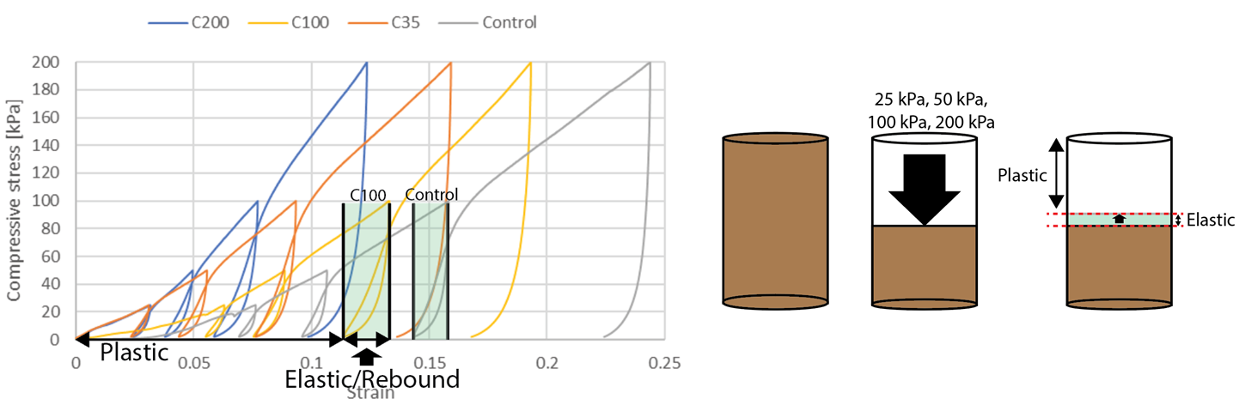

**B**

**A**

**Figure 1:** Stress v strain following the application of load to intact soil cores from a long term compost amendment trial. A- Elastic and plastic deformation highlighted with greater elastic rebound in C100 treatment when compared to control (no compost) treatment. B- graphical representation of soil compaction resilience assay.

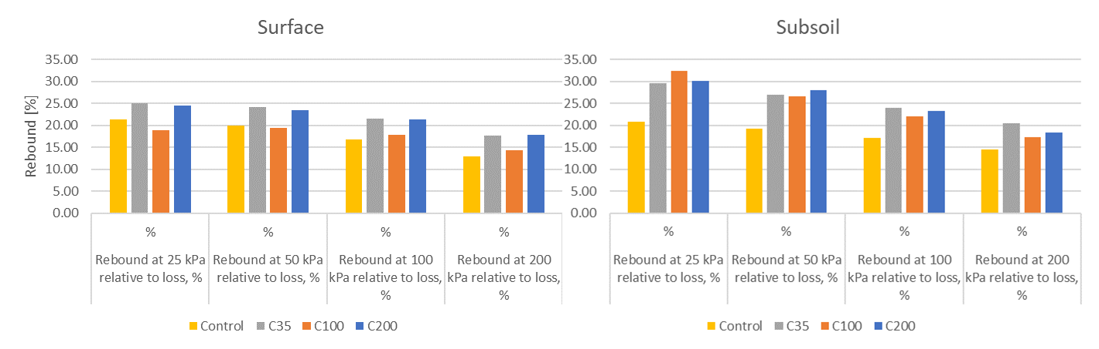

**B**

**A**

**Figure 2:** Elastic rebound following the application of load (25, 50, 100, and 200 kPa) to intact soil cores from a long term compost amendment trial. A- Rebound of surface sampled soil cores collected from plots amended with 35 to 200 t ha of compost (and control). B- Rebound of subsoil sampled soil cores collected from plots amended with 35 to 200 t ha of compost (and control).

***Compost screening***

The complete dataset of compost received by JHI over the project period screening was completed and the full dataset submitted to ILVO for inclusion in the compost database (February 2023). Data included particle size distribution, bulk density (both wet and dry), hydraulic conductivity, saturated water content, and water holding capacity after 24 hours drainage and equilibration at -10 kPa. Water holding measurements were measured in both cores containing 100% compost and also when compost mixed with a sandy loam soil (30% compost : 70% soil). Measures highlighted potential benefits in water holding capacity associated with the incorporation of compost material into soil to improve soil function.